Oral Histology

Development of the face

Lecture 2

Prof. Dr. Muna Merza

Fourth week:
Central nervous system (CNS) begins to develop differentiates from ectoderm, localised in embryo,
Neuroectoderm neural plate which is a band of cells that extends length of the embryo, from cephalic to caudal

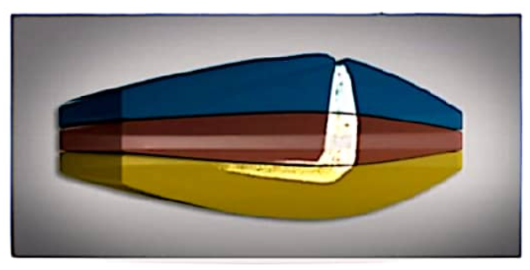

Plate undergoes further growth and thickening, which causes it to deepen and invaginate centrally, forming the neural groove.

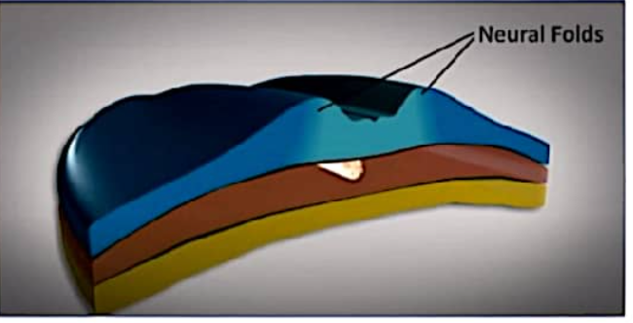

Neural groove deepens further and becomes surrounded by neural folds, which meet superior to neural groove, forming a neural tube which undergoes fusion at its most superior portion, future spinal cord

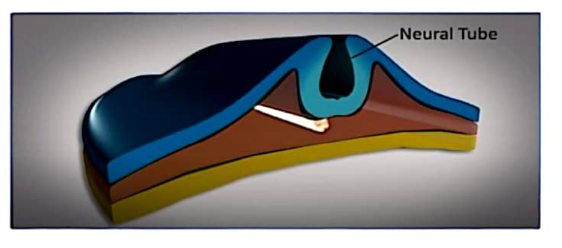

Disc now has a cephalic end (head) where the oropharyngeal membrane (buccopharyngeal membrane, (future mouth forms) and caudal end (tail) where cloacal membrane forms (future anus).
Cells along the back of the embryo grow more rapidly than the front, forming a curved shape.
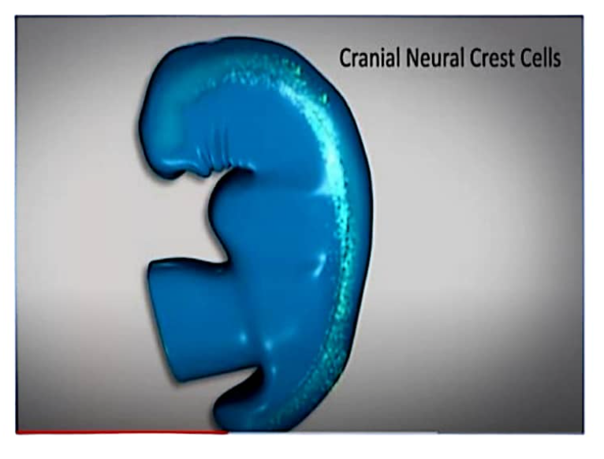

Neural cells develop from crest neuroectoderm, then migrate from neural folds and disperse within mesenchyme; they are IMPORTANT in development of head and neck structures such as branchial arches.

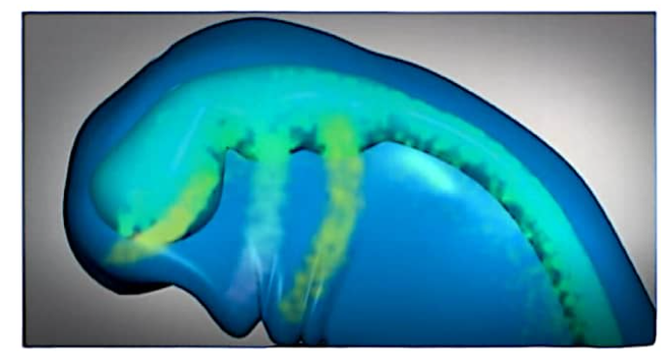

Endoderm tissue buds begin developing, and will later form the respiratory and digestive organs. Brain begins to develop, as do eye stalks and ear pits.
Ectoderm tissue buds develop, and will later form the limbs.
Ectoderm tissue folds develop as branchial arches, which will become the jaws and other neck structures.
Heart begins developing on the front of the embryo, beneath the head, and is pushed down into the chest as the branchial arches develop
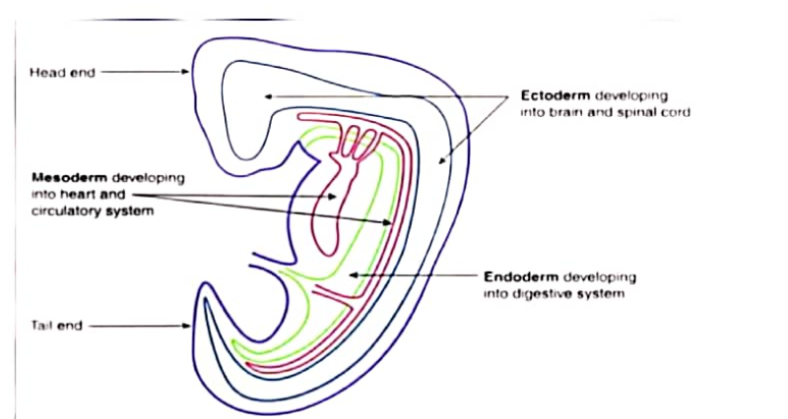
Fifth week
Nose begins developing as nasal pits. Jaws and ears form.
Hands and feet begin developing. All internal organs are developing.
Ectoderm tissue folds grow to join at the front and form the chest and abdominal cavity walls.
