University of Basrah
College of Engineering
Department of Chemical Engineering

Organic Chemistry Laboratory Experiment name
(( Recrystallizing process ))
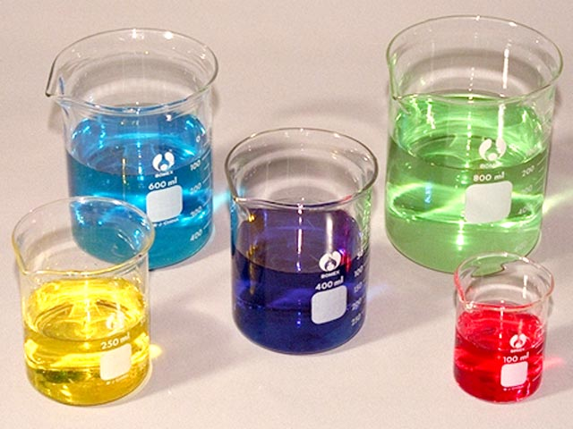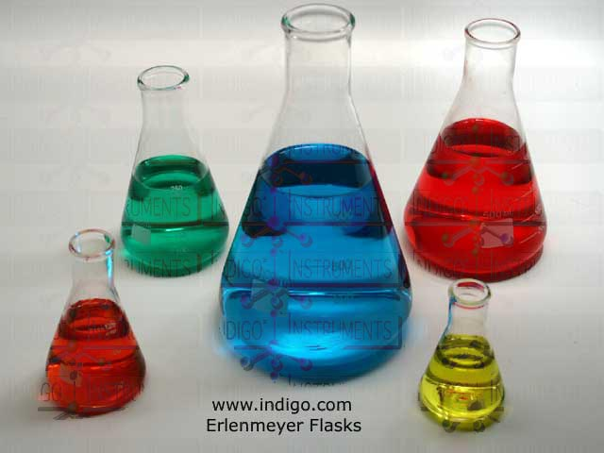

Prepare students
Hameed kadhim mohsin
First phase
Division _ B_

Name of the experiment: Solubility
Experience : first
The date of the experiment: 11 \ 12 \ 2012
The purpose of the experiment :

testing the solubility of substances in the solvent

Theory experiment
Solubility
Solubility Solubility reflect the spread of minutes solute Solute within minutes of the solvent Solvent, for the purpose of forming homogeneous solution Homogenous.
The attractive forces between molecules or atoms or ions are determined by the solubility dissolved in the solvent. The forces only link between molecules vehicles covalent nonpolar Non-Polar is strong van der Falls van der Wall's forces or the forces of London London Forces eg fourth chloride carbon and hydrocarbons, while vehicles Polar Polar compounds the molecules are linked with each other forces bipolar - dipole Dipole-dipole forces in addition to the forces of van der Falls. Some molecules are associated with each other as well as other attractive forces hydrogen bonds Hydrogen Bonds, eg water, ammonia and hydrogen halides This bond is characterized by its strength.
There is a general rule of solubility and called in English Like dissolve like means like dissolves likeness, as the polar compounds melt polar compounds as well as non-polar melt non-polar compounds while not melt polar compounds non-polar and vice versa.
The process of blending components of the solution usually under the temperature and pressure constant and explain the automatic blending of components along the path must be linked card Kibs
Can not determine the path taken when mixing thoroughly
because the process of mixing the ingredients usually out of control and there is no equilibrium of the system on the track except for the initial state and the final, for example, can be visualized mixing two components to configure the solution binary occur by adding a plug gradually to the amount of information from other The solution will consist if its formation was accompanied by a decrease in energy Kibs free system.

Ways of expressing solubility
Solubility can be expressed in a solution in several ways, the most important ...
1 - the percentage by weight:
It is the number of grams dissolved in 100 grams of solvent and in the case of gases can use the percentage size which is about the size of the gas at the rate of pressure and jolt heat which melts at 100 grams of solvent at room temperature and a given pressure.
2 - Number of molecular grams per liter:
Which is about the weight of material attributed to the molecular weight per liter
Of a solution (M).
3 - Molalah (m):
Which is about the weight of material attributed to the molecular weight dissolved in 100 g.
4 - partial fracture "mole Fraction"
It is the number of dissolved molecular Jermat n1 divided by the total number of grams per molecular solvent dissolved n2 and n1.
5 - percentage of partial break:
It is a partial fracture multiplied by 100.
There are nine types of lotions When the gas is dissolved, there are three types of solutions are:
1 - solution gas in a gas.
2 - gas in a liquid solution.
3 - solution gas in a solid.
When the molten liquid, there are three other types of solutions are 1
1 - liquid in gas solution.
2 - means in a liquid solution.
3 - liquid solution in a solid.
Where, however, the dissolved material rigid (solid) are found three other types of solutions are:
1 - rigid material in solution gas.
2 - solution rigid material in a liquid.
3 - rigid material in solution rigid material.
Explain some of the types rave solutions are
1 - solution gas in a gas:
Melt some gases in some fully soluble and is mixed together with all ratios and trace gases in a gas solvents gas laws the pressure resulting from the mixture of gases equal the sum of the partial pressures of gases
Components of this mixture which known Daltoan Law of partial pressure of the gas
Studies have shown minute Dalton law is quite right when
Very low pressure, but kind of diffraction occurs for this law at high pressures and gas due to the effect of particle size
And to the attractive forces located between them.
2 - Gas Guy solution means:
The gas in a liquid solution a real solution if the solution does not contain a great deal of gas and there is no interaction between the gas and the liquid as
College gas can be expelled from the solution either by removing the temperature and either ease
Pressure in the solution.
Examples of these gases, which are a real solution in water Ghazi "oxygen (O2) and nitrogen (N2)" They Ivopan a low not interact with water and can be completely expelled from the solution
The gases that react with water, such as "ammonia (NH3) and hydrogen chloride (HCl2) and carbon dioxide (CO2)" It may not be with the water solutions of the fact of gases in liquids because of the composition of the compounds with water.
Ammonia

And generally vary solubility of gases in liquids to a large extent they rely on "the type of gas and the nature of the liquid used" and there are factors
Affect the solubility of the most important:
A - Effect of Pressure:
Regulates the relationship between the pressure and the solubility of gas in liquid law known as "Henry's Law" Henry Low It provides for the following:
"Commensurate mass of dissolved gas in a certain amount of liquid when the temperature to directly proportional to the gas actually on the surface of the liquid"
B - the effect of temperature:
Temperature affects a significant impact on the melting of gases in liquids is less solubility of gas to raise the temperature and increase Pas Nkhvadha.
C - the effect of the presence of dissolved:
Experiment found that soluble gas in a liquid at least clear up when there is dissolved in the liquid gas dispute user This phenomenon seems to be clearly
In solutions of gases in the water, especially when it is dissolved electrolyte This property is known as the "expulsion salt" Salting out and vary this property of salt to last, but with a fixed value for a single type of salt dissolved whatever change the type of solute in solution
This can be explained this property assuming that the salt dissolved in water happen to him kind of hydrolysis or Agrna where they accumulate around some molecules of water and thus lose these particles ability to dissolve gas means that the number water molecules free capable of dissolving gas at least to some extent because of this hydrolysis leading to decrease the solubility of gas in solution

Tools used in the experiment
1. Test tube
2. Teaspoon
3. Washer water
Materials used in Aaltejrebh
Compounds that are tested Maipetha
1. Benzoic acid
2. Chloride Aalbotaseyoum
3. Elamite
4. Potassium permanganate
Solvents
1.Distilled water
2. Acidic solution PH -7
3. Basic solution PH + 7
4. Ethanol
5. Acetone
6. Gasoline

Modus operandi
Take a few organic material placed inside the test tube, then add a particular solvent and then shake the test tube containing the solute and solvent. Note the following
1. If be homogeneous solution of the solvent and solute is the chemical dissolved in the solvent
2. After shaking Matkon deposit in the bottom of the test tube, appeared stuck or separated into two layers, this solution shows that the material is dissolved in solution and recorded readings

Debate
Q 1 \ What do you mean solubility.
Q2\ factors affecting solubility
Q 3\ how they affect temperature increase on a solid solubility in liquid
Q 4 \ Why depends soluble solids in the liquid

