المحاضرة الحادي عشر/ التشريح والفسلجه / قسم هندسة الاجهزة الطبية
الاستاذ الدكتور خيري عبدالله
Lec. 11 / Anatomy and Physiology
Articulations or Joints : There are 360 Joints in the adult human .
Joint : It is a part of the body where two or more bones meet to allow movement .
Anatomical Classification of joints :
1 – Joints of hand 2 – Elbow joint
3 – Wrist joint 4 – Axillary joint
5 – Sterno-clavicular joint 6 – Vertebral articulation
7 – Temporo-mandibular joint 8 – Sacro-iliac joint
9 – Hip joint 10 – Knee joint
11 – Articulation of foot .
Histological classification of joints :
1 – Fibrous joints : Skull bones joined by dense regular connective tissue ( suture collagen fibers ) permit little or no mobility .
2 – Cartilagenous joints : inter-vertebral disc , slight mobility .
3 – Synovial joints : The most common types of joint , compose synovial cavity , contain synovial fluid enclosed synovial membrane associated with ligaments , like shoulder , hip joint , knee joint .
4 – Facet joints : These joints between two articular processes between two vertebrates .
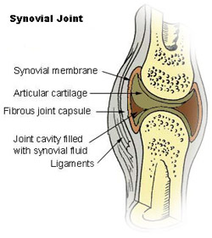

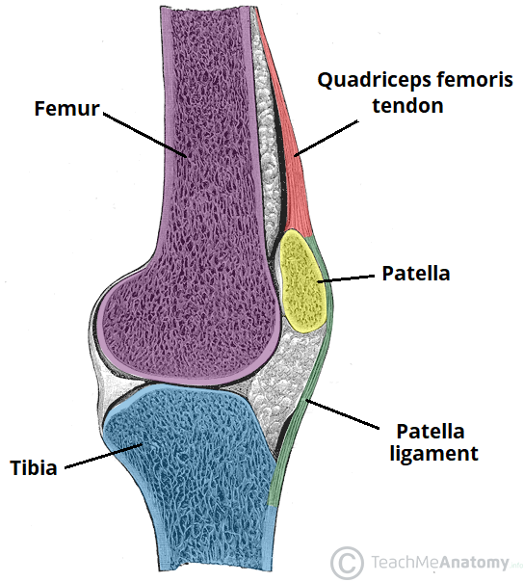
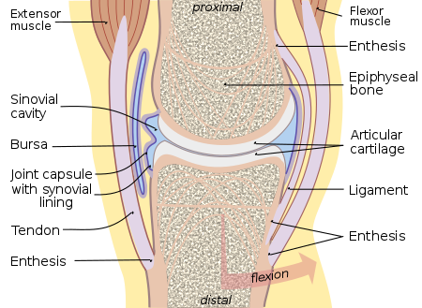

Arthritis : Inflammation of joints .
Rheumatiod arthritis (Rheumatism ) ; special type of arthritis / autoimmune disease .
Fractures of bones

