المحاضرة العاشرة / التشريح والفسلجه/ قسم هندسة الأجهزة الطبية / المرحلة الثانية / الاستاذ الدكتور خيري عبدالله
Lec. 10 Human Skeleton
- The human skeleton is the internal framework of the human body . It is composed of 270 bones at birth and decreased to 206 bones by adulthood ( some bones are fused ) .
- The bones mass in the skeleton about 14 % of the total body weight .
Human skeleton is divided to :
1 - Axial skeleton : include , skull , vertebral column and ribs .
2 – Appendicular skeleton , which attached to the axial skeleton , it is formed by : shoulders , pelvis and bones of upper and lower limbs .
Functions of human skeleton :
1 – Support 2 – Movement 3 – Protection
4 – Production of blood cells .
5 – Storage of minerals .
6 – Endocrine regulation .

Bones of Upper limb :
1 – Humerus 2 – Radius 3 – Ulna 4 – Carpus bones (8)Wrist
5 - Metacarpus( 5 hand palm) 6 – Phalanx bones ( 14)
Bones of Lower limb :
1 – Femur 2 – Patella 3 – Tibia 4 – Fibula 5– Seven tarsal bones
6 – Five Metatarsal bones 7 - (14) Phalanges
Bones of Skull :
1 – Frontal bone 2 – Occipital bone 3 – Two Parietal bones 4 – Cranial base 6 bones
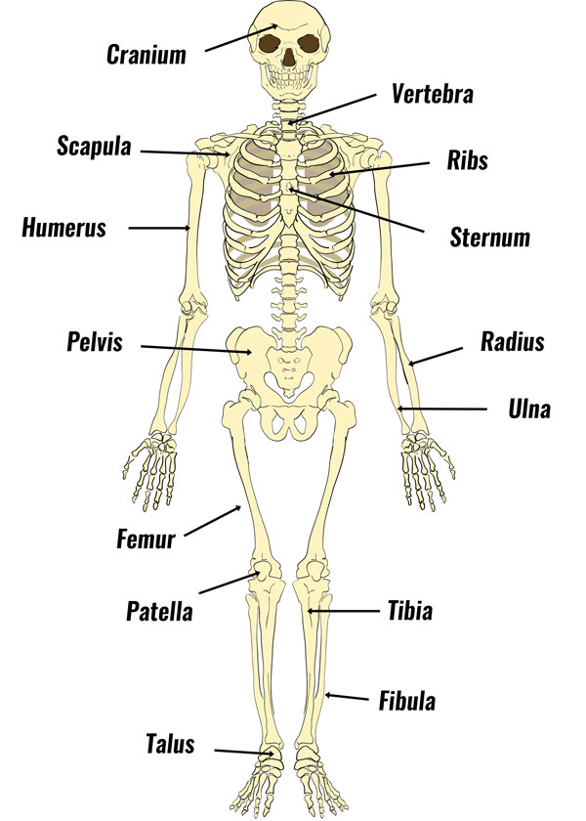
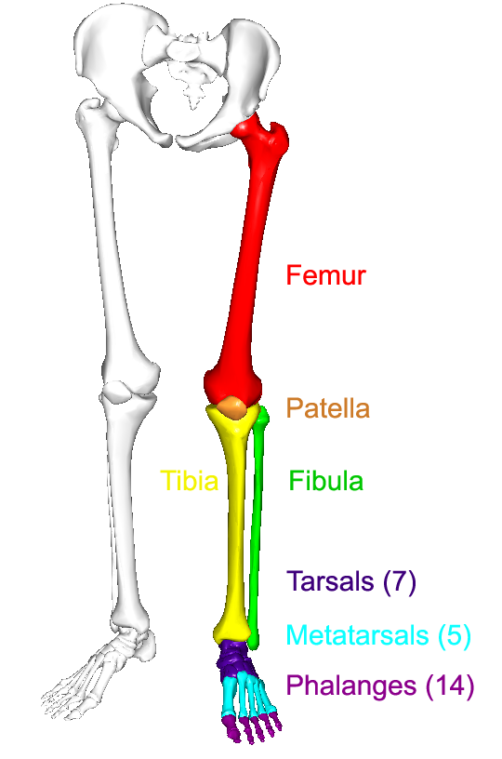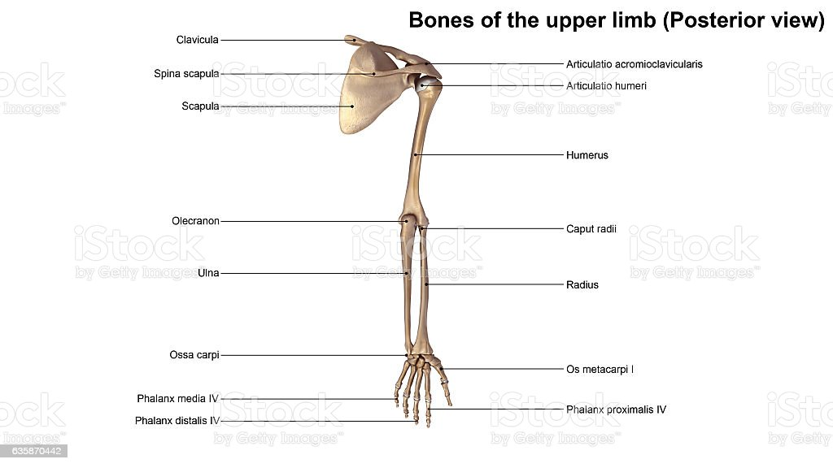
Bones of Skull :
1 – Frontal bone 2 – Occiptal bone 3 – Two Parietal bones
4 – Two Temporal bone 5– Cranial base bones . 6 – Two Sphenoid . 7– Two Ethmoid
Bones of vertebral column :
There are 33 vertebrates separated by intervertebral disc
1 – Cervical vertebrates ( 7, C1 – C7 ) 2 – Thoracic vertebrates ( 12 , T1 – T12 )
3 – Lumbar vertebrates ( 5 , L1 – L5 )
4 – Sacrum 5 fused ( S1 – S5 )
5 – Coccyx 4 vertebrates fused (tail bones ) .
Ribs and sternum :
Ribs (Thoracic cage ) , 12 pairs of ribs :
1 – True ribs 1- 7 connect to the vertebrates and to the sternum by their costal cartilage .
2 – False ribs 8 , 9 , 10 these ribs connect to the sternum by the costal cartilage of the above rib (rib 7 ) .
3 – The last two ribs called floating ribs ( do not have costal cartilage ) .
- Sternum have three parts :
1 – Manubrium 2 – body 3 – Xiphoid cartilage or process

