Cardiovascular System

Blood & lymphatic vessels in the connective tissue

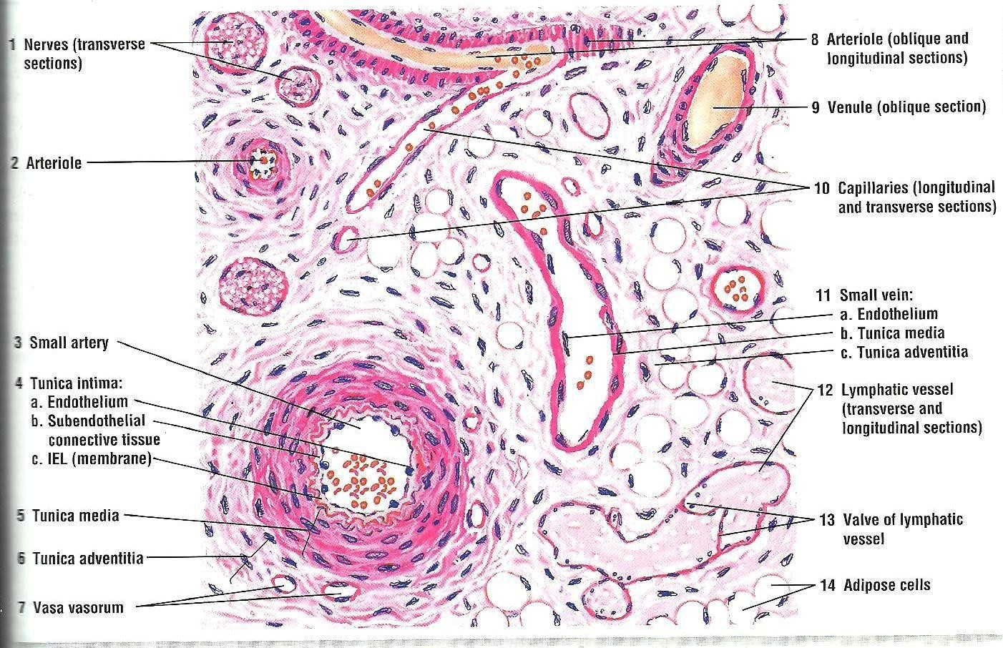

Constituents

Heart

- Blood vessels:

Arteries
  - Capillaries
  - Veins

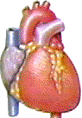
large vein
medium-sized vein venules
elastic arteries muscular arteries arterioles

capillaries/sinusoids

Arteries – ALWAYS carry blood away from the heart
Veins – ALWAYS return blood to the heart
All are lined on their inner surface by endothelial cells (simple squamous)

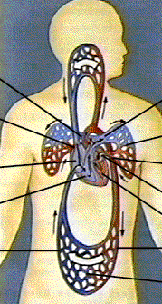
Gross Anatomy of Circulatory System

Pulmonary & Systemic Circulations

Pulmonary Circuit

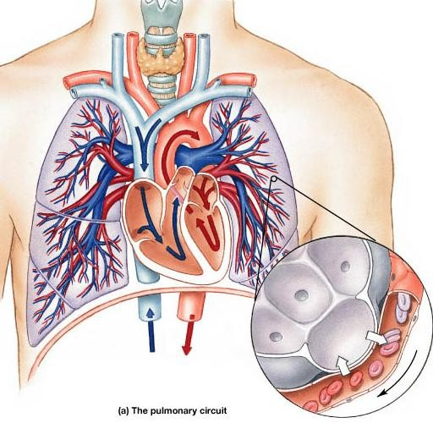
- Right ventricle into pulmonary trunk to pulmonary arteries to lungs.
- Return by way of 4
pulmonary veins to left atrium.

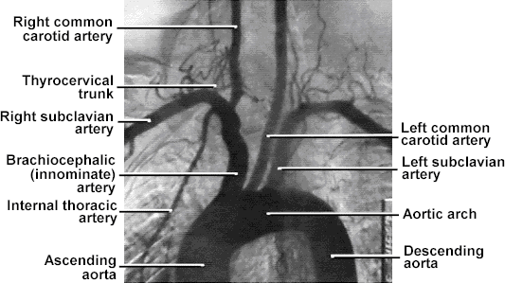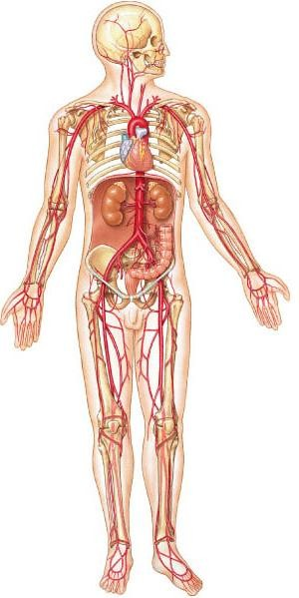Systemic Circuit

Basic structure of arteries
- Tunica interna or intima:
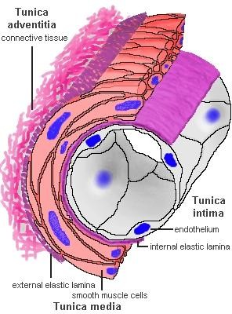
consists of-

  - Endothelium

  - Basal lamina

  - Sub endothelial connective tissue

  - Internal elastic lamina

- Tunica media

- Tunica externa or adventitia

Classification of Arteries

Elastic (conducting/ large size arteries):

e.g. aorta, pulmonary trunk, carotids, subclavian, axillary, iliac.

- Muscular (distributing/ medium size arteries)

- Arterioles

Elastic arteries
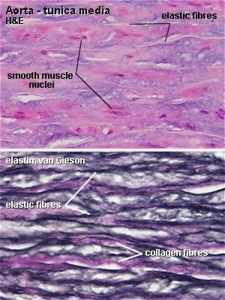
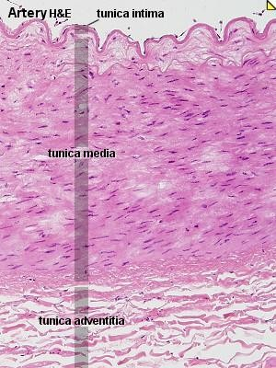
- Internal elastic lamina is ill- defined.

- Tunica media is predominantly made up of elastic fibres.

- Tunica adventitia contains blood vessels (vasa vasorum).

Diameter: > 1 cm

Elastic artery

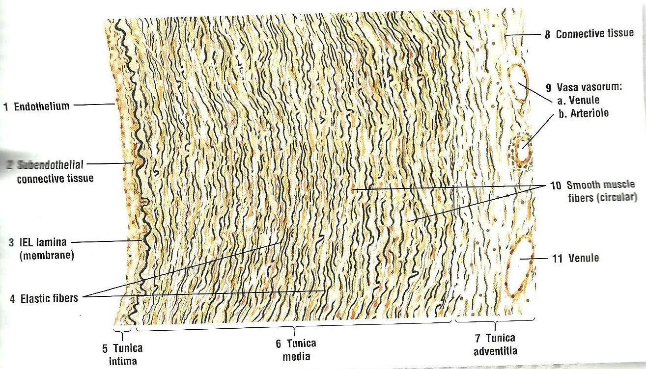

Muscular arteries (Medium sized arteries)
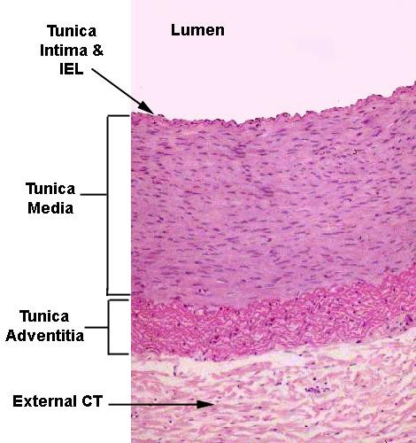
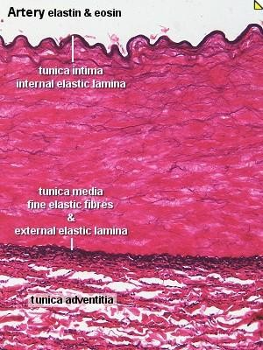
- Internal elastic lamina is
clearly visible.

- Tunica media is predominantly made up of smooth muscle cells.

- Tunica adventitia is thicker than of elastic artery.
Diameter: 2-10 mm

Arterioles
- Arterioles less than 50 μm diameter are called terminal arterioles.
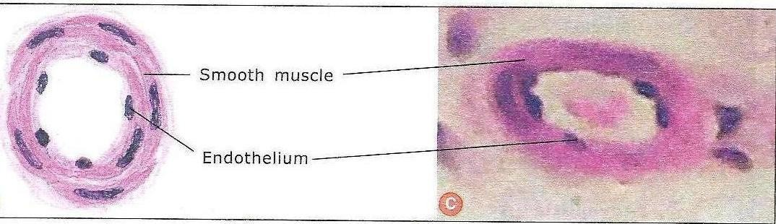
- The smallest terminal arteriole is < 12 μm
- Internal elastic lamina is
poorly developed.
- Thin layer of smooth muscle in tunica media.
- Precapillary sphincter
- Tunica adventitia is thin.
- Metarterioles Diameter: < 100 μm

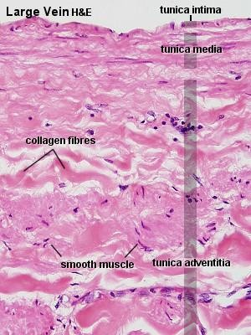
Veins
- Classified as large, medium & small (venules).
- All the 3 tunics are present but not well defined.
- T. intima: endothelial cells, basal lamina, subendothelial connective tissue & few smooth muscle cells
- T. media: larger amount of
collagen, thinner
- T. adventitia: thicker

Large vein

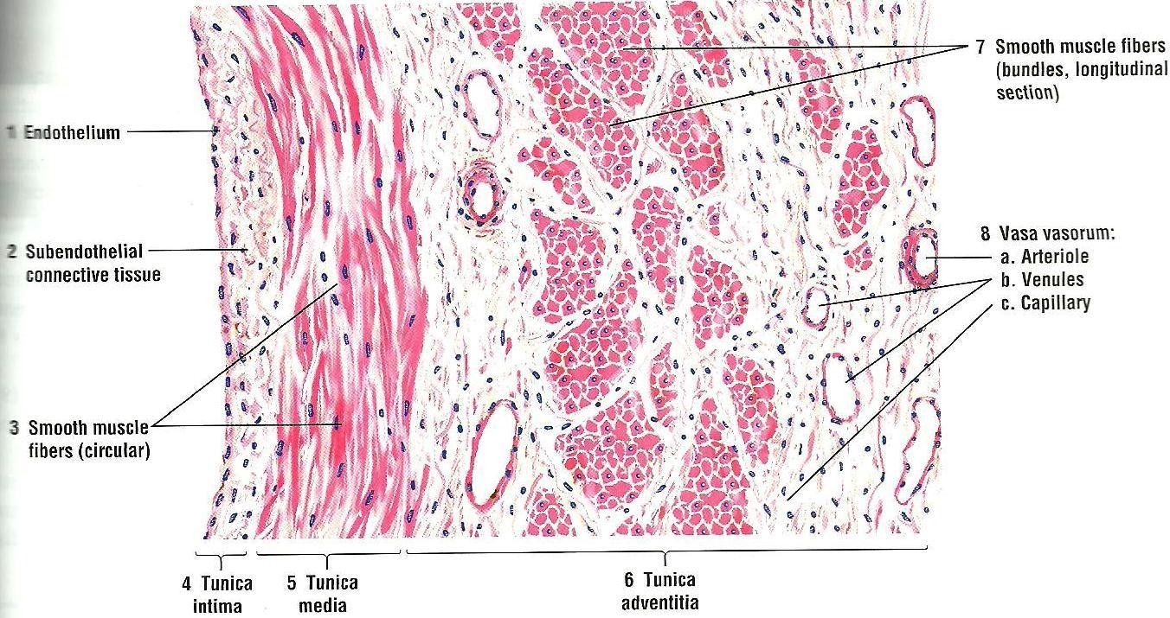

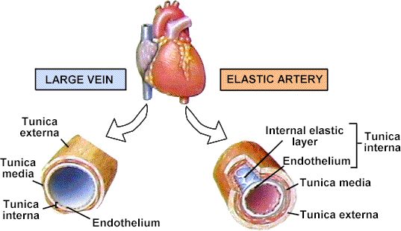
Largest conducting arteries – lead directly from heart, subject to high pressure

Superior & inferior vena cava and their tributaries
Pulmonary trunk & aorta and their major branches

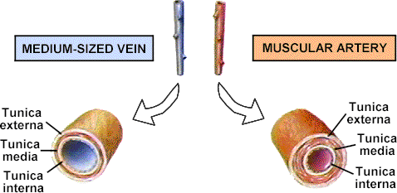

- 9 mm 4 mm
2
~

External and internal jugular, brachial & femoral veins
External and internal carotids, brachial & femoral arteries

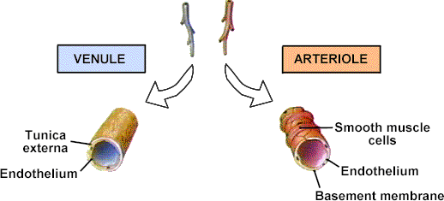

10-50 µm
~
30 µm
~

Capillaries

  - Thin-walled endothelial-lined microscopic vessels that connect arterioles & venules.

  - Extensive network

  - Diameter: 5-10 μm

  - Flow of blood through capillary is called Microcirculation.

  - Absence of T. media & adventitia.

Types of capillaries
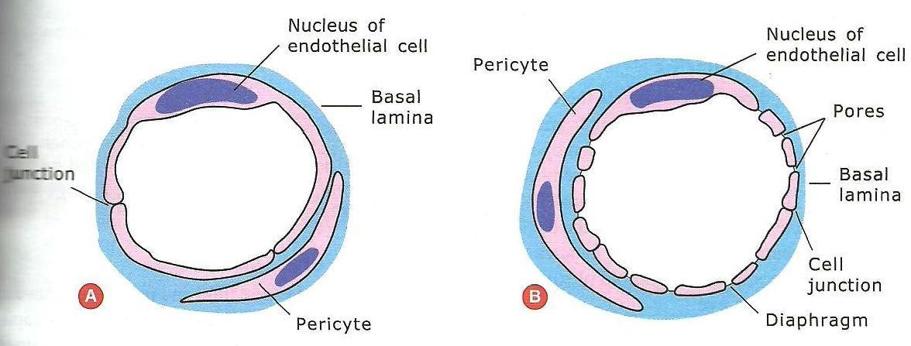

- Continuous capillaries

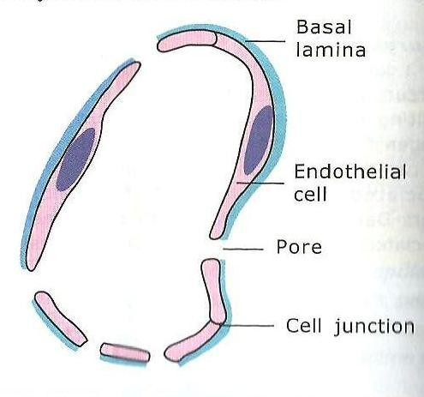
- Fenestrated capillaries

- Sinusoids

Capillaries
Only endothelium Variably permeable

~ 8 µm

somewhat
permeable
Characterized by circular fenestrae or pores that penetrate the endothelium - permit exchange of larger molecules.

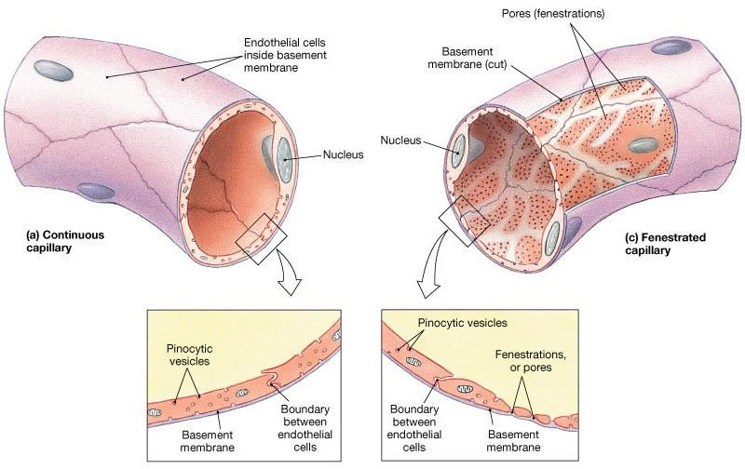

Intestinal mucosa, choroid plexus, endocrine glands, kidneys
Most body regions

Sinusoids

  - Resemble fenestrated capillaries but have:
  - irregular shapes
  - longer pores
  - thinner (or no) basement membrane

  - Blood flow is sluggish
  - Found in the liver, bone marrow, spleen etc.
  - Sometimes called as sinusoidal capillary.

