Ministry of Higher Education and Scientific Research Al-Mustaqbal University College
Radiology Techniques Department

Radiation Physics

Al-Mustaqbal University College 2nd
Radiology Techniques Department

By

Prof. Dr. Raad Shaker

First Semester
Lecture 1: X-Ray Tube (Introduction)

2022/2023

What is x-ray?
X-rays, or roentgen rays, are photons a form of electromagnetic radiation or energy of extremely short wavelength.
- The shorter the wavelength of an electromagnetic radiation form, the greater its energy and, as a rule, the greater its ability to penetrate various materials.
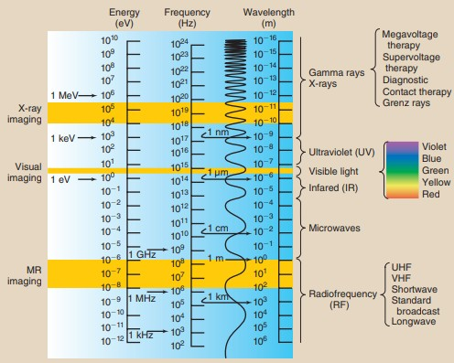
In November of 1895, Wilhelm Conrad Roentgen discovered x-rays while working with a Crookes tube in his laboratory at the University of Würzburg in Germany.
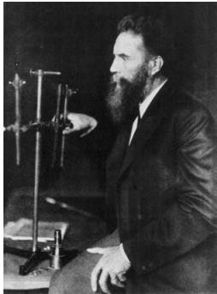
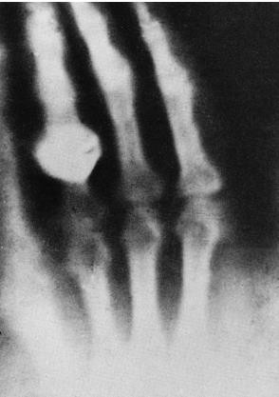
Wilhelm Roentgen
The hand shown in this radiograph belongs to Mrs. Roentgen. This first indication of the possible medical applications of x-rays

X-ray Tube
An x-ray tube consists of two electrodes sealed into an evacuated glass envelope.
- The cathode is the negative side of the x-ray tube; it has two primary parts, a filament (fine tungsten coil) and a focusing cup.
- The anode is the positive side of the x-ray tube; it conducts electricity, radiates heat, and contains the target. Usually of tungsten
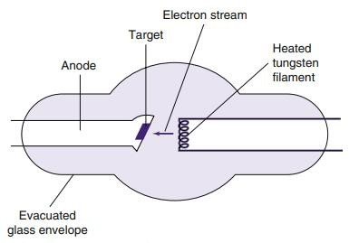

Cathode
The cathode assembly normally consists of two parts
- an electron source (emitter) and
- an auxiliary electrode surrounding it (see figure below).
- The electron emitter is usually a coiled wire filament 0.2–0.3 mm in diameter of reasonably high resistance.
- A metal is chosen for the cathode that will give a copious supply of electrons by thermionic emission at temperatures where there is very little evaporation of metal atoms into the vacuum (e.g. tungsten, melting point of 3370°C).
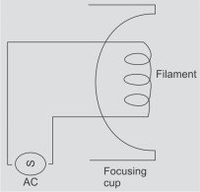

- An x-ray tube filament emits electrons when it is heated.
- When the current through the filament is sufficiently high, the outer- shell electrons of the filament atoms are “boiled off” and ejected from the filament. This phenomenon is known as thermionic emission

Anode
The anode is the positive side of the x-ray tube. There are two types of anodes, stationary and rotating
General-purpose x-ray tubes use the rotating anode because they must be capable of producing high-intensity x-ray beams in a short time

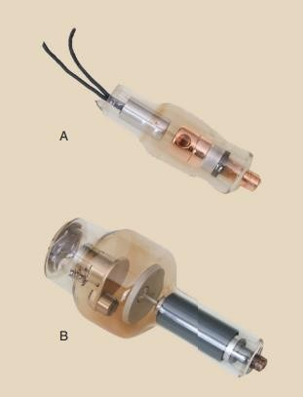

- The target is the area of the anode struck by the electrons from the cathode.
- In anode design as shown in figure 3, the anode surface is steeply angled to the electron beam.
Tungsten is the material of choice for the target for general radiography for three main reasons:
  - A high conversion efficiency for electrons into X-rays. High atomic numbers are favoured since the X-ray intensity is proportional to Z. At 100 keV, lead (Z = 82) converts 1% of the energy into X-rays but aluminium (Z = 13) converts only
about 0.1%.

  - A high melting point so that the large amount of heat released causes minimal damage to the anode, therefore can stand up under high tube current without pitting or bubbling.
  - A high conductivity so that the heat is removed rapidly.

