When the diagnostic primary x-ray beam interacts with anatomic tissues, three processes occur: absorption, scattering, and transmission
X- Rays interact with matter in the following five ways:
- Coherent scattering
- Compton scattering
- Photoelectric effect
- Pair production
- Photodisintegration.
Only Compton scattering and photoelectric effect are important in making an x-ray image. The conditions that govern these two interactions control differential absorption, which determines the degree of contrast of an x-ray image.
- During attenuation of the x-ray beam, the photoelectric effect is responsible for the total absorption of the incoming x-ray photon
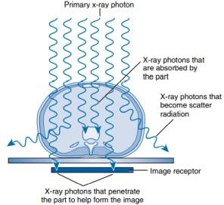

Coherent Scattering
The direction of the scattered x-ray is different from that of the incident xray. The result of coherent scattering is a change in direction of the x-ray without a change in its energy. There is no energy transfer and therefore no ionization.
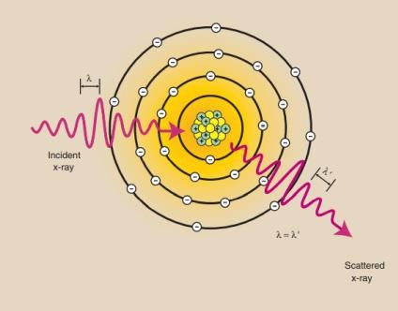
  - Coherent scattering contribute little to the medical image.
  - The wavelength of the incident x-ray is equal to the wavelength of the scattered x-ray

Compton Scattering
In Compton scattering, the incident x-ray interacts with an outer-shell electron and ejects it from the atom, thereby ionizing the atom. The ejected electron is called a Compton electron.
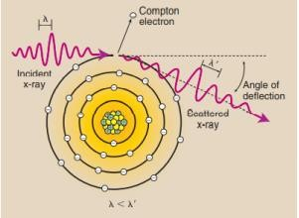
- The x-ray continues in a different direction with less energ

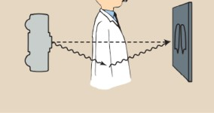
Mathematically, this energy transfer is represented as follows:
E_{i} = E_{s} + (E_{b} + E_{KE})
where E_{i} is energy of the incident x-ray, E_{s} is energy of the scattered x-ray, E_{b} is electron binding energy, and E_{KE} is kinetic energy of the electron
(H.W) A 30-keV x-ray ionizes an atom of barium by ejecting an O-shell electron with 12 keV of kinetic energy. The binding energy of an O-shell electron of barium is 0.04 keV. What is the energy of the scattered x-ray?

Features of Compton Scattering
- The probability of Compton scattering is inversely proportional to x-ray energy (1/E)
- The probability of Compton scattering does not depend on the atomic number of the atom
- As mass density of absorber increases Proportional increase in Compton scattering
- Compton scattering is a predominant interaction in the diagnostic energy range with soft tissue (100 keV-10 MeV).
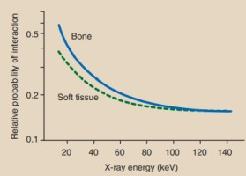
- Scattered X-rays provide no useful information, reduces image contrast, create radiation hazards in radiography

Photoelectric Effect
In the photoelectric effect (PE), a photon of energy E collides with an atom and ejects one of the bound electrons from the K or L shells
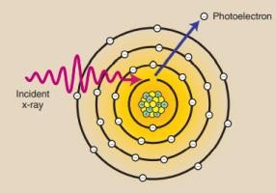
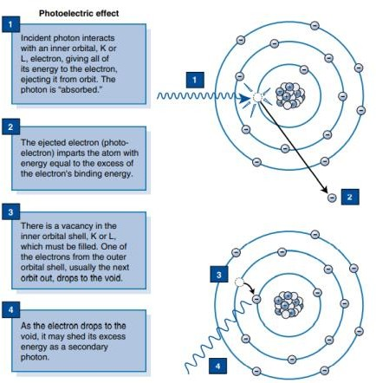
- The electron removed from the atom, called a photoelectron, escapes with kinetic energy equal to the difference between the energy of the incident x-ray and the binding energy of the electron.

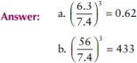
- The x-ray is not scattered, but it is totally absorbed. Mathematically, this is shown as follows:
E_{i} = E_{b} + E_{KE}
where E_{i} is the energy of the incident x-ray, E_{b} is the electron-binding energy, and E_{KE} is the kinetic energy of the electron.
(H.w)A 50-keV x-ray interacts photoelectrically with (a) a carbon atom and (b) a barium atom. K-Shell Electron Binding Energy is 0.3 KeV. What is the kinetic energy of each photoelectron

Features of Photoelectric Effect
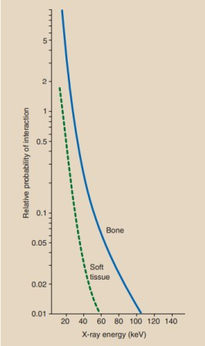
- The probability of the photoelectric effect is inversely proportional to the third power of the x-ray energy (1/E)3.

- The probability of photoelectric effect is directly proportional to the third power of the atomic number of the absorbing material (Z3 ).
Example: What is its relative probability of an 80-keV x-ray interacting with a. Fat? (Z = 6.3) b. Barium? (Z = 56), compared with soft tissue (Z = 7.4)

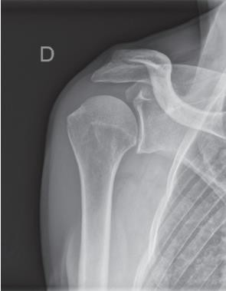
small variation in atomic number of the tissue atom or in x-ray energy results in a large change in the chance of photoelectric interaction.
- As mass density of absorber increases, Proportional increase in photoelectric absorption

Pair production
When a photon having energy > 1.02 MeV, it may escape interaction with electrons and come close enough to the nucleus of the atom to be influenced by the strong nuclear field
- The interaction between the x-ray and the nuclear field causes the xray to disappear, and in its place, two electrons appear one positively charged (positron) and one negatively charged. This process is an example for the conversion of energy into mass as predicted by Einstein.
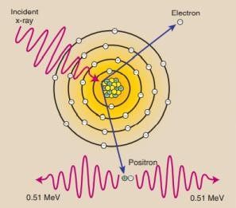

- The positron unites with a free electron, and the mass of both particles is converted to energy in the form of two photons in a process called annihilation radiation.

- It is unimportant in x-ray imaging, but it is forms the basis for positron emission tomography imaging (PET Scan) in nuclear medicine.

Photodisintegration
X-rays with energy above approximately 10 MeV can escape interaction with electrons and the nuclear field and absorbed directly by the nucleus
