X-Ray Quantity
X-ray quantity is the number of x-ray photons in the useful beam.
The intensity is a measure of quantity of radiation. The term exposure is often used in radiology

X-Ray Quality
The term quality describes the penetrating power of the radiation.
The penetrability of an x-ray beam is called the x-ray quality. X-rays with high penetrability are termed high-quality x-rays
- High-energy x-rays are able to penetrate tissue more deeply than low- energy x-rays.
- rays with high penetrability are termed high-quality x-rays

Factors That Affect X-ray Quantity and Quality
A number of factors under the control of radiographers influence the size and shape of the x-ray emission spectrum and therefore the quality and quantity of the x-ray beam

Exposure Time
Exposure time determines the length of time over which the x-ray tube produces x-rays.
  - An increase or decrease in mA, exposure time, or mAs directly affects the quantity of x-rays produced;
  - Patient dose is directly proportional to exposure time.
  - Automatic Exposure Control (AEC): These devices terminate the exposure when a specific quantity of radiation has reached the IR

Effect of mA and mAs (Tube Current and Time)
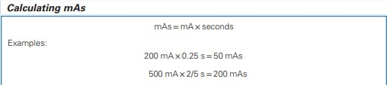
The product of tube current in milliamperes and exposure time in seconds (mA * sec) describes the total number of electrons bombarding the target.

Example: Calculate the total number of electrons bombarding the target of an x-ray tube operated at 200 mA for 0.1 sec
- The ampere, the unit of electrical current, equals 1 coulomb/sec.
- The product of current and time equals the total charge in coulombs.
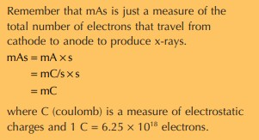
- X-ray tube current is measured in milliamperes, where 1 mA = 10⁻³ amp.
- The charge of the electron is 1.6 × 10⁻¹⁹ coulombs, so

1 mA · s = (10−3𝑐𝑜𝑢𝑙𝑜𝑚𝑏/𝑠𝑒𝑐)(𝑠𝑒𝑐)
1.6×10−19𝑐𝑜𝑢𝑙𝑜𝑚𝑏
𝑒𝑙𝑒𝑐𝑡𝑟𝑜𝑛
= 6.25 × 10¹⁸ electrons
No. of electron = (200 mA)(0.1 sec)( 6.25 × 10¹⁸ electrons/mA.sec)
= 1.25 × 10¹⁶ electrons
A change in mA or mAs results in a proportional change in the amplitude
of the x-ray emission spectrum at all energies.
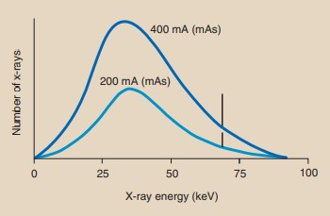
- ray quantity is directly proportional to the mAs
𝐼1 = 𝑚𝐴𝑠1
𝐼2 𝑚𝐴𝑠2
where I₁ and I₂ are the x-ray intensities at mAs₁ and mAs₂, respectively
Example2: The radiographic technique for a kidneys, ureters, and bladder (KUB) examination uses 74 kVp/60 mAs. The result is a patient
exposure of 2.5 mG𝑦𝑎. What will be the exposure if the mAs can be
reduced to 45 mAs?

𝐼1 2.5mG𝑦𝑎
45
= 60

𝐼1 =
2.5mG𝑦𝑎 × 45
60 = 1.9 mGya

  - The tube current affects only the quantity or the amount of x-ray photons produced but not the quality of the X-rays.

i.e. the intensity is ∝ mA.
Milliamperage (mA) is a measure of the current flow rate in the x-ray tube circuit. It determines the number of electrons available to cross the tube and thus the rate at which x-rays are produced

Effect of Kilovolt Peak (kVp) (Tube Voltage)
When kVp is increased:
  - The maximum photon energy
  - the X-ray production efficiency
  - The intensity
  - Quality of the X-rays
A change in kVp affects both the amplitude and the position of the x-ray emission spectrum.
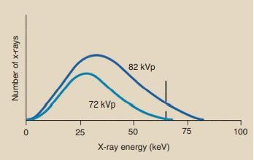
A change in kVp has no effect on the position of the discrete x-ray emission spectrum.
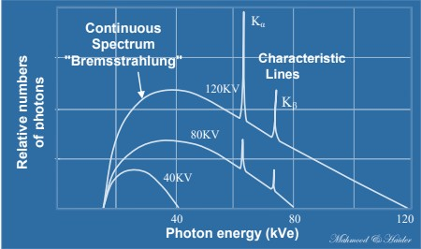
3

The rule states that a 15% increase in kVp is equivalent to doubling the mAs.
- A 15% increase in kVp does not double the x-ray intensity but is equivalent to doubling the mAs to the image receptor.
- To double the output intensity by increasing kVp, one would have to raise the kVp by as much as 40%.
- Radiographically, only a 15% increase in kVp is necessary because with increased kVp, the penetrability of the x-ray beam is increased.
- Therefore, less radiation is absorbed by the patient, leaving a proportionately greater number of x-rays to expose the image receptor

i.e. Radiation exposure (E) ∝ (kVp)²
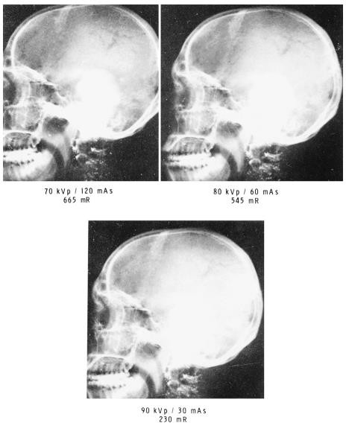
In other words, if were doub[led, the x-ray intensity would increase by a factor of four.

𝐼1
𝐼2
= (𝑘𝑉𝑝1)
𝑘𝑉𝑝2
2

Where 𝐼1and 𝐼2 are the X-ray intensities at 𝑘𝑉𝑝1and 𝑘𝑉𝑝2, respectively.

Example: A lateral chest technique calls for 110 kVp, 10 mAs and results in an x-ray intensity of 0.32 mG𝑦𝑎. What will be the intensity if the kVp is increased to 125 kVp and the mAs remains fixed?

0.32 mG𝑦𝑎
𝐼2
110 ²
= ( ) 125

125 ²
𝐼₂ = (0.32 mG𝑦_{𝑎}) (110)
𝐼2 = (0.32 mG𝑦𝑎)(1.14)²
𝐼2 = (0.32 mG𝑦𝑎)(1.29) = 0.41 mG𝑦𝑎

Effect of Target Material
The atomic number of the target affects both the number (quantity) and the effective energy (quality) of x-rays.
As the atomic number of the target material increases:
  - Increase characteristic energy
  - enhances the efficiency of x-ray production
  - Increase energy of bremsstrahlung x-rays.
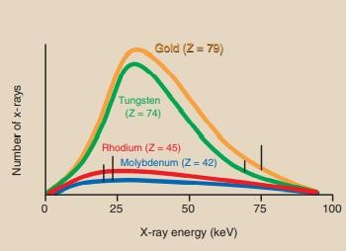

Effect of Voltage Waveform
There are five voltage waveforms: half-wave–rectified, full-wave– rectified, three-phase/six-pulse, three-phase/ 12-pulse, and high-frequency waveforms

- The x-rays produced when the single-phase voltage waveform has a value near zero are of little diagnostic value because of their low energy; such x-rays have low penetrability.
- With three-phase power, the voltage applied across the x-ray tube is nearly constant, never dropping to zero during exposure.
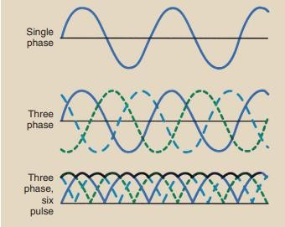

- High-frequency generators produce a nearly constant potential voltage waveform, improving image quality at lower patient radiation dose.

Where an x-ray emission spectrum from a full-wave–rectified unit, all operated at 92 kVp and at the same mAs:
  - The x-ray emission spectrum that results from high-frequency operation is more efficient than that produced with a single-phase or a three phase generator
  - Increased quantity of x-ray photons
  - Increased average energy
  - Minimum and maximum energy is constant

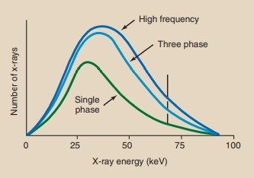

Effect of Added Filtration
  - Filters are thin sheet of material (Al,Cu).
  - The purpose of using filter is to reduce patient exposure at the skin level.
  - Filters alter both the quality and quantity of X-rays by selectively removing the low energy photons in the spectrum.
  - This reduces the photon number (quantity) and shifts the average energy to higher values by increasing the quality.

