Rating Chart
- Radiologic technologists are guided in the use of x-ray tubes by x-ray tube rating charts. It is essential that technologists be able to read and understand these charts
Three types of x-ray tube rating charts are particularly important: 1- The radiographic rating chart
2- The anode cooling chart, and 3- The housing cooling chart.
Exposure factors that determine radiographic output:
- Operating voltage (kV)
- Tube current (mA)
- Exposure time (sec)
- These factors determine radiographic output and heat generated on tube anode
- Anode should not be heated above the melting point of target material ( about 3000º C for tungsten)
- Tube rating charts curves help to avoid thermal damage to x-ray tube.

Radiographic Rating Chart
- For a given mA, any combination of kVp and time that lies below the mA curve is safe. Any combination of kVp and time that lies above the curve representing the desired mA is unsafe

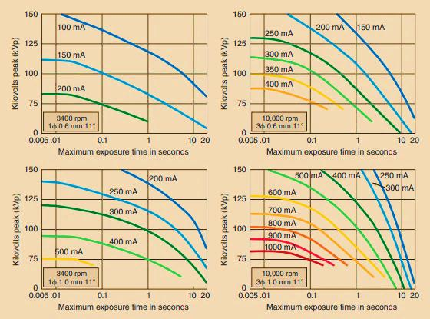
Figure 1: Representative radiographic rating charts for a given x-ray tube.
Each chart specifies the conditions of operation under which it applies.
Question: With reference to Figure 1, which of the following conditions of exposure are safe, and which are unsafe?
A- Radiographic examination with a tube that has a 0.6-mm focal spot and anode rotation of 3400 rpm requires technique factors 95 kVp, 150 mA, 1 s.
Sol: Operating conditions is unsafe for the tube
B- 10,000 rpm; 1-mm focal spot, technique factors 125 kVp, 500 mA, 0.1 s; Sol: Operating conditions is safe for the tube

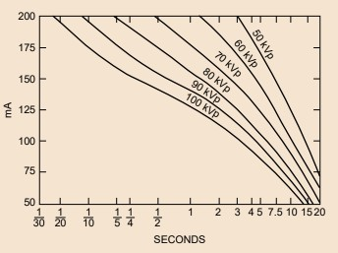
Figure 2: Rating chart for a Machlett Dynamax “25” x-ray tube with a 1-mm focal spot and single-phase, fully rectified voltage.
(H.W) From the rating chart in Figure 2 is a radiographic technique of 100 mA,
1.5 seconds at 100 kVp permissible?

Thermal Characteristics of The X-Ray Tube
X-ray tube failure has several causes, most of which are related to the thermal characteristics of the x-ray tube. This heat can be dissipated in one of three ways: radiation, conduction, or convection (Figure 2).

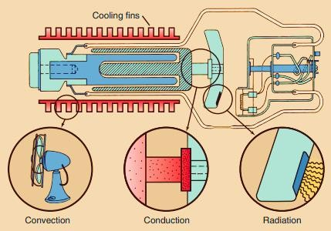

Figure 3: Heat from an anode is dissipated by radiation, conduction, or convection, most often radiation.

Radiation is the transfer of heat by the emission of infrared radiation. The anode may glow red hot. It always emits infrared radiation.
Conduction is the transfer of energy from a higher to lower temperature region. Some heat is conducted through the neck of the anode to the rotor and glass enclosure.
Convection is the transfer of heat by the movement of a heated substance from one place to another. The heated glass raises the temperature of the oil bath; this convects the heat to the tube housing and then to room air.

Anode Cooling Chart
The anode has a limited capacity for storing heat. It is possible through prolonged use or multiple exposures to exceed the heat storage capacity of the anode.
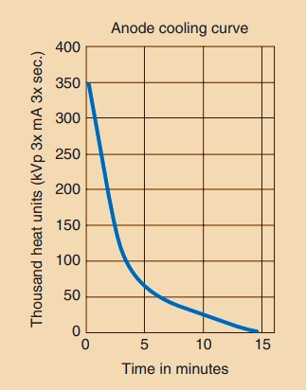
Figure 4: Anode cooling chart shows time required for heated anode to cool.
- During x-ray production, most of the kinetic energy of the electrons is converted to heat. This heat can damage the x-ray tube and the anode target.
- The amount of heat produced from any given exposure is expressed by the heat unit (HU).
Heat Units (HU) = (Tube voltage) (Tube current) (Time)
= (kVp) (mA) (sec) . Constant

Generator type | Constant
Single Phase 1𝜑 | 1
Three Phase 3𝜑 | 1.41
High Frequency | 1.45

Example: Radiographic examination of the lateral lumbar spine with a single- phase imaging system requires 98 kVp, 120 mAs. How many heat units are generated by this exposure?
HU= 98 kVp ×120mAs ×1= 11760 J
Example: How much heat energy (in joules) is produced during a high-frequency mammographic exposure of 25 kVp, 200 mAs?
HU = 25 kVp × 200 mAs × 1.4= 7000 J
Example: A examination is performed with a high frequency imaging system at 120 kVp and 500 mA 0.7 s. Calculate the length of time necessary for the anode to cool to 50,000 HU after 5 exposures?
- For one exposure
HU = 120 kVp ×500mA × 0.7s × 1.45
= 60,900 J
- For 5 exposure
HU = 5 × 60,900
= 304,500 J
From the chart (Figure 4), I went to just 50,000 HU which is about 6.25

Housing Cooling Chart
The cooling chart for the housing of the x-ray tube has a shape similar to that of the anode cooling chart and is used in precisely the same way.
- Based on the quantity of heat units, these charts provided radiographers with information regarding the amount of time that must elapse before initiating another exposure.

