What is Radiation?
Radiation is energy that comes from a source and travels through space at the speed of light 3x10³ m/sec . This energy has an electric field and a magnetic field associated with it, and has wave-like properties. You could also call radiation “electromagnetic waves”.

The Electromagnetic Spectrum
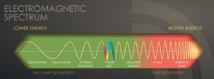
- There is a wide range of electromagnetic radiation in nature. Visible light is one example.
- Radiation with the highest energy includes forms like ultraviolet radiation, x-rays, and gamma rays.
- X-rays and gamma rays have a lot of energy. When they interact with atoms, they can remove electrons and cause the atom to become ionized.

The Ionized Atom
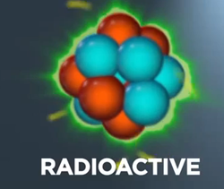
- Radioactive atoms have unstable blends of protons and neutrons.
- Radioactivity is the spontaneous release of energy from an unstable atom to get to a more stable state.
- Ionizing Radiation is the energy that comes out of a radioactive atom.
- Radioactive isotopes are radioactive atoms of the same element that have different numbers of neutrons.

Properties of Radioactive Isotopes
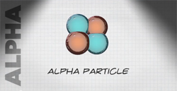
- Radioactive atoms can give off four types of ionizing radiation: alpha particles, beta particles, gamma rays, and neutrons.
- Each type of radiation has different properties. Their properties affect how we can detect it and how it can affect us.
- An unstable atom changes into a more stable atom of a different element by giving off radiation. This process is called radioactive decay.
- A half-life is the length of time it takes for half of the radioactive atoms in a group of radioactive isotopes to decay.

