Introduction
Nobel prize was given to the discovery computed tomography scanner in 1979, for both GN Hounsfield (UK) and Alan M Cormack (USA). In 1963, Alan Cormack built laboratory model for image reconstruction.

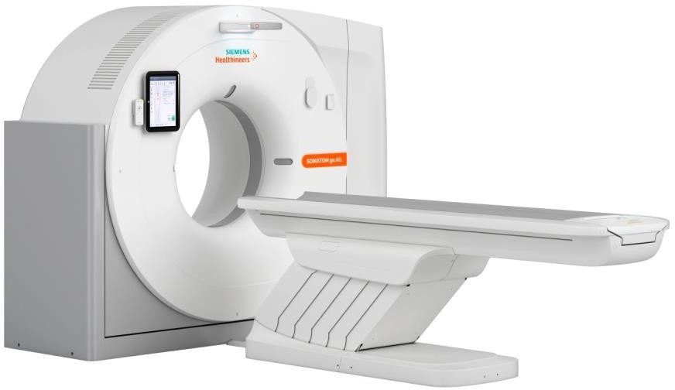

- The gantry includes the x-ray tube, the detector array, the high-voltage generator, the patient support couch
- Multislice helical CT x-ray tubes are very large. They have an anode heat storage capacity of 8 MHU or more. They have anode cooling rates of approximately 1 MHU per minute because the anode disc has a larger diameter, and it is thicker
- CT x-ray tubes are expected to last for at least 50,000 exposures.
- Detector array converts the projection values, in the form of radiation intensities, into electrical quantities.
- All multislice helical CT imaging systems operate on high-frequency power

Generations of Computed Tomography First Generation CT Imaging Systems
This scanners where limited because
  - Only head scans could be performed. Type of beam: pencil-like X- ray beam
  - Generates a lot of heat requiring water and an elaborate cooling system.
  - Translate-rotate movement of tube-detector
  - Scan time was very slow. About 1 minute per slice therefore the duration of scan (average): 25-30 mins and single detector

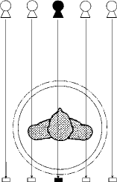
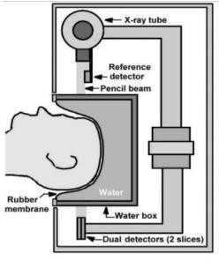

Second Generation CT Imaging Systems
The 2nd generation CT scanners were developed to overcome some of the challenges of the 1st generation scanners.
- Multiple detector (up to 30 detectors)
- Shorter imaging times were possible about 20 seconds per slice therefore duration of scan (average): less than 90 sec
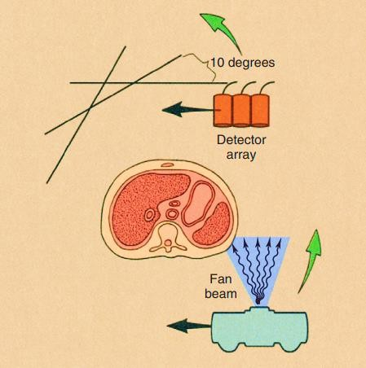
- Fan-shaped x-ray beam (fan angle 10 º)

Third Generation CT Imaging System
This generation of scanners was developed to primarily reduce scan time.
- wide fan beam between 30 and 60 degrees
- Arc of detectors (500 to 1000)
- Tube-detector movements: Rotate-rotate (no rotate-translate)
- Scan time of as fast as 0.5sec per rotation or per slice therefore duration of scan (average): approximately 5 sec
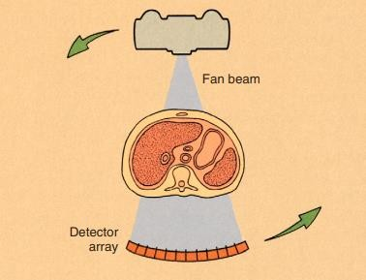

360 rotation
- Ring artifacts can occur in third-generation computed tomography imaging systems because each detector views an annulus (ring) of anatomy during the examination.

Fourth Generation CT Imaging System
Fourth-generation CT were developed because they are free of ring artifacts.
- The x-ray source rotates, but the detector assembly does not
- x-ray beam is fan shaped
- Duration of scan: subsecond imaging time

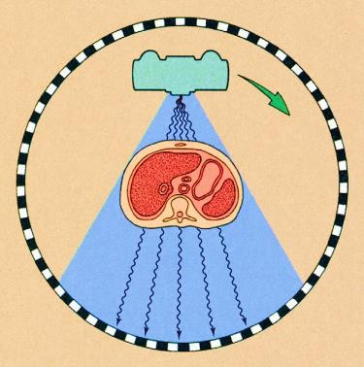

Fifth Generation CT Imaging System
The fifth generation scanner is a stationary/stationary system, developed specifically for cardiac tomography imaging
- No conventional X-ray tube is used, instead large arc of tungsten
- duration of scan very fast (50 ms)
- electron gun that deflects and focuses a fast moving electron beam along tungsten target ring
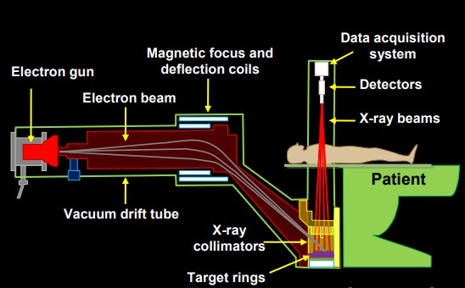

Slip Ring Technology and Helical Scans:
When the examination begins, the x-ray tube rotates continuously. While the x-ray tube is rotating, the couch moves the patient through the plane of the rotating x-ray beam. The x-ray tube is energized continuously, data are collected continuously, and an image then can be reconstructed at any desired z-axis position along the patient (see figure below)

