Arrhythmias or dysrhythmias, are irregularities in the heartbeat, including when it is too fast or too slow. A heart rate that is too fast – above 100 beats per minute in adults – is called tachycardia, and a heart rate that is too slow – below 60 beats per minute – is called bradycardia..
Symptoms
Some types of arrhythmias have no symptoms, when symptoms present, may include palpitations or feeling a pause between heartbeats. In more serious cases, there may be lightheadedness, shortness of breath or chest pain loss of conscious. most cases of arrhythmia are not serious, some predispose a person to complications such as stroke or heart failure. Others may result in sudden death.
Arrhythmias are often categorized into tow groups: atrial arrhythmia and ventricular arrhythmias
I Atrial arrhythmia
- Premature atrial contractions (PACs), abnormal heartbeats originating in the atria. While the sinoatrial node typically regulates the heartbeat during normal sinus rhythm, PACs occur when another region of the atria depolarizes before the sinoatrial node and thus triggers a premature heartbeat.
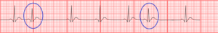
Premature atrial contractions are often benign, requiring no treatment.

- Sinus bradycardia is a sinus node dysfunction with a rate that is lower than normal. In humans, bradycardia is generally defined to be a rate of under 60 beats per minute. 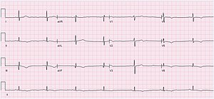

People who practice sports may have sinus bradycardia, because their trained hearts can pump enough blood in each contraction to allow a low resting heart rate. Sinus bradycardia can also be an adaptive advantage; for example during cold,
The decreased heart rate can cause a decreased cardiac output resulting in symptoms such as lightheadedness, dizziness, hypotension, vertigo, and syncope. The slow heart rate may also lead to atrial, junctional, or ventricular ectopic rhythms.
Cuases
- Physiological. Like In athletes.
- Drugs like beta blockers
- Hypothyroidism
- Acute MI and ischemia that involves AV node and purkinje fibers. Like in inferior MI.
Treatment is to stop medication which cause the problem and treat underlying condition like ischemia and hypothyroidism. Some drugs are used to increase sinus node discharge like atropine can be used or ventolin.
- Sinus tachycardia is increase in the rate of electrical impulses arising from the sinoatrial node. In adults, sinus tachycardia is defined as a heart rate greater than 100 beats/min (bpm)

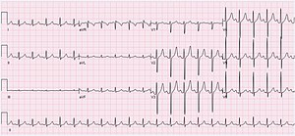
Sinus tachycardia is a normal response to physical exercise, when the heart rate increases to meet the body's higher demand for energy and oxygen, but sinus tachycardia can also indicate a health problem. Thus, sinus tachycardia is a medical finding that can be either physiological or pathological, causes include
- Pain
- Fever
- Anxiety
- Hypovolemia with hypotension and shock
- Anemia
- Hyperthyroidism
- Pulmonary embolism
- Acute coronary ischemia and myocardial infarction
Treatment for physiologic sinus tachycardia involves treating the underlying causes of the tachycardia response. Beta blockers Calcium channel blockers may be used to decrease tachycardia in patients with certain conditions, such as ischemic heart disease and rate-related angina.
- Atrial tachycardia is when the electrical impulse comes from an ectopic focus in atria, not from the sinoatrial node, the atrial rate faster than 150/min but still regular, The AV node cannot conduct atrial rates of greater than about 170 - 200/min. If the atrial rate is faster than this, ‘atrioventricular block’ occurs, with some P waves not followed by QRS complexes.
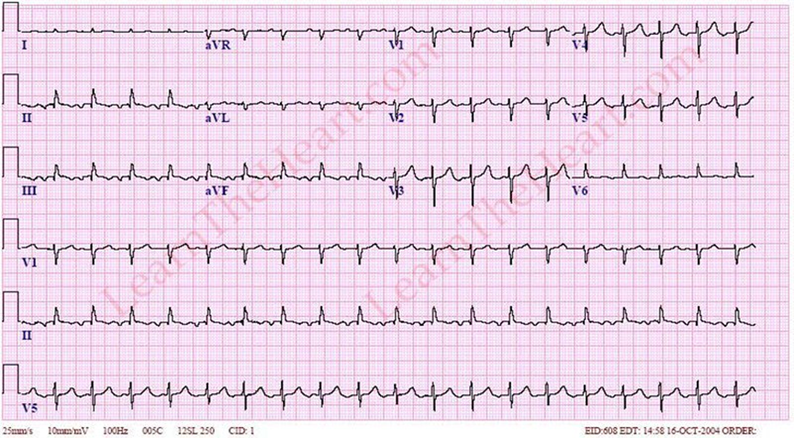

focal atrial tachycardia often occurs in healthy individuals without structural heart disease. Other possible etiologies are listed below:
- Hypoxia
- Pulmonary disease
- Ischemic heart disease
- Stimulants: cocaine, caffeine.
- Alcohol
- Metabolic disturbances
- Digoxin toxicity

- Atrial flutter (AFL) is fast heart rate which is characterized by a sudden-onset regular abnormal heart rhythm on an electrocardiogram (ECG) in which the atrial rate is fast greater than 250/min,.
Typical atrial flutter is recognized on an electrocardiogram by presence of characteristic "flutter waves" at a regular rate of 200 to 300 beats per minute
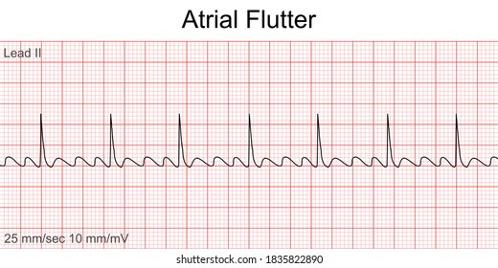
The most important complication is thrombus formation. Treatment like that of AFib.

- Atrial fibrillation (AF or A-fib) is an abnormal heart rhythm characterized by irregular beating of the atrial chambers of the heart , Episodes can be asymptomatic. Symptom may involve heart palpitations, lightheadedness, shortness of breath, or chest pain. Atrial fibrillation is associated with an increased risk of heart failure, thromboembolism and stroke.
High blood pressure and valvular heart disease , heart failure, coronary artery disease, cardiomyopathy, alcohol intake, tobacco smoking, diabetes mellitus, and thyrotoxicosis. and congenital heart disease.
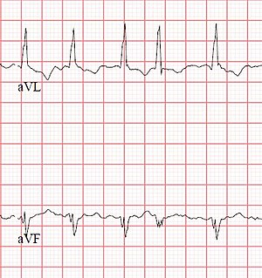

Rhythm control means returning the sinus rhythm can be done with either drugs like amiordaron or with electrical DC shock , while rate control can be achieved with drugs like Beta Blockers and digoxine
Anticoagulation with warfarin or native oral anticoagulants and heparin used to prevent stroke and thromboembolism.
- Paroxysmal supraventricular tachycardia (SVT) is a type of supraventricular tachycardia, named for its intermittent episodes of abrupt onset and termination. Often people have no symptoms. Otherwise symptoms may include palpitations, feeling lightheaded, sweating, shortness of breath, and chest pain
Vagal maneuvers, such as the Valsalva maneuver,and carotid massage are often used as the initial treatment. If not effective and the person has a normal blood pressure the medication adenosine may be tried. If adenosine is not effective a calcium channel blocker or beta blocker may be used. Otherwise synchronized cardioversion is the treatment. Future episodes can be prevented by catheter ablation.
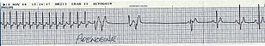

II Ventricular Arrythmia
  - A premature ventricular contraction (PVC) is a relatively common event where the heartbeat is initiated from Purkinje fibers in the ventricles not from the sinoatrial node. PVCs may cause no symptoms or may be perceived as a "skipped beat" or felt as palpitations in the chest. Single beat PVCs do not usually considerd a danger.
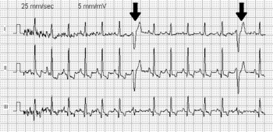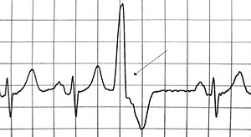
Common causes includes
- Alcohol
- Caffeine
- Nicotine
- Hypertension
- Cardiomyopathy.
Treatment is with Beta blockers.

  - Accelerated idioventricular rhythm another name is slow V.T. is a ventricular rhythm with a rate of between 60 and 100 beats per minute. Idioventricular means “relating to or affecting the cardiac ventricle alone” and refers to any ectopic ventricular arrhythmia.
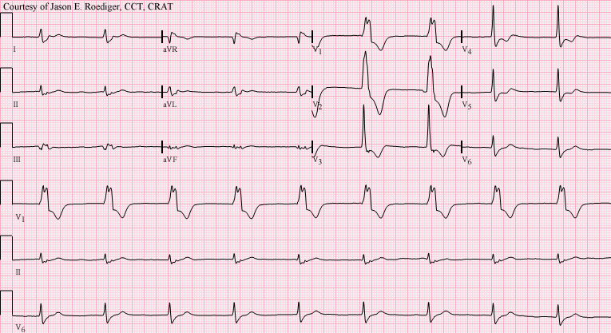
Sinoatrial depolarization and subsequent propagation of the electrical impulse suppress the action of the lower natural pacemakers of the heart, which have slower intrinsic rates, The accelerated idioventricular rhythm occurs when depolarization rate of a normally suppressed focus increases to above that of the sinoatrial node and the atrioventricular node. This most commonly occurs in the setting of a sinus bradycardia. Or after revascularization of MI, it is benign phenomena. Treated with overdrive pacing through increasing sinus node rate either with drug or pacemaker.

  - Ventricular tachycardia (V-tach or VT) is a fast heart rate MORE THAN 100 arising from the ventricles of the heart. a few seconds may not result in problems, longer periods are dangerous that can lead to Ventricular fibrillation and cardiac arrest.
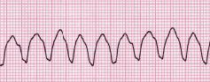
Ventricular tachycardia can occur due to coronary heart disease, aortic stenosis, cardiomyopathy, electrolyte problems, or a heart attack. Diagnosis is by an electrocardiogram (ECG) showing a rate of greater than 100 beats per minute and at least three wide QRS complexes in a row, It is classified as
- non-sustained VT that lasts less than 30 sec.
- 2- sustained VT that lasts more than 30 sec.
monomorphic ventricular tachycardia, the shape of each heart beat on the ECG looks the same because it arise from single focus. The most common cause of monomorphic ventricular tachycardia is scarring of the heart muscle from a previous myocardial infarction .
Polymorphic ventricular tachycardia it arise from multiple sites, is most commonly caused by abnormalities of ventricular muscle repolarization. The predisposition to this problem usually manifests on the ECG as a prolongation of the QT interval. QT prolongation may be congenital or acquired.
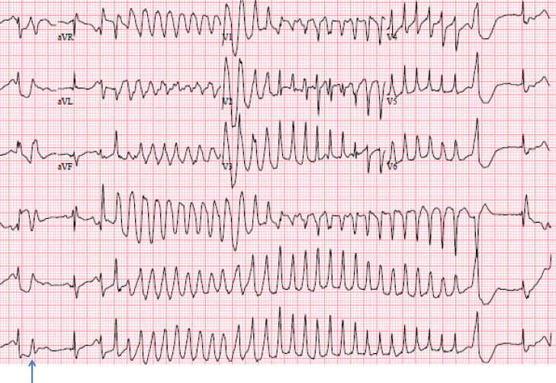
Congenital problems include long QT syndrome.
Acquired problems are usually related to drug toxicity or electrolyte abnormalities, but can occur as a result of myocardial ischemia. Some drugs can prolong the QT interval . relatively common drugs including some antibiotics like erythromycin and clarithromycin and antimalarial and antihistamines, in particular when combined with one another. Problems with blood levels of potassium, magnesium and calcium may also contribute. High-dose magnesium is often used as an antidote in cardiac arrest protocols.
Treatment is by electrical Cardio version and medication to treat electrolyte disturbance , if the cause is congenital or non modifiable , implantable cardiac defibrillator (ICD) implantation is mandatory.
  - Ventricular fibrillation is an irregular and uncoordinated contraction of the cardiac muscle of ventricles. It is a common cause of cardiac arrest and is usually fatal if not reversed by defibrillation. Common causes is Myocardial ischemia and cardiomyopathy, electrolyte disturbance.
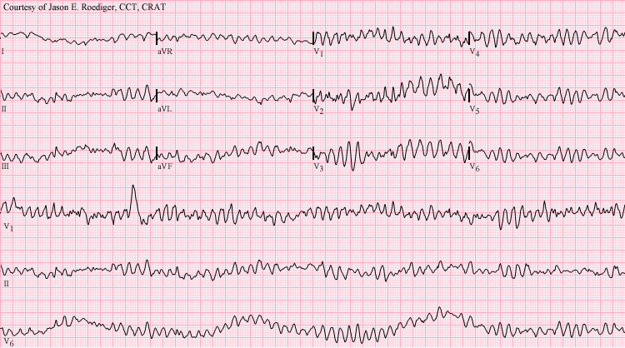

III conduction problem
  - First degree AV block
It means there is delay in conduction of depolarization that originates in the SA node to the ventricles, which appears as prolonged PR interval on the ECG
Causes include coronary artery disease, acute rheumatic carditis, digoxin toxicity or electrolyte disturbances.
The patients are either asymptomatic or feels dizzy and fatigue.
Treatment is avoiding any drug that can develop brady cardia like BB.
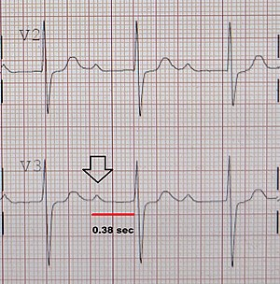
  - SECOND DEGREE HEART BLOCK
Sometimes excitation completely fails to pass through the AV node or
the bundle of His.
- Mobitz I in which there is gradual prolongation of the PR interval then complete failure of transmission of the p wave to the ventricles.
- Mobitz II when there is failure of passage of p wave to the ventricles either intermittent or fixed with 2:1 or 3:1 ratio.
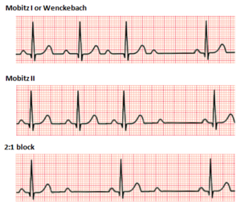

  - THIRD DEGREE HEART BLOCK
Complete heart block (third degree block) is atrial contraction is normal but no beats are conducted to the ventricles. Her the patient may develop syncope or shock and he need Pacemaker. The causes can be due to drugs, ischemia, hypothroidism
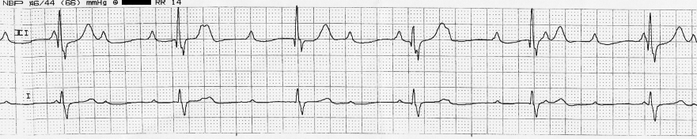

  - RIGHT BUNDLE BRANCH BLOCK
In RBBB, no conduction occurs down the right bundle branch but the septum is depolarized from the left side as usual, causing an R wave in a right ventricular lead (V1) and a small Q wave in a left ventricular lead(V6).
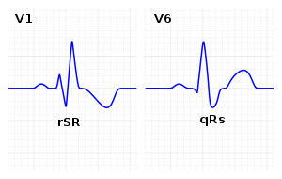
  - LEFT BUNDLE BRANCH BLOCK
If conduction down the left bundle branch fails, the septum becomes depolarized from right to left, causing a small Q wave in lead V1, and an R wave in lead V6.
It can occur in Hypertension, Aortic stenosis and Ischemia.
