**Cardiac Cells Physiology**

In their resting state, CARDIAC CELLS are electrically polarized; MEANS, their insides are negatively charged with respect to their outsides. This electrical polarity is maintained by membrane pumps that ensure the appropriate distribution of ions (primarily potassium, sodium, chloride, and calcium) necessary to keep the insides of these cells relatively electronegative. These ions pass into and out of the cell through special ion channels in the cell membrane.

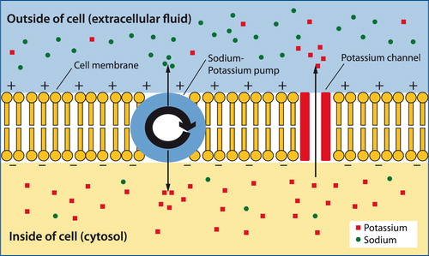

**The Cells of the Heart**

the heart consists of three types of cells:

Pacemaker cells—the electrical power source of the heart

Electrical conducting cells—the hard wiring of the heart

Myocardial cells—the contractile machinery of the heart

**De-polarization**

Depolarization IS changing the resting cells potentials which is propagated from cell to cell, producing a wave of depolarization that can be transmitted across the entire heart. This wave of depolarization represents a flow of electricity, an electrical current, that can be detected by electrodes placed on the surface of the body.

After depolarization is complete, the cardiac cells restore their resting polarity through a process called repolarization.

**Repolarization** is accomplished by the membrane pumps, which reverse the flow of ions. This process can also be detected by recording electrodes.

All of the different waves that we see on an ECG are manifestations of these two processes:

depolarization and repolarization.



In *A*, a single cell has depolarized. A wave of depolarization then propagates from cell to cell (*B*) until all are depolarized (*C*).

Repolarization (*D*) then restores each cell's resting polarity.

**THE ELECTRICITY OF THE HEART**

Although the heart has four chambers, from the electrical point of view it can be thought of as having only two, because the two atria contract together and then the two ventricles contract together.

THE WIRING DIAGRAM OF THE HEART

The electrical discharge starts in the ‘sinoatrial (SA) node’

then spreads through the atrial muscle fibres. the current reaches AV node where it delay the transmission of discharge to the ventricles, this physiologic delay in conduction is essential to allow the atria to finish contraction before the ventricles begin to contract permitting the atria to empty their volume of blood completely into the ventricles before the ventricles contract., the electrical discharge travels very rapidly down bundle of His which is ’specialized conduction tissue, ‘, which divides in the septum between the ventricles into right and left bundle branches. The left bundle branch itself divides into two anterior fascicle and posterior fasicle.

Within the mass of ventricular muscle, conduction spreads somewhat more slowly, through ‘Purkinje fibres’.

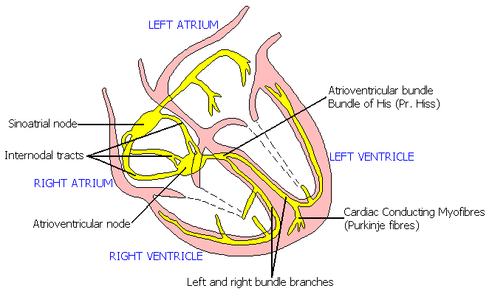

**ECG’** stands for electrocardiogram, or electrocardiograph. In some countries, the abbreviation used is ‘EKG’

The standard ECG has 12 leads. Six of the leads are considered “limb leads” because they are placed on the arms and/or legs of the individual. The other six leads are considered “precordial leads” because they are placed on the torso (precordium).

The six limb leads are called lead I, II, III, aVL, aVR and aVF. The letter “a” stands for “augmented,” as these leads are calculated as a combination of leads I, II and III.

The six precordial leads are called leads V1, V2, V3, V4, V5 and V6.



**THE DIFFERENT PARTS OF THE ECG**

The muscle mass of the atria is small compared with that of the ventricles, and so the electrical change accompanying the contraction of the atria is small. Contraction of the atria is associated with the ECG wave called ‘P’. The ventricular mass is large, and so there is a large deflection of the ECG when the ventricles are depolarized: this is called the ‘QRS’ complex. The ‘T’ wave of the ECG is associated with the return of the ventricular mass to its resting electrical state (‘repolarization’).

the interval between the S wave and the beginning of the T wave is called the ST ‘segment’.

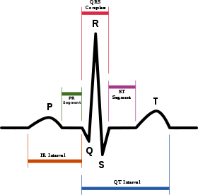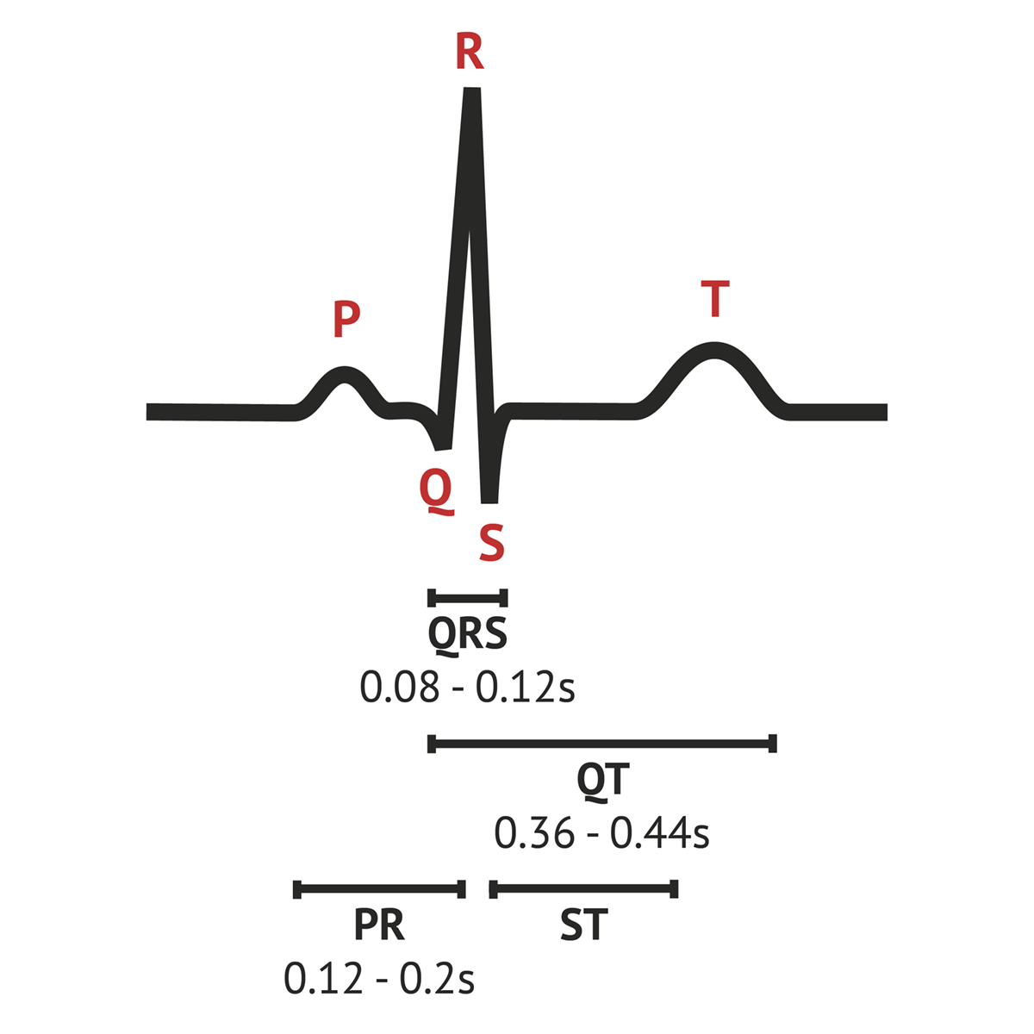

TIMES AND SPEEDS

ECG machines record changes in electrical activity by drawing a trace on a moving paper strip. ECG machines run at a standard rate of 25 mm/s and use paper with standard-sized squares. Each large square (5 mm) represents 0.2 seconds (s), i.e. 200 milliseconds (ms) . Therefore, there are five large squares per second, and 300 per minute. So an ECG event, such as a QRS complex, occurring once per large square is occurring at a rate of 300/min. The heart rate can be calculated

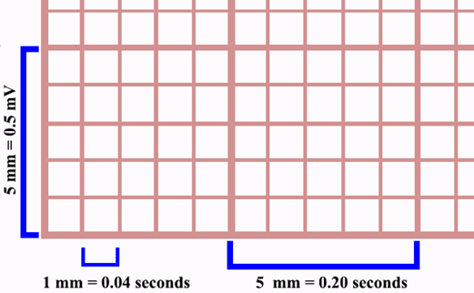



the distance between the different parts of the P–QRS–T complex shows the time taken for conduction of the electrical discharge to spread through the different parts of the heart.

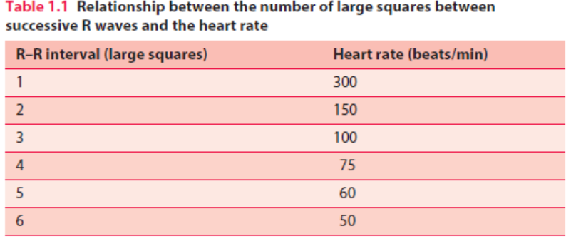

Calibration of the ECG

An electrocardiogram detects and prints out cardiac electrical activity, How can we be sure that an electrocardiograph can accurately measure and print out cardiac electrical activity? Is the electrical activity measured and printed correctly? ECG Calibration meets this requirement.

Standard calibration of the ECG is 10mm/mV. At this calibration, 1 miliVolt calibration signal is expected to produce a rectangle of 10 mm height ,

If the recording speed of ECG (sweep speed) is adjusted at 25 mm/second, 1 miliVolt calibration signal is expected to produce a perfect square with 5mm width.

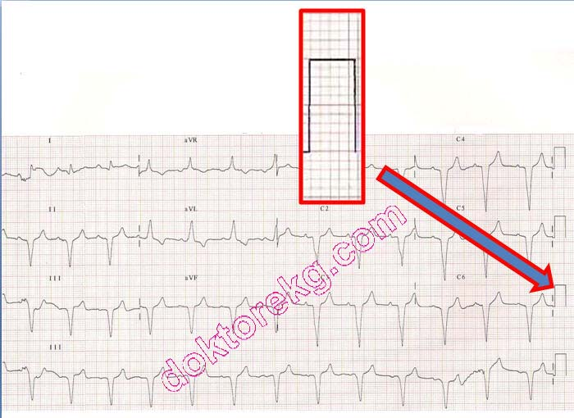

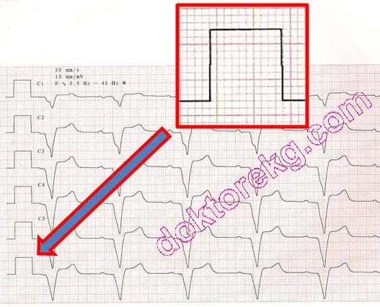

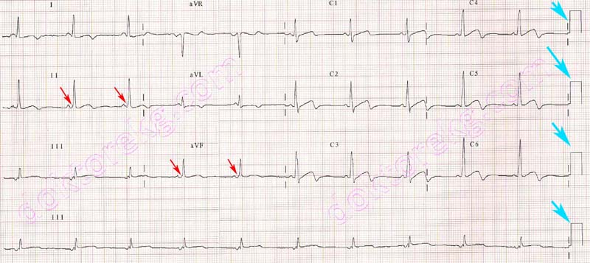

Calibration= 1mv/10 mm, 25mm/sec

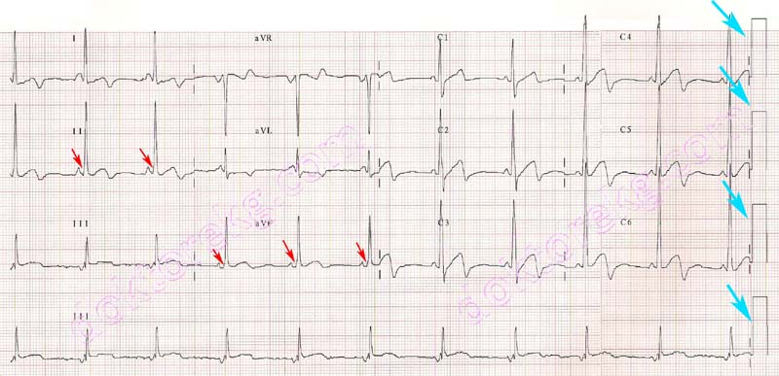

Calibration= 1mv/20mm, 25mm/sec

The Component of ECG



1. The PR interval is measured from the beginning of the P wave to the beginning of the QRS complex, and is the time taken for excitation to spread from the SA node, through the atrial muscle and the AV node ,down the bundle of His and into the ventricular muscle. The normal PR interval is 120–200 ms, represented by 3–5 small squares. Most of this time is taken up by delay in the AV node If the PR interval is very short, either the atria have been depolarized from close to the AV node, or there is abnormally fast conduction from the atria to the ventricles.

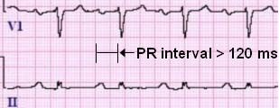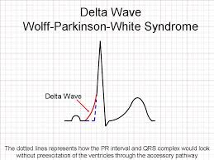

1. The duration of the QRS complex shows how long excitation takes to spread through the ventricles. The QRS duration is normally 120 ms (represented by three small squares) or less, but any abnormality of conduction takes longer, and causes widened QRS complexes.



1. The QT interval varies with heart rate. It is prolonged in patients with some electrolyte abnormalities, and more importantly it is prolonged by some drugs. A prolonged QT interval (greater than 450 ms) may lead to ventricular tachycardia.

