The stomach

it is a muscular, [hollow organ](https://en.wikipedia.org/wiki/Organ_(anatomy)) in the [gastrointestinal tract](https://en.wikipedia.org/wiki/Gastrointestinal_tract) of humans

 The stomach has a dilated structure and functions as  [digestive](https://en.wikipedia.org/wiki/Digestion) organ, It performs a chemical breakdown by means of enzymes and hydrochloric acid. the stomach is located between the [oesophagus](https://en.wikipedia.org/wiki/Oesophagus" \o "Oesophagus) and the [small intestine](https://en.wikipedia.org/wiki/Small_intestine).

Two [sphincters](https://en.wikipedia.org/wiki/Sphincter) keep the contents of the stomach contained; the [lower oesophageal sphincter](https://en.wikipedia.org/wiki/Oesophagus#Sphincters) (found in the cardiac region), at the junction of the oesophagus and stomach, and the [pyloric sphincter](https://en.wikipedia.org/wiki/Pyloric_sphincter) at the junction of the stomach with the duodenum.

Stomach devided into four regions

* The *cardia*
* The*fundus*
* The *body*
* The[*pylorus*](https://en.wikipedia.org/wiki/Pylorus)

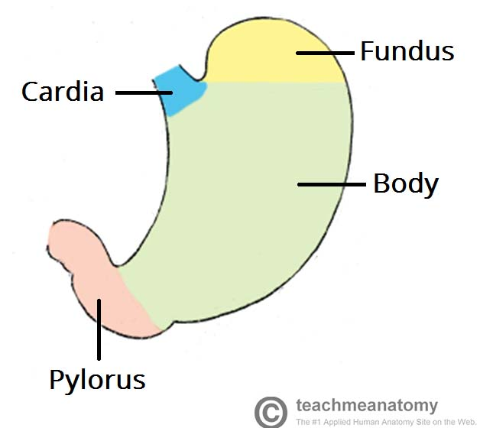

The stomach bed include the [pancreas](https://en.wikipedia.org/wiki/Pancreas), [spleen](https://en.wikipedia.org/wiki/Spleen),

The arterial supply to the stomach comes from the [**celiac trunk**](https://teachmeanatomy.info/abdomen/vasculature/arteries/coeliac-trunk/) and its branches.

Nerve supply , **Parasympathetic:** vagus nerve ( cranial nerve X) which acts excitatory and stimulates the secretion of gastric juice.  
**Sympathetic:** celiac plexus (T5-T12) which acts as inhibitory.

The stomach is much like a bag with a lining. The stomach is made of these 4 layers:

* **Mucosa.** This is the first and innermost layer or lining. It contains the glands that release digestive juices. These are called hydrochloric acid and pepsin. This is where most stomach cancers start.
* **Submucosa.** This second layer supports the mucosa. It is rich in blood vessels, lymphatic vessels, and nerves.
* **Muscularis.** The third layer is made of thick muscles. They help to mix food with the digestive juices.
* **Serosa.** This is the last and outermost layer. It’s the lining that wraps around the stomach to confine it.

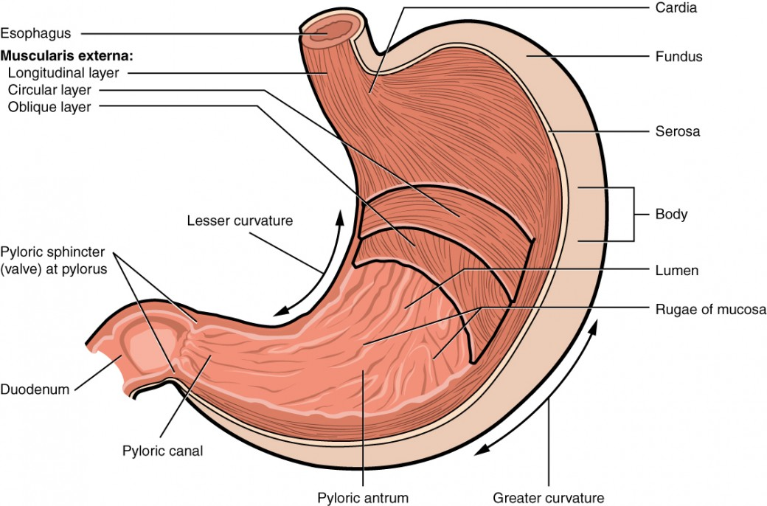

Figure 1. The stomach has four major regions: the cardia, fundus, body, and pylorus. The addition of an inner oblique smooth muscle layer gives the muscularis the ability to vigorously churn and mix food.

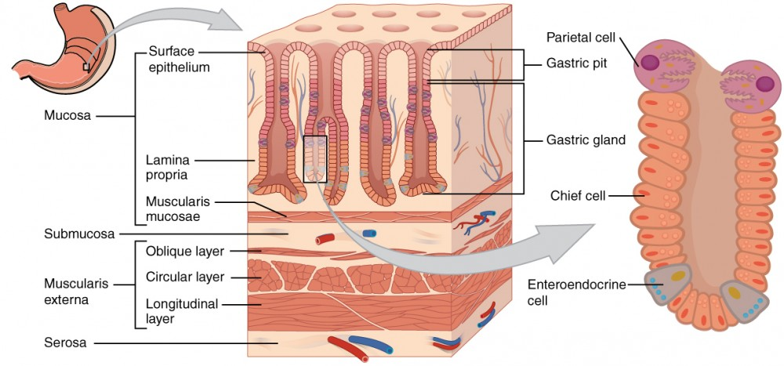

Figure 2. The stomach wall is adapted for the functions of the stomach. In the epithelium, gastric pits lead to gastric glands that secrete gastric juice. The gastric glands (one gland is shown enlarged on the right) contain different types of cells that secrete a variety of enzymes, including hydrochloride acid, which activates the protein-digesting enzyme pepsin.

The Duodenum

the most proximal portion of the small intestine, forms a C-shaped loop around the head of the pancreas and is in continuity with the pylorus proximally and the jejunum it is devided into four parts

The [duodenal bulb](https://en.wikipedia.org/wiki/Duodenal_bulb), about 2 cm (0.79 in) long, is the first part of the duodenum and is slightly dilated. Then the second ,third and fourth segments.

The wall of the duodenum also devided like the stomach

To mucosa, submucosa, muscularis, and serosa layers

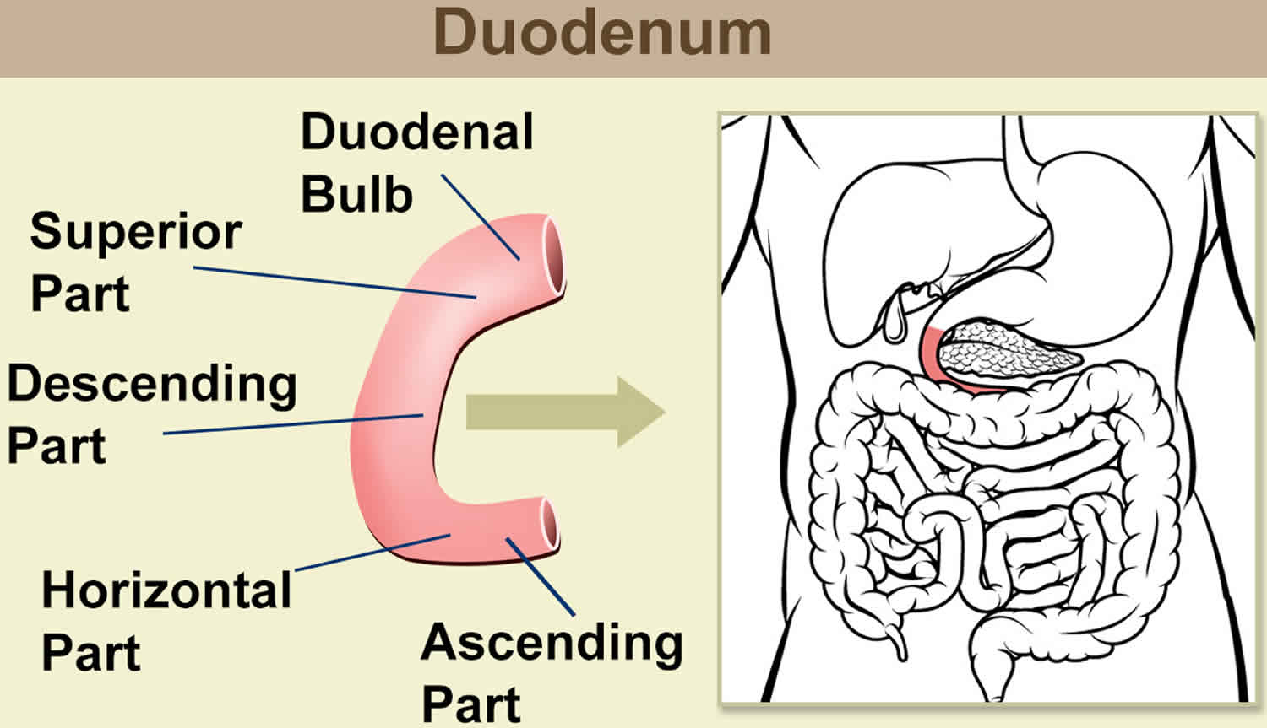

the duodenum has a [mucosa](https://en.wikipedia.org/wiki/Mucosa), [submucosa](https://en.wikipedia.org/wiki/Submucosa" \o "Submucosa), [muscularis externa](https://en.wikipedia.org/wiki/Muscularis_externa" \o "Muscularis externa), and [adventitia](https://en.wikipedia.org/wiki/Adventitia). Glands line the duodenum, known as [Brunner's glands](https://en.wikipedia.org/wiki/Brunner%27s_gland), which secrete [mucus](https://en.wikipedia.org/wiki/Mucus) and [bicarbonate](https://en.wikipedia.org/wiki/Bicarbonate) in order to neutralise stomach acids.

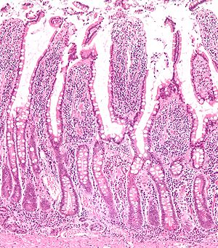

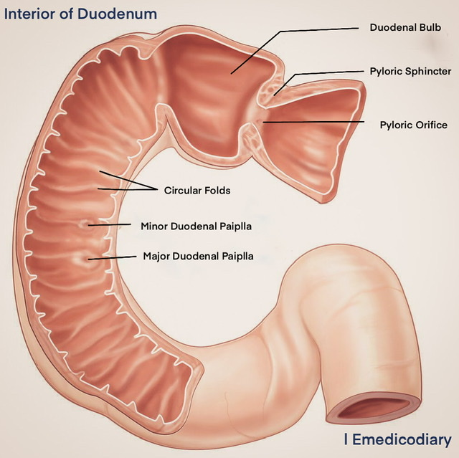

Gastroduodenal Mucosal Secretions and Protective Factors

Although hydrochloric acid (HCl) is the primary gastric

secretion, the stomach also secretes water, electrolytes

(hydrogen [H+], sodium [Na+], potassium [K+], chloride

[Cl-], and bicarbonate [HCO3]), enzymes (pepsin and

gastric lipase), and glycoproteins (intrinsic factors and

mucin) to assist in a wide variety of physiologic functions.

The digestion of proteins and triglycerides, as well as the

complex process of vitamin B12 absorption, begins in the

gastric lumen. Gastric acid also prevents the development of enteric colonization and systemic infections. The normal

human stomach contains about 1 billion parietal cells that secrete H+ ions into the gastric lumen in response to various physiologic stimuli.

The Mucosal Barrier

The mucosa of the stomach is exposed to the highly corrosive acidity of gastric juice. Gastric enzymes that can digest protein can also digest the stomach itself. The stomach is protected from self-digestion by the mucosal barrier. This barrier has several components.

**First**, the stomach wall is covered by a thick coating of bicarbonate-rich mucus that neutralize acid.

Second, the epithelial cells of the stomach’s mucosa meet at tight junctions, which block gastric juice from penetrating the underlying tissue layers.

**third**, stem cells located where gastric glands join the gastric pits quickly replace damaged epithelial mucosal cells, when the epithelial cells are shed. In fact, the surface epithelium of the stomach is completely replaced every 3 to 6 days.

**Gastritis**

CLINICAL PRESENTATION

Gastritis represents a nonspecific inflammation of the

mucosal surface of the stomach. Clinically, the three most

common causes of gastritis are *Helicobacter pylori,* nonsteroidal anti-inflammatory drugs (NSAIDs), and stress-related mucosal changes.

*Helicobacter pylori*

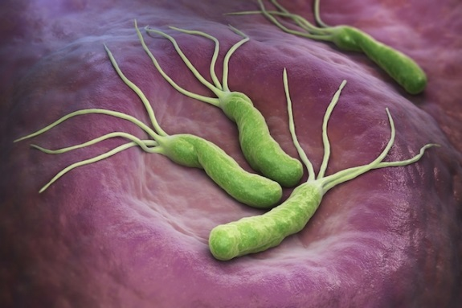

Helicobacter pylori are curved, flagellated, gram-negative

rods found only in gastric epithelium or in gastric metaplastic epithelium. H. pyloriorganisms clearly cause histologic gastritis and are found in 50% to 95% of patients with gastroduodenal ulcers.

However, only a minority of patients with *H. pylori* gastritis develop peptic ulcer disease (PUD) or gastric cancer.

*H. pylori* organisms reside in the mucus layer overlying

gastric epithelium and are characterized as noninvasive

organisms.

Factors important in the organism’s ability to

colonize the stomach include its

1. motility,
2. production of urease, and
3. bacterial adherence.

Ammonia generated from urea by *H. pylori* urease neutralizes acid, creating a more hospitable microclimate in which the bacteria can survive. *H. pylori* also have the ability to bind specifically to gastric type Epithelium

Other important factors that may influence the outcomes

of the infection include the host response, environmental factors, and age at the time of infection.

**Nonsteroidal Antiinflammatory Drugs**

NSAIDs are one of the most widely used classes of drugs.

Although generally well tolerated, NSAIDs are associated

with a small but significant percentage of adverse gastrointestinal (GI) events, NSAIDs have direct toxic effects on the gastroduodenal mucosa and indirect effects through active hepatic metabolites and decreased **synthesis of mucosal prostaglandins**.

Prostaglandin inhibition, in turn, leads to reduction in epithelial mucus, decreased secretion of HCO3, impaired mucosal blood flow, reduced epithelial proliferation, and decreased mucosal resistance to injury.

The metabolism of prostaglandins is catalyzed by the

cyclo-oxygenase (COX) pathway .





NSAID-related mucosal injury includes

a combination of subepithelial hemorrhages, erosions, and

ulcerations, Erosions are likely to be small and superficial, whereas ulcers tend to be larger (more than 5 mm in diameter) and deeper.

**Stress-Related Gastric Mucosal Damage**

During critical illness, events such as shock, hypotension,

and catecholamine release are associated with **reduced blood flow and mucosal ischemia**. When blood flow to the mucosa is inadequate, the normal mucosal protective mechanisms, including epithelial turnover and mucus and HCO3 secretion, are altered.

**Peptic Ulcer Disease**

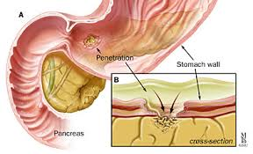

Peptic ulcers are a common clinical problem characterized

by mucosal defects of the mucosa of the stomach or the duodenum. Men and women are at equal risk for developing PUD, and the overall lifetime risk for both genders is 10%.

The most important risk factors for the development of peptic ulcers are infection with *H. pylori* and use of NSAIDs.

Common sites of gastric ulcer is in the antrum and the lesser curvature

Common sites of the duodenal ulcer is in the first part mostly anterior surface, then posterior surface.

Pathophysiology

The risk for NSAID induced ulceration and complications is **dose related** and **increases with age older than 60 years**, **concurrent corticosteroid use**, **increasing duration and dose of therapy**, **anticoagulant therapy**, and a **history of prior ulcer disease**

CLINICAL PRESENTATION

Peptic ulcers can exhibit in a variety of forms ranging from

Asymptomatic, iron deficiency anemia to abdominal pain,

obstruction, perforation, and hemorrhage haematemesis and malena.

Symptoms may mimic those of other diseases, including cholecystitis, pancreatitis, gastric cancer, and gastroesophageal reflux. **Myocardial ischemia** or infarction, especially of the inferior wall, can cause abdominal pain that resembles peptic ulcer.

Abdominal pain is generally epigastric and is usually

described as a dull ache but may be sharp or burning.

NSAID-associated ulcers typically produce painless bleeding.

Nausea and vomiting are commonly associated with peptic ulcers, being slightly more common with gastric ulcers.

Diagnosis

Although contrast radiology (barium upper GI series) can

be used,

endoscopy is usually preferred because, in addition to characterizing the ulcer, it allows tissue sampling to exclude malignancy, assessment of *H. pylori* infection, and, in cases of acute ulcer hemorrhage, delivery of endoscopic therapy for the control of hemorrhage.

DIAGNOSTIC TESTS FOR *HELICOBACTER PYLORI*

13C- or 14C-labeled urea breath test.

The urea breath test is more accurate

than serologic tests, and although more expensive and less widely available, it is the noninvasive test of choice to document successful *H. pylori* eradication after antibiotic therapy

**Complications of Peptic Ulcer Disease**

BLEEDING

PUD is the leading cause of upper GI bleeding,

PERFORATION

Perforation, which occurs when a peptic ulcer erodes

through the full thickness of the stomach or duodenum

GASTRIC OUTLET OBSTRUCTION

edema, spasm, and inflammation lead to obstruction, or as a consequence of chronic ulceration with scarring and fibrosis. early satiety, bloating, nausea, vomiting, and weight loss. Endoscopy is the diagnostic test of choice.

**Treatment of Peptic Ulcer Disease**

Regardless of the cause, the inhibition of gastric acid secretion continues to be the cornerstone of therapy for PUD.

**PPIs**, the most potent inhibitors of gastric acid secretion

available, heal gastroduodenal ulcers more rapidly than H2 receptor antagonists

TREATMENT OF *HELICOBACTER PYLORI* INFECTION

Successful therapy requires a combination of drugs that prevents the emergence of resistance and effectively reaches the bacteria. Therapy must be of sufficient duration to ensure that a small population of bacteria does not remain viable.

Combinations of two antibiotics, plus a PPI most widely amoxillin and claribac with omiprazole

TREATMENT AND PROPHYLAXIS OF NSAID-INDUCED ULCERATION

The optimal treatment in patients with NSAID-induced gastroduodenal ulcers is the discontinuation of the offending agent. If NSAIDs must be continued, therapy with an antisecretory agent should be instituted

SURGERY

surgery now plays a marginal role in treating uncomplicated PUD. Surgical intervention is now mostly reserved for managing the complications of peptic ulcers, especially gastric outlet obstruction and perforation.