The heart is a muscular organ, which pumps blood through the blood vessels of the circulatory system. The pumped blood carries oxygen and nutrients to the body, while carrying metabolic waste such as carbon dioxide to the lungs and other materials to the kidneys and the liver. the heart is approximately the size of a closed fist and is located between the lungs, in the middle compartment of the chest.
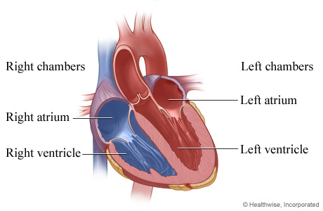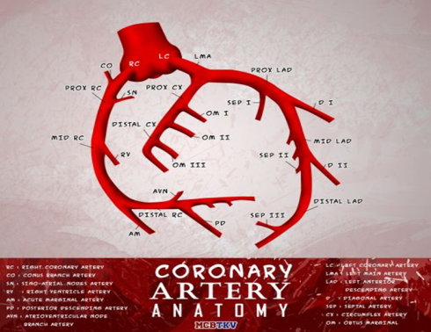
the heart is divided into four chambers: upper left and right atria and lower left and right ventricles. Commonly the right atrium and ventricle are referred together as the right heart and their left counterparts as the left heart.
The coronary arteries are the arterial blood vessels of coronary circulation, which transport oxygenated blood to the heart muscle. The heart requires a continuous supply of oxygen to function and survive.
The coronary arteries wrap around the entire heart. The two main branches are
- The left main coronary artery (LCA) that bifurcates into left anterior descending artery (LAD)and the circumflex artery LCX .
- The right coronary artery (RCA).
Reduced function of the coronary arteries can lead to decreased flow of oxygen and nutrients to the heart. This can affect the ability of the heart to pump blood throughout the body. Therefore, any disorder or disease of the coronary arteries can have a serious impact on health, possibly leading to angina, a infarction, heart failure and death.
The left anterior descending artery supply the anterior wall of the left ventricle including the inter-ventricular septum. The left circumflex artery supply the left ventricular free wall and posterior wall and supply the left atrium
The right coronary artery supply the right ventricle and the right atrium and inferior part of the inter-ventricular septum.
The microscopic structure of the arteries
It is composed from several layers
- The Tunica intima which is the inner most layer.
- The Tunica media, which is made up of smooth muscle cells, elastic tissue and collagen fibres.
- The adventitia (Tunica Externa),which is composed of collagen fibers and elastic tissue.
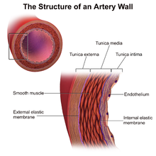
Atherosclerosis occurs when atheromatous plaque are accumulated . Initially, there are generally no symptoms. When severe, it can result in coronary artery disease, stroke, peripheral artery disease, or kidney problems, depending on which arteries are affected.
Atheromatous plaque is accumulation of material in the inner layer of tunica intima ,the material consists from macrophage cells, cholesterol , calcium and a variable amount of fibrous tissue. The accumulated material forms a swelling in the artery wall, which may intrude into the lumen of the artery, narrowing it and restricting blood flow.
If this process grow gradually it will results in gradual symptoms as angina but if this plaque ruptured this will results in acute unstable condition due to formation of thrombous and results in sudden narrowing or closure of the lumen of the artery resulting in acute myocardial infarction.
Risk factors include 1- increase age, 2- abnormal cholesterol levels, 3-high blood pressure, 4-diabetes, 5-smoking, 6- obesity, 7- family history, and an 8- unhealthy diet.
Signs and symptoms
Stable Angina
The narrowing of coronary arteries reduces the supply of oxygen-rich blood flowing to the heart, which becomes more pronounced during strenuous activities during which the heart beats faster, severity symptoms changes according to the gender and age of the patient and to presence of certain comorbidities like DM .
The most common symptom is chest pain or discomfort that occurs regularly with activity, after eating, or at other predictable times. Angina also includes chest tightness, heaviness, pressure, numbness, fullness, or squeezing. The main feature is that this pain is predictable and can be relieved with rest or medication like angesid.
Angina that changes in intensity, character or frequency is termed unstable.
Unstable angina may precede myocardial infarction.
A myocardial infarction (MI), occurs when blood flow significantly decreases or stops to the coronary artery of the heart, causing damage to the heart muscle with release of cardiac specific proteins(troponin I &T) and enzymes. The most common symptom is chest pain or discomfort which may travel into the shoulder, arm, back, neck or jaw. The pain lasts more than 15 minutes and dose not relieved with rest or angesid, the pain may be associated with nausea and vomiting, pallor and sweating.
Symptoms may be associated with abnormal cardiac rhythm that can evolve to death.
In adults who go to the emergency department with an unclear cause of pain, about 30% have pain due to coronary artery disease
Diagnosis
medical history, physical exam. diagnostic tests may include:
- Electrocardiogram (ECG). An electrocardiogram records electrical signals as they travel through heart. An ECG can often reveal evidence of a previous heart attack or one that's in progress.
- Echocardiogram. An echocardiogram uses sound waves to produce images of the heart. an echocardiogram, can determine whether all parts of the heart wall are normally moving . This may be a sign of coronary artery disease or other conditions.
- Exercise stress test. Includes
    - ECG stress test: walk on a treadmill or ride a stationary bike during an ECG.
    - Echo stress test: echocardiogram is also done while doing these exercises.
    - Pharmacological Stress test: medication is used to stimulate heart rate to be used instead of exercise and heart is monitored with echo to detect abnormality.
- Nuclear stress test. This test is similar to an exercise stress test but adds images to the ECG recordings. It measures blood flow to heart muscle at rest and during stress. A tracer is injected into bloodstream, and special cameras can detect areas in the heart that receive less blood flow.
- Cardiac catheterization and angiogram. During cardiac catheterization, a a catheter is inserted into an artery or vein in groin or arm and up to the heart. X-rays are used to guide the catheter to the correct position. dye is injected through the catheter. The dye helps blood vessels show up better on the images and outlines any blockages.
- Cardiac CT scan. A CT scan of the heart can help to detect calcium deposits in coronary arteries that can narrow the arteries. The concentration of calcium discovered is associated with coronary artery disease.
- CT coronary angiogram, in which one receive a contrast dye that is given Intravenously during a CT scan, can produce detailed images of heart arteries.
Lab tests includes : measuring serum cardiac enzymes like troponins , routine assessment of blood sugar, renal function, blood picture and blood lipids.

Treatment
Treatment for coronary artery disease usually involves lifestyle changes and, if necessary, drugs and certain medical procedures.
Lifestyle changes
- Quit smoking.
- Eat healthy foods.
- Exercise regularly.
- Lose excess weight.
- Reduce stress.
Drugs
Various drugs can be used to treat coronary artery disease, including:
- Cholesterol-modifying medications. These medications reduce (or modify) the primary material that deposits on the coronary arteries, cholesterol levels the most famous are statins like resuvastatin.
- Beta blockers. These drugs slow heart rate and decrease blood pressure, which decreases heart's demand for oxygen.
- Nitroglycerin. Nitroglycerin tablets, sprays and patches can control chest pain by temporarily dilating coronary arteries and increase blood supply to heart muscle.
- Heparin is and anticoagulant that prevent thrombus formation .
- Antiplatelet Medication like Aspirin and clopidogril prevent platelets activation and decrease liability of thrombus formation.
- Thrombolytics like actilyse

Procedures to restore and improve blood flow
Angioplasty and stent placement (percutaneous coronary revascularization)
A long, thin tube (catheter) is inserted into the artery. A wire with a deflated balloon is passed through the catheter to the narrowed area. The balloon is then inflated, compressing the deposits against artery walls.
A stent is often left in the artery to help keep the artery open. Most stents slowly release medication to help keep the arteries open and prevents thrombus formation .

Coronary artery bypass surgery

A surgeon creates a graft to bypass blocked coronary arteries using a vessel from another part of your body. This allows blood to flow around the blocked or narrowed coronary artery. Because this requires open-heart surgery, it's most often reserved for people who have multiple narrowed coronary arteries.
Complication of CAD.
  - Heart failure: Over time, CAD can lead to heart failure. Heart failure means that heart isn’t able to pump enough blood to the rest of body. This can cause fluid buildup in the lungs, difficulty breathing, and swelling of the legs, liver, or abdomen.
  - An abnormal heartbeat is called an arrhythmia which includes bradycardia, (a slow heart rate), tachycardia, (a fast heart rate) atrial fibrillation, (a chaotic, irregular rhythm in the atria)
  - Valve dysfunction.
  - Death.

