Cardiac arrest is a sudden loss of the pumping activity of the heart that results in loss of blood flow throughout the body especially the brain , It is a rapidly fatal medical emergency requiring immediate intervention with cardiopulmonary resuscitation (CPR) until further treatment can be provided. Cardiac arrest results in rapid loss of consciousness and followed with loss of breathing.
Sign and symptoms.
in approximately 50 percent of people Cardiac arrest is not preceded by any warning symptoms. For individuals who do experience symptoms, the symptoms are usually nonspecific to the cardiac arrest. This can present in the form of new or worsening: chest pain, fatigue, blackouts, dizziness, shortness of breath, weakness and vomiting
Causes.
Cardiac arrest occur when the heart develop ventricular arrhythmia, There are many different types of arrhythmias, but the most frequently recorded in sudden cardiac arrest are ventricular tachycardia and ventricular fibrillation. After prolong Ventriclar arrhythmia pulseless electrical activity (PEA), bradyarrhythmias or asystole will resulted.
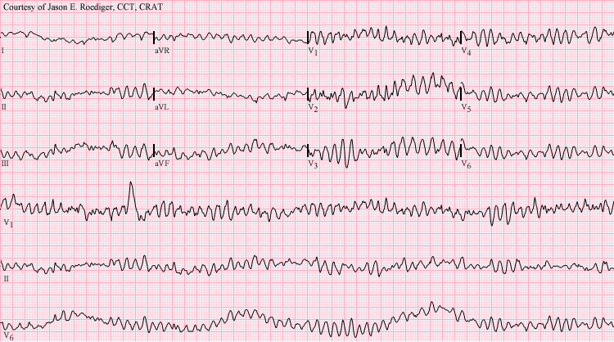
I - Cardiac causes
- Atherosclerotic coronary artery disease like unstable angina and myocardial infarction.
- Non-atherosclerotic coronary artery abnormalities, WHICH includes
- Congenital anomaly of the coronary artery.
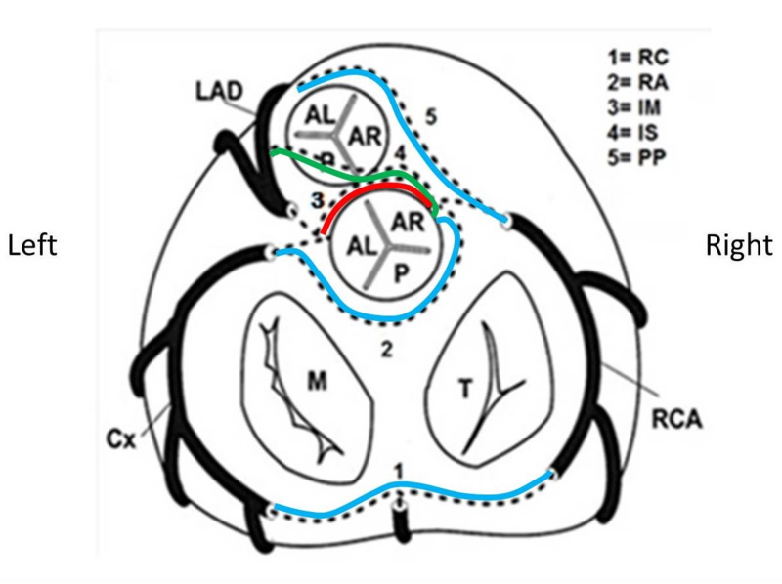
- Vasculities like Kawasaki disease. inflammation of the coronary artery.
- Embolism like septic or valve disease. Closure of the Coronary artery with embolus.
- coronary artery dissection which can be attributed to Marfan Syndrome or pregnancy.

- Structural heart diseases not related to coronary artery disease account for 10% of all sudden cardiac deaths. Examples of these include:
- cardiomyopathies (Hypertrophic, Dilated),
- cardiac rhythm disturbances, like prolong QT syndrome.
- myocarditis, inflammation of the cardiac muscle.
- congestive heart failure

Inherited arrhythmia syndromes
Arrhythmias that are not due to structural heart disease account for 5 to 10% of sudden cardiac arrests. These are frequently caused by genetic disorders that lead to abnormal heart rhythms. The genetic mutations often affect ion channels that conduct electrically charged particles across the cell membrane like K channels, Calcium channels, and this group of conditions are therefore often referred to as channelopathies. Examples of these inherited arrhythmia syndromes include inherited Long QT syndrome (LQTS), Brugada Syndrome, Catecholaminergic polymorphic ventricular tachycardia, and Short QT syndrome.
Prolong QT
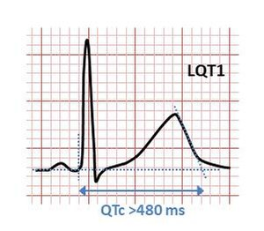
Brugada ECG
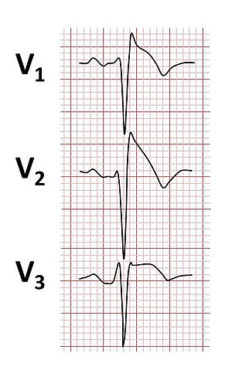

Non-cardiac causes
Non-cardiac causes accounts for 15 to 25% of cardiac arrests.
Hs
- Hypovolemia – A lack of blood volume
- Hypoxia – A lack of oxygen
- Hydrogen ions (acidosis) – An abnormal pH in the body
- Hyperkalemia or hypokalemia – Both increased and decreased potassium can be life-threatening.
- Hypothermia – A low core body temperature
- Hypoglycemia or hyperglycemia – A low or high blood glucose
Ts
- Tablets or toxins such as drug overdose
- Tamponade – Fluid building up around the heart
- Tension pneumothorax – A collapsed lung
- Thromboembolism (pulmonary embolism) – A blood clot in the lung
- Traumatic cardiac arrest

Classifications of cardiac arrest
Clinicians classify cardiac arrest into "shockable" versus "non-shockable", using defibrillation. The two "shockable" rhythms are ventricular fibrillation and pulseless ventricular tachycardia while the two "non-shockable" rhythms are asystole and pulseless electrical activity.
Mnagement
Sudden cardiac arrest may be treated via attempts of resuscitation. This is usually carried out based upon basic life support (BLS), advanced cardiac life support (ACLS)
Early cardiopulmonary resuscitation (CPR) is essential to surviving cardiac arrest with good neurological function. Defibrillation with DC should be started immediately, then chest compressions should be continued for two minutes before a rhythm check is again done. This is based on a compression rate of 100-120 compressions per minute, a compression depth of 5–6 centimeters into the chest, full chest recoil, and a ventilation rate of 5 breath ventilations per minute( breathing every 25-30 compression) , If high-quality CPR has not resulted in return of spontaneous circulation and the person's heart rhythm is in asystole, discontinuing CPR and pronouncing the person's death is reasonable after 20 minutes, Exceptions to this include certain cases with hypothermia or who have drowned or suffocated with smoke. Some of these cases should have longer and more sustained CPR until they are nearly normothermic.
Some drugs can be used like intravenous atropine& adrenaline.

