The pleurae are the two opposing layers of serous membrane overlying the lungs and the inside of the surrounding chest walls.
The inner pleura, called the visceral pleura, covers the surface of each lung and dips between the lobes of the lung as fissures,
The outer layer, called the parietal pleura, lines the inner surfaces of the thoracic cavity on each side of the mediastinum,
Between two pleurae is a potential space called the pleural cavity (also pleural space), which is normally collapsed and filled with only a tiny amount of serous fluid (pleural fluid) secreted by the pleurae,
Pleural Effusion
A pleural effusion is accumulation of excessive fluid in the pleural space, the potential space that surrounds each lung. Under normal conditions, pleural fluid is only 5–15 millilitres of fluid, which helps to maintain a functional vacuum between the parietal and visceral pleurae. Excess fluid within the pleural space can impair inspiration by upsetting the functional vacuum and hydrostatically increasing the resistance against lung expansion, resulting in a fully or partially collapsed lung.
Various kinds of fluid can accumulate in the pleural space, such as serous fluid (hydrothorax), blood (hemothorax), pus (pyothorax, more commonly known as pleural empyema), chyle (chylothorax).
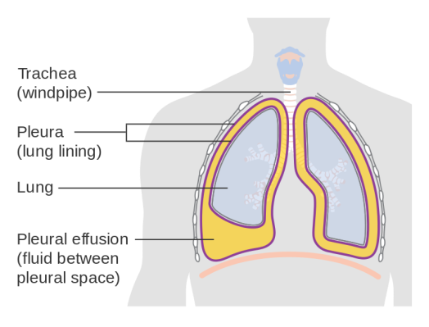
Classification of pleural fluid
- Transu-dative, mean low concentration of protein 0.5 mg, most common cause
- Congestive heart failure ( increased hydrostatic pressure )
- Liver cirrhosis ( decrease oncotic pressure)
- Nephrotic syndrome (decrease oncotic pressure)
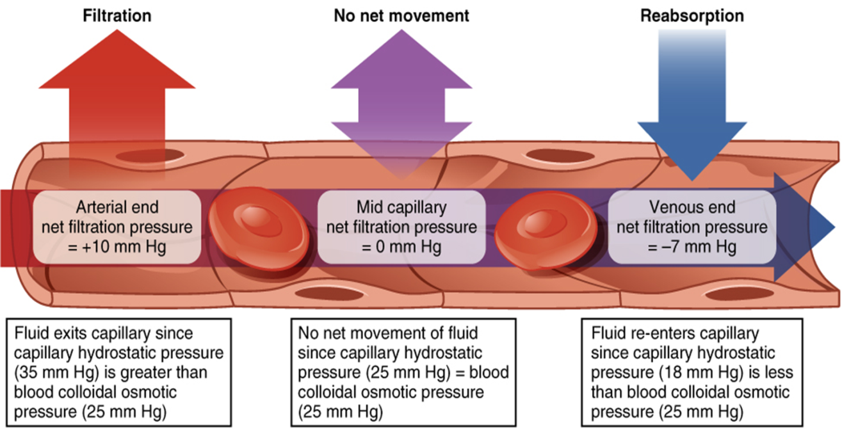

- Exudative, means high protein and fibrous content, common causes
- Parapneumonic effusion due to pneumonia
- Malignancy (either lung cancer or metastases to the pleura from elsewhere)
- Infection (empyema due to bacterial pneumonia)
- Trauma
- Pulmonary infarction
- Pulmonary embolism
- pancreatits
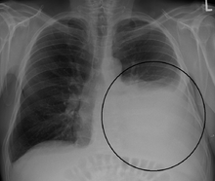
Diagnosis
Once accumulated fluid is more than 300 mL, there are usually detectable clinical signs,
Imaging
A pleural effusion appears as an area of whiteness on a standard posteroanterior chest X-ray. Normally, the space between the visceral pleura and the parietal pleura cannot be seen.
Treatment depends on the underlying cause of the pleural effusion. Therapeutic aspiration may be sufficient; larger effusions may require insertion of an intercostal drain.
Pneumothorax:
a collection of air within the pleural cavity, arising either from the outside or from the lung. Pneumothoraces may be traumatic( due to trauma from outside as in car accedant), iatrogenic ( as in aspiration of fluid or inserting central venous line) , or spontaneous. A tension pneumothorax is a particular type of pneumothorax where the air may enter (though a defect of the chest wall, lung, or airways) on inspiration, but cannot exit on expiration. Each breath increases the amount of trapped air in the chest cavity, leading to further lung compression. This is often an urgent situation and may progress to a medical emergency if there is compromise of the venous return to the heart causing hypotension and rarely shock.
Primary spontaneous

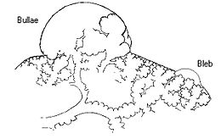
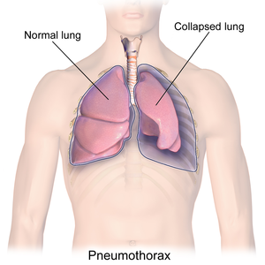
Spontaneous pneumothoraces are divided into two types: primary, which occurs in the absence of known lung disease, and secondary, which occurs in someone with underlying lung disease. The cause of primary spontaneous pneumothorax is unknown, but established risk factors include being of the male, smoking, and a family history of pneumothorax. Smoking either cannabis or tobacco increases the risk.

Secondary spontaneous
Secondary spontaneous pneumothorax occurs in the setting of a variety of lung diseases. The most common is chronic obstructive pulmonary disease (COPD), which accounts for approximately 70% of cases
Diagnosis
CXR, CT scan

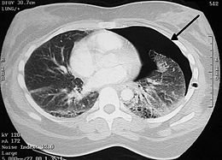
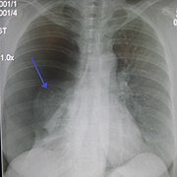
Ultrasound may be more sensitive than chest X-rays in the identification of pneumothorax after blunt trauma to the chest
The treatment of pneumothorax depends on a number of factors and may vary from discharge with early follow-up to immediate needle decompression or insertion of a chest tube.
Pleurisy
Is inflammation of the pleura , The most common cause is a viral infection. Other causes include bacterial infection, pneumonia, pulmonary embolism, autoimmune disorders, lung cancer, following heart surgery, in addition to pain, symptoms may include shortness of breath, cough, fever or weight loss, depending on the underlying cause
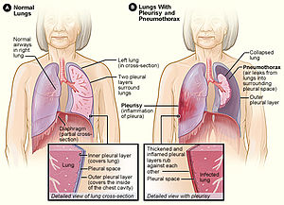Diagnostic testing may include a chest X-ray, electrocardiogram (ECG), and blood tests Treatment include nsaid and antibiotics.

