Ministry of Higher Education And Scientific Research Al-Mustaqbal University College
Department of Medical laboratory techniques

Platelets
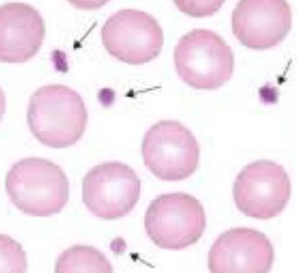
Lec 17 3ed stage hematology

Platelets
- Platelets, or thrombocytes, are small, irregularly shaped
- Nucleus: a nuclear cells
- Diameter 2-4µm
- Site production: bone marrow, in bone marrow, by budding off from
megakaryocytes.
- Each megakaryoblast produce about 5000-10000 platelets
- Control production: Thrombopoietin hormone which produced from
the liver and kidney (often abbreviated as TPO).
- Platelets count are 150000-450000/cum
- Old platelets are destroyed by the spleen and by Kupffer cells in the liver
- Normal life span 7-10 days.

Platelets structure
1-on the membrane
The platelet membrane is important to the whole process of clot f
Membrane structure
contain the following substances
1-phosphlipds
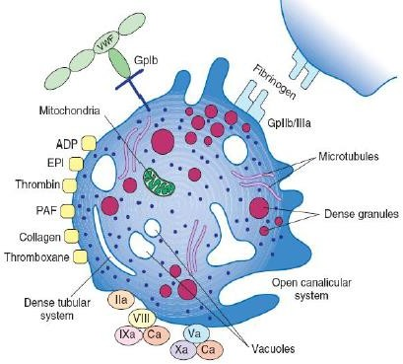
which are important for coagulation factors function (also called Platelets Factor 3)
2-receptors
- Glycoprotein Ib, Which binds
von Willebrand factor (vWF),
- Glycoprotein GPIIb/IIIa Which binds fibrinogen

Major receptors found on the surface of resting platelets

- vonWillebrand factor (VWF) The receptor for vWF is GPIb.
- ADP - Thrombin - Epinephrine - thromboxane A2 – Collagen
-Fibrinogen The receptors for fibrongen are GPIIb/IIIa
They are essential for platelet aggregation
- Prevents the adherence of platelets to normal endothelium.
-Accelerates the adherence of platelets to collagen and damaged endothelium in ruptured blood vessels
-Forms a receptor for ADP and thromboxan2 ,Thrombin ,von
Willebrand factor , Fibrinogen etc.

2-Platelet structure - Inside the platelets

Contain 2 unique types of granules
  - The alpha granules contain proteins such as fibrinogen , a heparin
antagonist , von willbrand factor vWf, factor V
  - The dense granules the dense granules Contain chemicals such as
    - Adenosine diphosphate - ADP b) Adenosine triphosphate - ATP c)
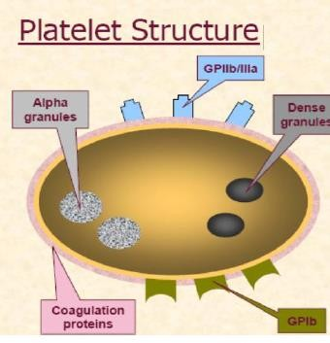
Serotonin
d) Magnesium e) Calcium

2-Platelet structure
Hormones a)Adrenaline , b) Serotonin c) Histamine ( vascular and local tissue reactions d) Catecholamines ( epinephrine , norepinephrine) The contents of both the alpha and dense granules are released during the PLATELETS ACTIVATION Platelets activation leads to production of thromboxane A2, encourages platelet aggregation
Dense Tubular System (DTS) Important structure present in the
cytoplasm of the platelets. The DTS is the site of prostaglandin and thromboxane (TxA2) synthesis and sequestration of calcium. open canalicular system is an open canalicular system linking the interior of the platelet to the exterior (plasma)

Platelet structure
Thromboxane (TxA2) function
Potentiate platelet adhesion and aggregation
Prostacyclin (PGI2) function
from endothelial cells, inhibits platelet aggregation
Platelets membrane phospholipid function
forming an ideal site for important coagulation reactions to take place
Summary the platelets function in hemostasis are
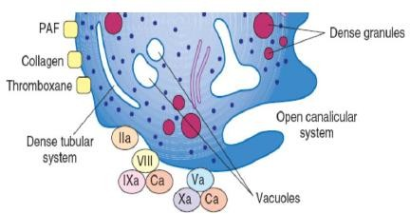
- Stimulated by injury
- Forming the unstable platelets plug
- Maintain the vascular integrity

- Provide a surface for coagulation reaction
- Have a role in inflammatory response (activating the fifth component of complement

