Ministry of Higher Education And Scientific Research Al-Mustaqbal University College
Department of Medical laboratory techniques

Leukemia
Lec 15 3ed stage hematology

Definition
Definition It is a group of malignant disorder, affecting the blood and blood –forming-
.tissue of the bone marrow lymph system and spleen
The word Leukemia comes from the Greek leukos which means "white" and aima- "which means "blood

Acute leukemia consist of predominantly immature, poorly differentiated 1 cells (usually blast forms). Acute leukemia are divided into
(Acute Lymphocytic Leukemia (ALL- (Acute Myelogenous Leukemia (AML-
.Chronic leukemia have more mature cells than acute leukemia-2
They usually manifest as abnormal leukocytosis and mostly asymptomatic person. Chronic leukemia are divided into
Chronic lymphocytic leukemia –CLL- Chronic myelogenous leukemia-CML-

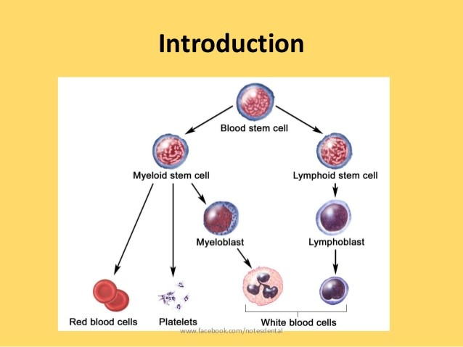

Acute Myeloblastic Leukemia

Stem cell disorder characterized by malignant neoplastic proliferation and accumulation of immature and nonfunctional hematopoietic cells in the BM
Risk factors Chemo/radiation -Exposure to benzene
AML is a malignant, clonal disease that involves proliferation of blasts in Bone marrow and Peripheral Blood
AML is: It is a blood cancer ,Failure to produce normal cells (Neutrophil etc) ,Highly heterogeneous ,Mostly in adult with a median age of onset of 50 yr , Belong to myeloid group cancer mainly Neutrophils There is no enough Neutrophils for killing bacteria
AML is based on Cellular differentiation

(?What type of cell )

(granulocyte, monocyte , erythroid, or megakaryocytic) Classified as
M0 Minimally differentiated-1
.M1 Myeloblastic 2-M2 Myeloblastic with differentiation-2 M3 Promyelocytic -3
M4 Myelomonocytic-4 M5 Monoblastic -5
M6 Erythroleukemia -6
M7 Megakaryocytic -7

Pathophysiology
Uncontrolled growth of blasts in marrow leads to Stop normal cells production .
.Appearance of blasts in peripheral blood
.(Accumulation of blasts in other sites (Kidney , Liver, spleen
.Function disorders of many organs

(Patient`s Symptoms (Clinical Features of AML
(Anemia (weakness, fatigue, dyspnea on exertion (thrombocytopenia ,Bleeding (mucosal bleeding, purpura (Leukopenia -Infection (neutropenia

Lab Features: Peripheral blood Lab

WBC count: 20% blasts present -1
Auer rods: fused primary granules in myeloblasts
RBCs Decreased - Hgb < 10g/dL Inclusions reflect rbc maturation-2 Platelets Decreased Megakaryocyte fragments -3
Bone marrow aspirate-and biopsy >20% blasts in BM myeloblast is the predominant cell-4

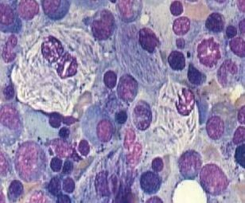

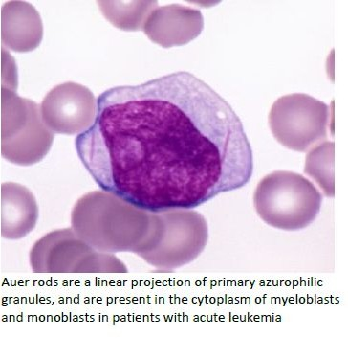
Bone marrow aspirate-and biopsy

(Acute lymphoblastic leukemia (ALL
Acute lymphoblastic leukemia (ALL) is a malignant (clonal) disease- of the bone marrow in which early lymphoid precursors proliferate
.and replace the normal hematopoietic cells of the marrow
ALL is the most common type of cancer and leukemia in children-

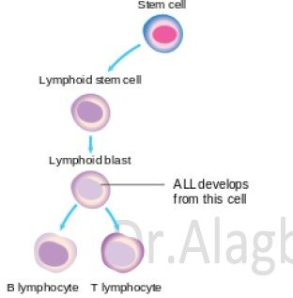
Classification
(B-cell precursors (80 to 85% of cases
.(T-cell precursors (15 to 20% of cases

(Acute lymphoblastic leukemia (ALL

(a blood cancer , It is a failure to produce normal cells (Lymphocytes Incidence about 85% of childhood leukemia
Belong to Lymphoid group cancer
There is no enough Lymphocytes to kill viruses, fungus and produce antibodies

Laboratory findings
WBC 1. Normal count 2. Lower count 3. Higher count-1 Blood smear study RBC: Normocytic anemia-2
PLTs: Low count , WBC: lmphoblast 90% = Normal other cells 10%
:Bone marrow biopsy and aspirate-3
Must presence of 30% cells are blast ,abnormal white blood cells

