Ministry of Higher Education And Scientific Research Al-Mustaqbal University College
Department of Medical laboratory techniques

Chronic Leukemia
Lec 16 3ed stage hematology

The Chronic Myeloproliferative Disorders CMPD

- CMPDs are malignant Clonal stem cell disorder
- Each disorder has specific genetic abnormalities.
- Bone marrow fibrosis in all CMPDs
- Fibrosis is secondary phenomen
- loss of regulatory signals that control the production of the mature cells
- Most of these disorders are seen in older adults (50-70yrs aged) Could be also in children

classification

Clonal hematopoeitic disorders Granulocytic
  - Granulocyte Chronic myeloid Leukemia CML
  - Erythroid RBC Polycythemia Vera (PV)
  - Megakaryocytic Platelets Essential thrombocythemia ET

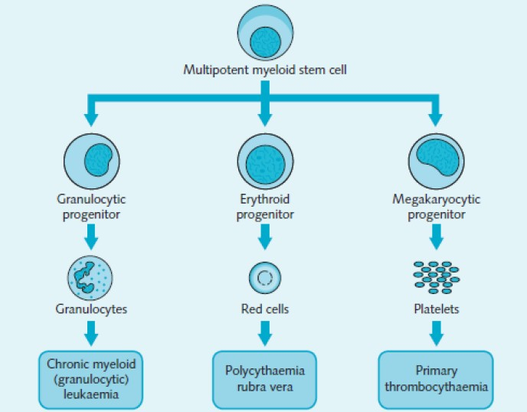

Chronic Myeloid Leukemia (CML)
also known as chronic myeloid leukemia,
- Definition: is a myeloproliferative disorder characterized by increased proliferation of the granulocytic cell line without the loss of their capacity to differentiate.
- associated with a characteristic chromosomal translocation called the
Philadelphia chromosome.
- It accounts for 20% of all leukemia affecting adults..

Philadelphia chromosome
is an acquired cytogenetic anomaly that is characterizes in all leukaemic cells in CML 90-95% of CML have Ph chromosome Shared translocation of chromosome 22 and chromosome 9
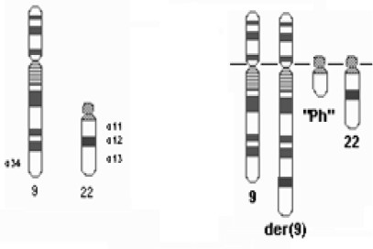

CML- phases
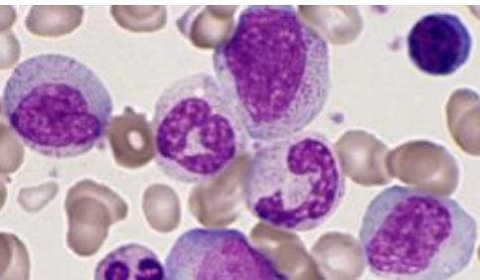
Disease Course of Chronic myelogenous leukemia classically
occurs in three phases:
1-A chronic phase (last 4-5 years up to 15 years) asymptomatic or have only mild symptoms of fatigue and the % Of blast is less than 5%

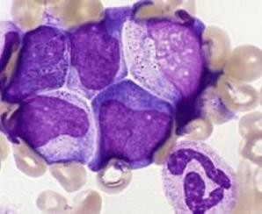
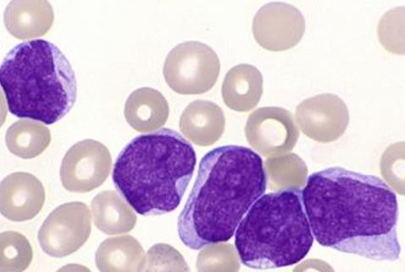
  - An accelerated phase (last 6-9 months)
a gradual increase in blasts in the blood or bone marrow ,
it is short, may transformed to AML or myelofibrosis,
and the % Of blast is between 5-20%

  - Blast crisis (last for3-6 months)
rapid progression and short survival , and the % Of blast
is more than 20% in the peripheral blood and bone marrow

CML Diagnosis

1- CBC
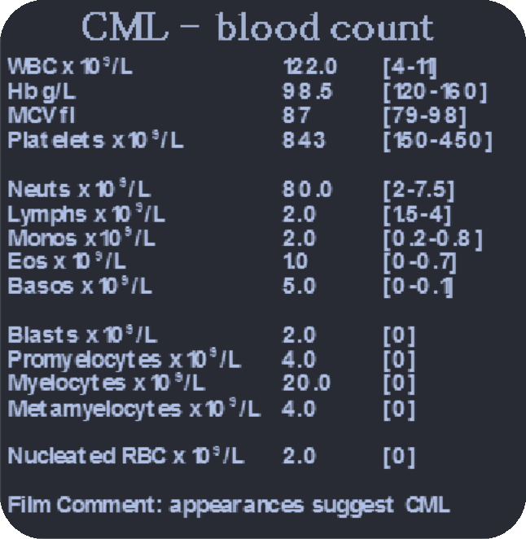
shows increased granulocytes of all types,
typically including mature myeloid cells. Basophils and Eosinophils are almost commonly increased; this feature may help differentiate CML from a leukemoid reaction RBC:
- Hb: is low
- NRBC: may present
Platelet count :increase
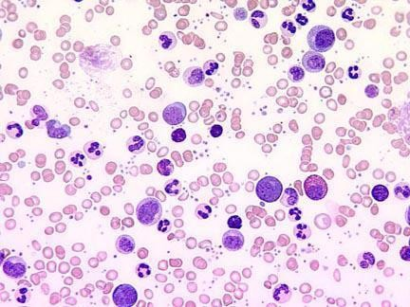

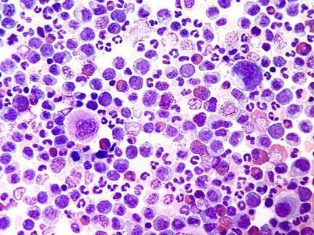
CML Diagnosis

2-Bone Marrow study
- Cellularity: Hypercellular, Increase reticulin fibrosis in 30-40%
- Granulocytic hyperplasia blasts less 10%
- Ph.chromsome test: positive [t(9;22)]

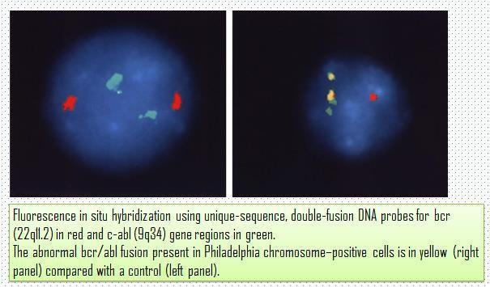
  - cytogenetics that detects the translocation t(9;22) which involves the ABL1 gene in chromosome 9 and the BCR gene in chromosome 22
As a result of this translocation known as the
Philadelphia chromosome chromosomal abnormality

Chronic lymphocytic leukemia (CLL)

- Chronic lymphoproliferative disorder
- Cell: B cells, Non adequate functional,
- Accumulated in the P. blood , bone marrow, spleen, liver and lymphnodes
- Age: 55-70 yrs
- Sex: frequent in males than females
- Life: 2 yrs. up to 20 yrs.
- Some die rapidly, within 2-3 years of diagnosis;
- Discovered incidentally after a blood cell count is performed for another reason 25-50% of patients will be asymptomatic at time of presentation.

Symptoms

    - Enlarged lymph nodes, liver, or spleen
    - Recurring infections
    - Loss of appetite or early satiety
    - Abnormal bruising (late-stage symptom)
    - Fatigue
    - Night sweats

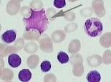
CLL Diagnosis

Peripheral blood show CBC
- RBC: mild anemia
- WBC: over 50.000 / with lymphocytosis
- PLT: slight decrease

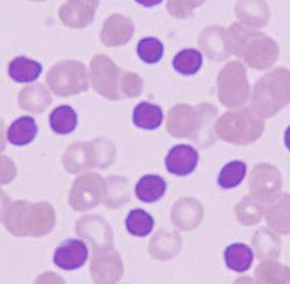
P.B.S
shows the presence of blood smear show
small lymphocytes &smudge cells

