Pathological Analysis Department Title of the lecture: WBC Disorders

Lec3-14
Hematology

Quantitative changes of the WBC

- Leucocytosis - Quantitative changes
Definition .. Is a raised white blood cell count (the leukocyte count) above the normal
- Leucopenia - Quantitative changes
Definition.. Total WBC lower than the reference range for the age is defined as leucopenia
Leukocytosis

The mechanism of leukocytosis can be of several forms
-Increase bone marrow production
- Splenectomy (Increase cells)

Classification of leukocytosis

Leukocytosis(Neutrophilia-Lymphocytosis.-Monocytosis.-Eosinophilia)

Leukocytosis may indicate
1-Bacteria, viral or parasitic infection 2-Blood malignancy (Leukemia)
3-Drugs effects

Laboratory Signs of infection (cytotoxic)
- Presence of toxic granulation in neutrophils
- Presence of toxic vacuolization in neutrophils 3-increase of band form over 5%

1

Other tests
1-Increase of ESR 2-Positive CRP test
3- LAP( leukocyte alkaline phosphatase) test positive

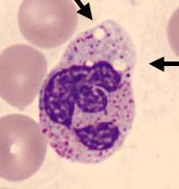
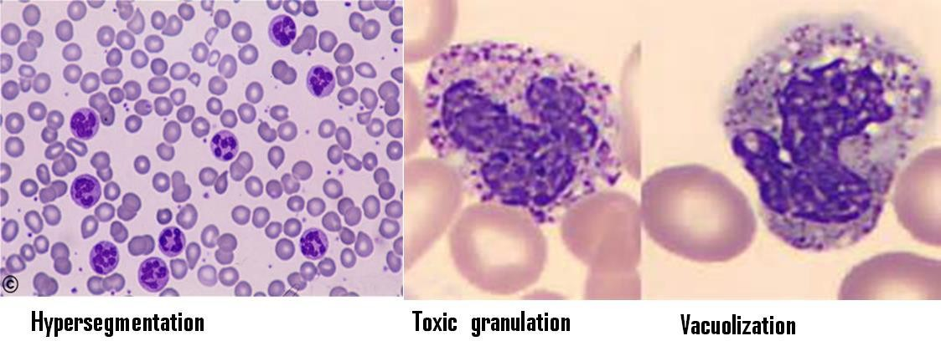

granulation and toxic vacuolization in neutrophil

Granulocytosis 1-Neutrophilia
Definition.. Increase in the number of neutrophils Increase Production
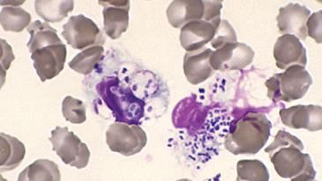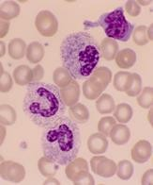
Toxic vacuolation: neutrophils showing phagocytosed bacteria in a case of severe septicaemia

2

Causes of Neutrophilia
Infection, Bacterial,viral, fungal
Inflammatory conditions, Autoimmune disorders
Gout, Neoplasia, Metabolic conditions, Uraemia –Acidosis - Haemorhage Corticosteroids, Marrow infiltration/fibrosis Cigarette smoking, Post-splenectomy Myeloproliferative disorders -leukemia.

Diagnosis of neutrophila
CBC \ count of Neutrophils absolute count \Blood film study evaluation of band form presence over 5%
Toxic granulation in the cytoplasm and Toxic vacuolization Bone marrow study
Uses of some stain such as -- A leukocyte alkaline phosphatase (LAP)
- Eosinophilia
Causes of Eosinophilia
- Allergy:Atopic, - Drug sensitivity
- pulmonary eosinophilia
- Infection :Parasites, recovery from infections
- Malignancy: Hodgkin’s disease
- Skin disorders
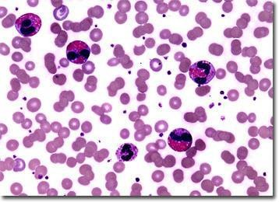
- Basophilia
- allerigic reactions
- chronic myelocytic leukemia
- polycythemia vera
- Basophilia is also reported in hypothyroidism.

3

Monocytosis
- myeloproliferative disorders.
- Monocytosis may result from viral, fungal, and protozoal infections.
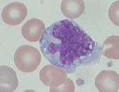

Leukopenia
Definition: Is a decrease in the number of circulating white blood cells (leukocytes) in the peripheral blood lower than 4000/cells/μL (for adult)
Result of leukopenia? Increased risk for infection
Causes of leukopenia
a) Chemotherapy, radiation therapy, leukemia (as malignant cells overwhelm the bone marrow), myelofibrosis, aplastic anemia ,Medications

Neutropenia
- Patients with neutropenia are more susceptible to bacterial infections
- Patients with fevers and frequent infections.

Causes of Neutropenia
1-Aplastic anemia2-Viral infections
- Radition4-Autoimmune 5-Medication

4

Lymphocytosis.
Is an increase in the number of lymphocytes in the blood according to the patient age

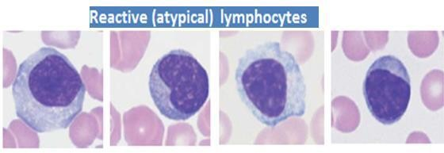

Lymphocytopenia:
Decrease of the absolute count of lymphocytes lower than normal
May be seen with
chemo Rx, irradiation,
Hodgkin's disease, HIV infection

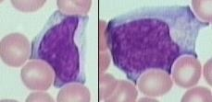

5

