Ministry of Higher Education And Scientific Research Al-Mustaqbal University College
Department of Pathological analysis techniques

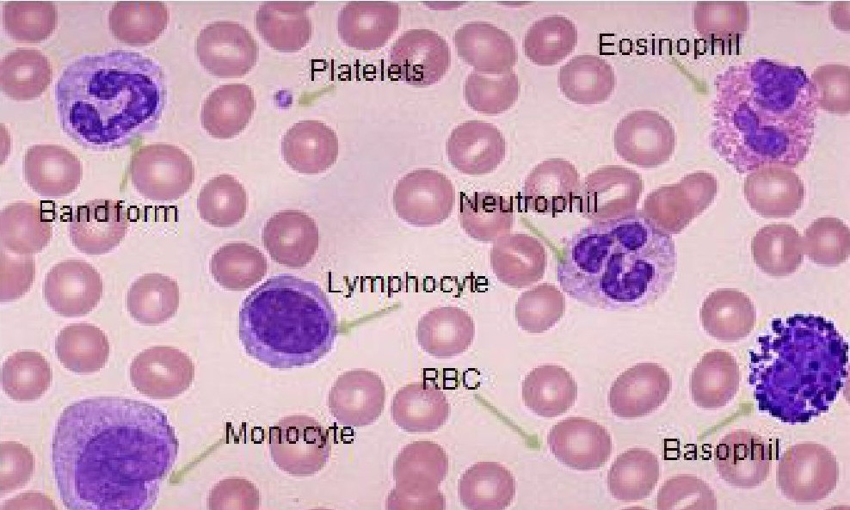
White Blood Cells

Lec 13 3ed stage
Hematology

Leucocytes in the human body
White blood cells are a group of cells circulating in the peripheral blood

Divided into two systems 1-Phagocytic system are
Neutrophils, Eosinophils, Basophils Mononuclear phagocytic cells
2-The non-phagocytic system (Lymphocytes) B-cells .T-cells
-The normal adult human leukocyte count in peripheral blood is 4.0-10.0 x 109/L.
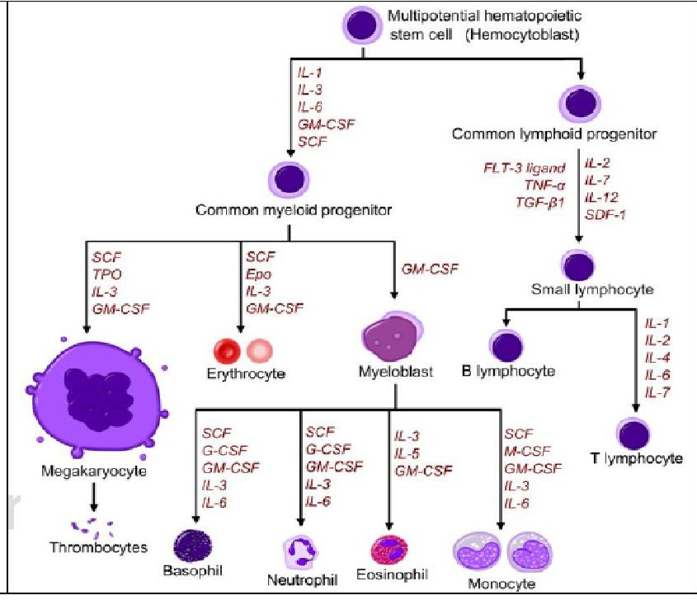

Cells distribution

1-In bone marrow: RBC:WBC=1:5 2-In Circulation: RBC:WBC=500:1
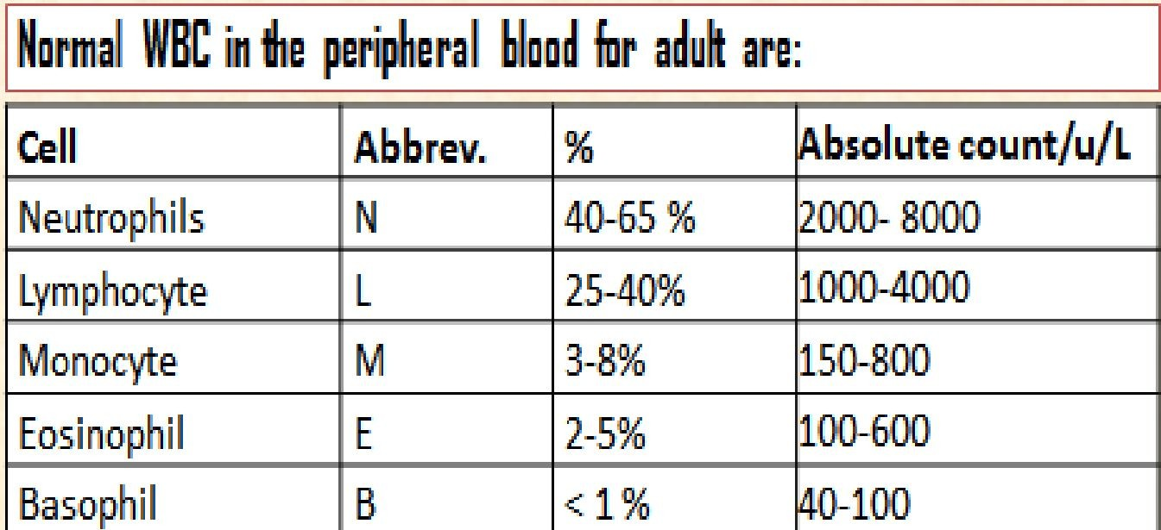

1 Granulocytes:
are a group of white blood cells characterized by the presence of granules in their cytoplasm
They are 3 types:
1-Neutrophils

Polysegmented nucleus (3-5 lobes)
Enzymes, Peroxidase reacting enzyme, and Alkaline phosphates
Percentage. 40-65 %,
Function ,Kill bacteria, Called pus cells
Storage place1- Mainly in Bone marrow 2- inside wall of vessels (veins) 3- spleen

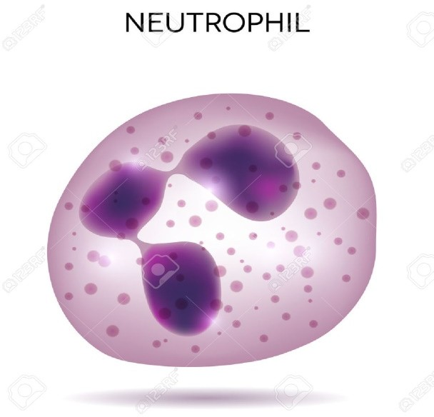

Stages of granular white cell phagocytosis
In the presence of bacterial or fungal infections, the neutrophil is activated

A- CHEMOTAXIS:
chemical signals sent by foreign body, More neutrophils mobilize and rush to site of infection.

B- OPSONIZATON:
needs the help of IgG+C3 to make it easily recognized by neutrophil and ingested.

C- INGESTION:
The foreign body is engulfed by the neutrophilic pseudopod membranes

D-KILLING:
the foreign body killed by the neutrophilc enzym

2-Eosinophilic
2 lobes, content: histamine, serotonin, and heparin etc.
Function is defense Against parasites; and allergic cases.

3-Basophilic
Nucleus: 2 lobes ,content: histamine, serotonin, and heparin, Function :increase vascular permeability , the basophils in the tissue called mast cell( more specific cells)
contain acid phosphatase, alkaline phosphatase, and protease.

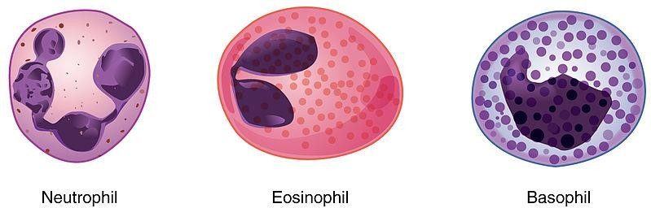

4-Monocytes
Immature cell in the peripheral blood and cannot fight infectious , After they stay 2-3 days in the peripheral blood they migrate into the tissues to form Macrophage.
it take new name in that tissue
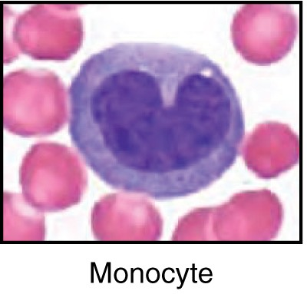
1-Macrophages in the Lymph Nodes 2-Alveolar Macrophages in the Lungs
3-Kupffer Cells Macrophages in the Liver Sinusoids 4-Macrophages of the Spleen and Bone Marrow
5-Microglia in brain
Function of Macrophage (Monocyte) :
1-Defense against bacteria, fungi, viruses, and foreign bodie 2-Remove the dead cells from tissue and circulation
s

Phagocytosis by Macrophages
- Much more powerful than neutrophils,Can phagocytoze more bacteria
- Engulf much larger particles (ex.leishmania and toxoplasma), malarial parasites

Lymphocytes

Types: two major groups T and B lymphocytes, non granular, has one rounded nucleus General function: responsible for the immunity in the body
T-lymphocytes :(Thymus)
Percentage of all lymphocyte: 60-80%, Site of production: Bone marrow, Site of developing: thymus Function: The main immune cell responsible for cellular immunity.
B-lymphocytes :(Bone marrow)
B lymphocytes mature in the bone marrow Percentage 20% of all lymphocyte: 20%
Site of production: Bone marrow Site of developing: the secondary lymphoid organs (spleen, lymph nodes, etc)
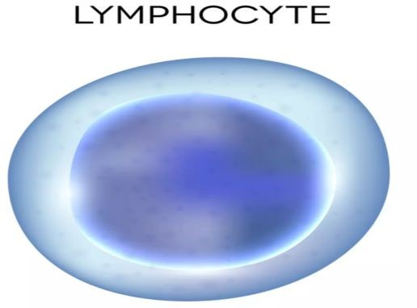
Function: humoral immunity (against viruses, bacteria, and allergens) secreting plasma cells, to produce antibodies

