Pathological Analysis Department Title of the lecture : Hemolytic Anemia

Lec3-10
Hematology

MSc. Amal Hesham
MSc. Dhuha Salman
Hemolytic Anemia
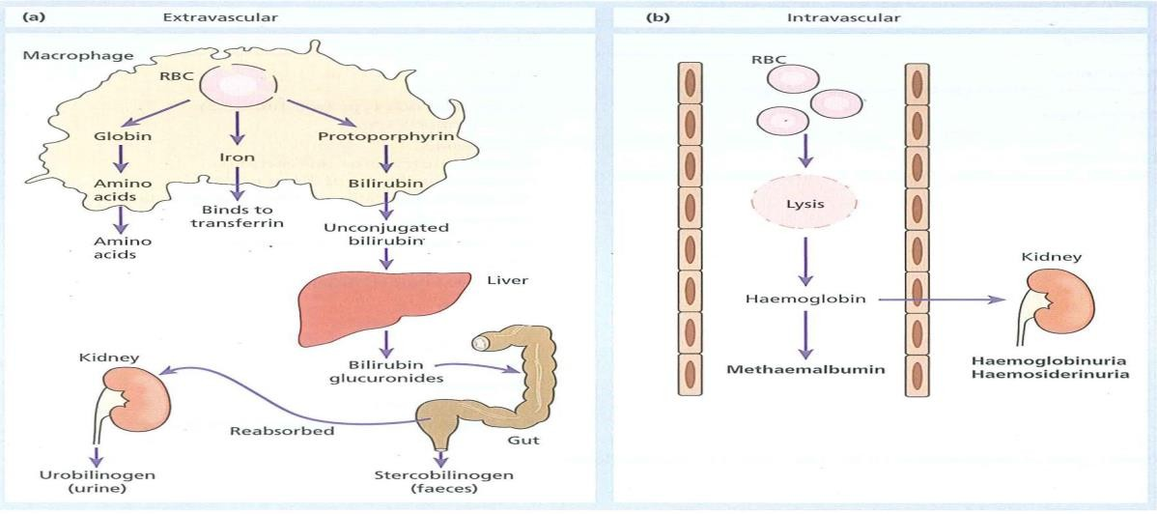
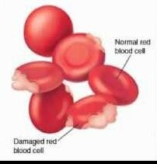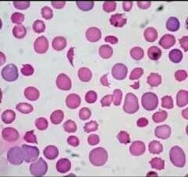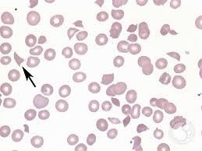

There are two main mechanisms whereby red cells are destroyed in haemolytic anaemia.

intravascular haemolysis
they broken down directly in the circulation in a process known intravascular hemolysis, free hemoglobin is released which rapidly saturates plasma haptoglobins and the excess free hemoglobin is filtered by the glomerulus. If the rate of hemolysis saturates the renal tubular
re absorptive capacity, free hemoglobin enters urine.

2-(extravascular haemolysis)
Red cell destruction usually occurs after a mean lifespan of 120 days when the cells are removed extravascularly by the macrophages of the reticuloendothelial (RE) system, especially in the marrow but also in the liver and spleen..
The breakdown of haem from red cells liberates iron for recirculation via plasma transferrin to marrow erythoblasts,
protoporphyrin which is broken down to bilirubin. Bilirubin circulates to the liver where it is conjugated to glucuronides which are excreted into the gut via bile and converted to stercobilinogen and stercobilin(excreted in faeces)
Globin chains are broken down to amino acids which are reutilized for general protein synthesis in the body.

Three proteins remove it’s from the plasma and they are 1-Haptoglopin (HP)
It is alfa protein Produced from the liver

The first protein which remove the toxic iron immediately after hemolysis

Hemopexin:
It is beta protein Produced from the liver

The second protein which remove the toxic iron ,Its work start after the depleted of haptoglobin

Meth-hem -albumin.
- if the haptoglobin and hempexin depleted and the hemolysis is sever the free iron compound with albumin and called methhemalbumin

- When the liver produce new haptoglobin and hemopexin they take the toxic iron from albumin to carry it into the liver

Hemolytic anemia classification
  - Inherited hemolytic anemia

They are genetic ,They has no therapy ,They are permanent They are chronic ,They starting early in the life ,Some starting after 7 month of the birth and Some needs other factors to starting

Types of Inherited hemolytic anemia
- Related to Hb disorders

- Enzymopathies: related to enzymes deficiency of RBC (G6PD and PK)

- Membrane disorders:

Hemoglobinopathies:
- Quantitative defects :
absence of one or tow or three or four chain of hemoglobin

Structure defects:
the abnormality in the sequence of amino acids on the beta chains of hemoglobin only

Enzymopathies:
Enzyme Defects: Absence or decreased function of a metabolic enzymes (G6PD or PK)
- Membrane Defects: Abnormalities in the proteins that make up the cytoskeleton of the cell membrane

2-Acquired hemolytic anemia
Destruction of red blood cells (RBCs) not due to genetic or congential disorder They has therapy ,They are not permanent ,They are acute ,They starting late in the life

Caused by factors during the life such as
Malaria ,Antibodies against RBC ,Toxins ,Chemicals ,Drugs

Diagnosis of Hemolytic Anemia?
Two main principles
- One is to confirm that it is hemolysis
- Two is to determine the cause

The study of hemolysis in the laboratory must include:
- CBC (anemia)
- Blood film study
- Reticulocyte count
- Plasma hemoglobin (increased)
- Serum Haptoglobin (HP) (absent)
- Serum Hemopexin (absent)
- Methemalbumin (positive)
- Serum bilirubin

