**Lab. 11- Streptococci**

**General characteristics:**

1. Gram- positive cocci, arranged in chain or pairs.
2. Non motile, non-spore forming.
3. Some strains are capsulated, which are important in pathogenicity.
4. Catalase – negative.
5. Majority are facultative anaerobes; few are obligate anaerobes.
6. They are fastidious microorganisms grow on enriched media such as blood agar, have small, pin head, opaque , circular colonies.
7. 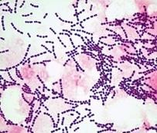Sensitive to drying, heat and disinfectant

**Streptococcus bacteria**

**Classification:**

Species of this genus is classified according to the following:

**1- Hemolysis :**

* β- Hemolysis : complete destruction of RBCs . e.g. ***Streptococcus Pyogenes***
* $α$-hemolysis : partial destruction of RBCs e,g. ***S.mutans***
* ɤ- hemolysis: non- hemolysis .

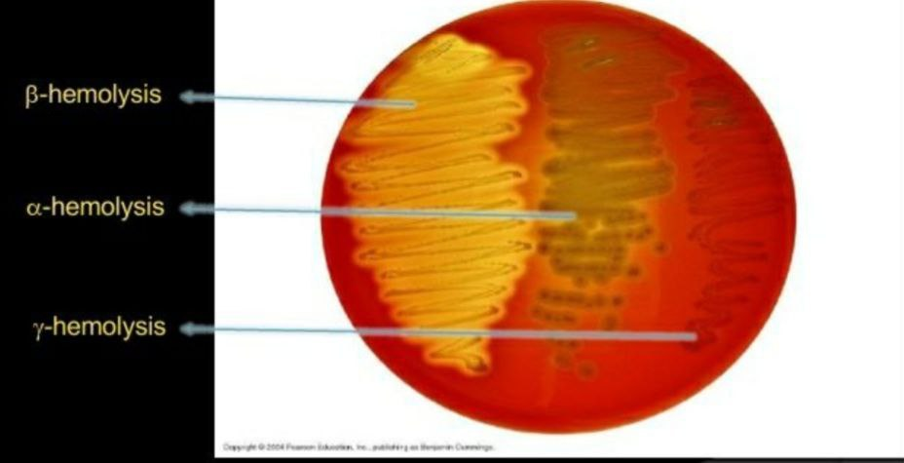

**Hemolysis on Blood agar**

►Serology ( Lancefield grouping ):

There are differences in the polysaccharide antigens ( group- specific carbohydrate ) of the cell wall . Depending on these specific polysaccharide antigens. Streptococci are named as groups from A- H and K- U .

Streptococci



Group A

*S. pyogenes*

Group D

*Enterococcus*

Other

groups

(E-U)

Group B

*S. agalactiae*

Group C

*S. equisimitis*

* **Streptococcus pyogenes**
* Gram- positive cocci occurring in chains of varying length ,non – motile and non- spore forming
* **Diagnosis**

1. Specimens : swab ( throat in sore throat )

Purulent lesion in wound infection

Blood – in septicemia

1. Gram -stain
2. from colonies grown on blood agar ( small , semitransparent colonies with large zone of $β$- hemolysis )

Incubation at 37c for 24- 48 hrs . with 5-10% Co2 .

1. Bacitracin sensitivity test:

A disk 0.04 IU of bacitracin disk placed on the primary culture plate .

***Strep. pyogenes*** : $β$- hemolytic shows a zone of inhibition around the disk .

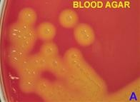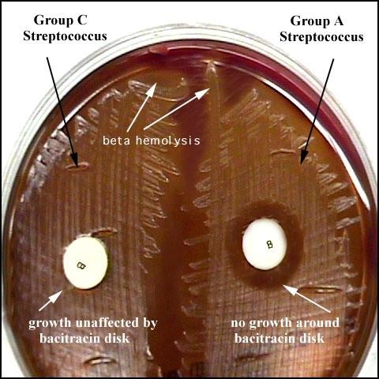Catalase test : Give negative reaction .

Hemolysis on blood agar Bacitracin test

**►Streptococcus pneumonia ( Diplococcus pneumonia) ( Pneumococcus )**

• The organism typically occurs as oval or spherical cells in pairs , singly or as short chains . the distal ends of paired organism tend to pointed or lancet – shaped .

• Streptococcus pneumonia is non motile and usually encapsulated.

• Streptococcus pneumonia is bile soluble and this characteristic serves as the most reliable means of differentiating the pneumococcus from other coccal forms .

• The pneumococci differentiated from other alpha hemolytic cocci

**Bile Solubility test**

►Principle:

* *S. pneumonia* produce a self- lysing enzyme to inhibit the growth
* The presence of bile salt accelerate this process

Procedure :

Add ten (10 ml ) of the broth culture of the organism to be tedted to one part (1 ml ) of 2% Na deoxycholate ( bile ) into the test tube .

Negative control is made by adding saline instead of bile to the culture . incubate at 37 c for 15 min , Record the result after 15 min .

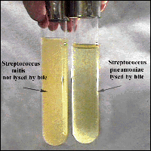Result :

Positive test appears as clearing the presence

of bile , while negative test appears as turbid .

***S. pneumonia***soluble in bile whereas

***S.viridans*** insoluble .