كلية المستقبل الجامعة / قسم تقنيات المختبرات الطبية
المرحلة الثالثة / التقنيات المختبرية / العملي
المحاضرة الاولى / الكورس الثاني

ـــــــــــــــــــــــــــــــــــــــــــــــــــــــــــــــــــــــــــــــــــــــــــــــــــــــــــــــــــــــــــــــــــــ
The enzyme-linked immunosorbent assay (ELISA)
The enzyme-linked immunosorbent assay (ELISA) is a common laboratory technique which is used to measure the concentration of an analytic (usually antibodies or antigens) in solution.
The basic ELISA, or enzyme immunoassay (EIA), is distinguished from other antibody-based assays because separation of specific and non-specific interactions occurs via serial binding to a solid surface, usually a polystyrene multiwell plate, and because quantitative results can be achieved.
The steps of the ELISA result in a colored end product which correlates to the amount of analytic present in the original sample.
ELISAs are quick and simple to carry out, and since they are designed to rapidly handle a large numbers of samples in parallel, they are a very popular choice for the evaluation of various research and diagnostic targets. Figure 1 shows a typical ELISA result.
ELISAs were first developed in the early 1970s as a replacement for radioimmunoassays. An ELISA test may be used to diagnose:
- -HIV, which causes AIDS
- -Lyme disease

- -Rotavirus.
- -Squamous cell carcinoma
- -Syphilis
- -Toxoplasmosis
- -Varicella-zoster virus, which causes chicken pox and shingles

Basic ELISA Procedure:-
ELISAs begin with a coating step, where the first layer - either an antigen or an antibody - is adsorbed to a polystyrene 96 well plate.
Since the assay uses surface binding for separation, several washes are repeated between each ELISA step to remove unbound materials. During this process it is essential that excess liquid is removed in order to prevent the dilution of the solutions added in the next stage. For greatest consistency specialized plate washers are used.

Four Typical ELISA Formats:-

The ELISA provides a wealth of information in its simplest formats, but it can also be used in more complex versions to provide enhanced signal, more precise results, or if certain reagents are not available. The four typical ELISA formats are described briefly below.

1- Direct ELISA:-
An antigen coated to a multiwell plate is detected by an antibody that has been directly conjugated to an enzyme.
This type of ELISA has two main advantages:
1-It is faster, since fewer steps are required
2-It is less prone to error, since there are fewer steps and read so are not easily reusable.
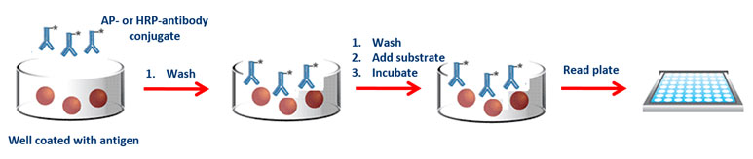

2-Indirect ELISA:-
Antigen coated to a polystyrene multiwell plate is detected in two stages or layers. First an unlabeled primary antibody, which is specific for the antigen, is applied. Next, an enzyme-labeled secondary antibody is bound to the first antibody. The secondary antibody is usually an anti-species antibody and is often polyclonal.
This method has several advantages:
1-Increased sensitivity, since more than one labeled antibody is bound per primary antibody
2-Flexibility, since different primary detection antibodies can be used with a single labeled secondary antibody
3-Cost savings, since fewer labeled antibodies are required.

3-Sandwich ELISA:-
Sandwich ELISAs typically require the use of matched antibody pairs, where each antibody is specific for a different, non-overlapping part (epitope) of the antigen molecule.
The first antibody, termed the capture antibody, is coated to the polystyrene plate. Next, the analyte or sample solution is added to the well.
A second antibody layer, the detection antibody, follows this step in order to measure the concentration of the analyte.
Polyclonals can also be used for capture and/or detection in a sandwich ELISA provided that variability is present in the polyclonal to allow for both capture and detection of the analyte through different epitopes.
This type of assay has several advantages:
1-High specificity, since two antibodies are used the antigen/analyte is specifically captured and detected
2-Suitable for complex samples, since the antigen does not require purification prior to measurement
3-Flexibility and sensitivity, since both direct and indirect detection methods can be used.

4-Competition or Inhibition ELISA:-

The key event of competitive ELISA (also known as inhibition ELISA) is the process of competitive reaction between the sample antigen and antigen bound to the wells of a microtiter plate with the primary antibody. First, the primary antibody is incubated with the sample antigen and the resulting antibody–antigen complexes are added to wells that have been coated with the same antigen. After an incubation period, any unbound antibody is washed off. The more antigen in the sample, the more primary antibody will be bound to the sample antigen. Therefore, there will be a smaller amount of primary antibody available to bind to the antigen coated on the well, resulting in a signal reduction

Summary of Key Steps in Different ELISA Types

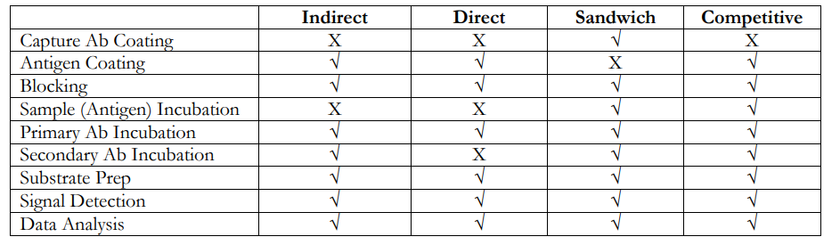

ELISA Results:-
The ELISA assay yields three different types of data output:
1-Quantitative:-
ELISA data can be interpreted in comparison to a standard curve (a serial dilution of a known, purified antigen) .
2-Qualitative-:
ELISAs can also be used to achieve a yes or no answer indicating whether a particular antigen is present in a sample, as compared to a blank well containing no antigen or an unrelated control antigen.

Sensitivity
ELISAs are one of the most sensitive immunoassays available. The typical detection range for an ELISA is 0.1 to 1 of ml or 0.01 ng to 0.1 ng, with sensitivity dependent upon the particular characteristics of the antibody –antigen interaction.

