Medical Laboratory Techniques Department
Lab 8 : helminths
The word, helminths from Greek means "Worm" and originally referred to intestinal worms but it is more usually interpreted to include both parasitic & free-living species of round worms (phylum Nemathoda )"hair snakes" or gordiid worms (Phylum – Nematomorpha), tubellarians, flukes & tape worms ( phylum-plathyhelminthes) & thorny - headed worms (phylum Acanthecephala). The helminths are generally macroscopic, and the adult worms vary tremendously in size from barely visible to 10 meters in length

Helminths, which occur as parasite in humans belong to 2 phyla:
* Phylum Platyhelminthes: It includes 2 classes:
* Class – Cestoda (tapeworms) * Class – Trematoda (flukes or digeneans)
* Phylum Nemathelminthes – It includes class nematoda and 2 subclasses:
* Subclass – Adenophoraea (Aphasmidia) * Subclass – Secernentea (Phasmidia).
Phylum Platyhelminthes
The platyhelminths are tape-like, dorsoventrally flattened worms. • They either lack alimentary canal (as in cestodes) or their alimentary canal is incomplete, lacking an anus (as in trematodes).
General characteristics:
1. Dorso-venterally flattened (leaf ortape-like)
2. Bilaterially symmetrical.
3. They are provided with a nervous system and an elaborate excretory apparatus.
4. Digestive system may be absent, or when present it is rudimentary and without anus. It obtains its nutrient by absorption through cuticle.
5. Respiratory, circulatory system and body cavity are absent.
6. Tape worms are hermaphrodites and have well developed reproductive system.
7. Each unit of chain (segements) is known proglottides. The entire chain of proglottids is called strobili
8. The body is divided into three main body regions; this are
Head (scolex): attachment organ and may have grooves, suckers, and rostellum armed with hooklets; this varies with species..Body parts of tape worm Infection persists as long as the scolex and the neck region remain attached to the intestinal wall.
Neck: growth region, proglottids proliferate from this region.
Strobila: varies in number, shape, size, and maturity. It is divided into three regions:

a/ immature: sex organ are immature
b/ mature: sex organs are fully mature.
c/ gravid : reduced or atrophied primary genital organs, uterus is filled with eggs

• Locomotion
is generally by muscular contraction and relaxation.

Egg: - Two type
1. Operculated, immature when voided to the external environment.
2. Non-operculated ,fully embryonated when voided to the external environment.
Larvae: -Generally two type
I. Solid : eg. Procercoid, Plerocercoid, cysticercoid
II. Cystic( true bladder): can be with:- Single scolex eg. Cysticercus; Many scolexes and/or with daughter cyst eg. hydatid cyst, coenurus cyst, etc
Taenia saginata

Common name (beef tape worm)
Geographical Distribution
World wide distribution where cattle are raised and beef is eaten raw or under cooked. More common parasite of man unlike Taenia solium. It is very common in Ethiopia.
Habitat Adult: In small intestine of man Larvae: In muscular tissues of cattle Eggs: In faeces of man or in gravid segments.

Morphology:
Colour: ivory white Scolex (head): quadrate, with four suckers, no looks, no rostellum

Mature Proglottides
Broader than long - Genital pores are arranged irregularly alternate on the lateral margin of each segment
Gravid proglottide
Detach when fully develop and pass through the anus independently.
Larvae : known as Cysticercus bovies

Found in skeletal and muscular tissues of cattle. Has four suckers and no rostellum and hooklets
Egg (Embryophore): - Shape: -Round

Colour: - Shell-dark yellowish-brown, content light yellowish gray.
Shell:- Thick, Smooth, brown,striated (embryo)

Content: - A round granular mass enclosed by a fine membrane with six hooklets

Life cycle
Requires two hosts to complete its life cycle. Man as a definitive host and cattle as intermediate host.

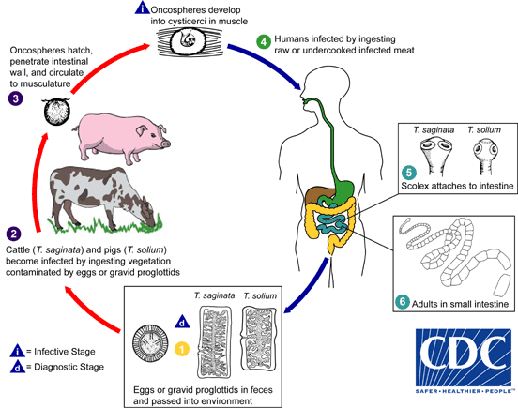

Laboratory Diagnosis
1. Detecting eggs in faeces. Morphologically eggs of T.saginata and T. solium are indistinguishable unless stained by AFB.
2. Identifying gravid segments and scolex recovered from clothing or passed in faeces. Single rectangular segments found in underclothes and bed clothes

