Hooke's law

Purpose of the experiment: To investigate experimentally the extension of a spring and how it is related to the applied force, and recall that the extension of a spring is directly proportional to the force applied, provided that the limit of proportionality is not exceeded.
The main variables in a science experiment are the independent variable, the dependent variable and the control variables.
The Independent Variable is what we change or control in the experiment.
The Dependent Variable is what we are testing and will be measured in the experiment.
The Control Variables are what we keep the same during the experiment to make sure it’s a fair test.
- Independent Variable is the stretching force F. This is the weight attached to the spring and is calculated using W = mg.
- Dependent Variable is the extension of the spring e.
- Control Variables are the material of the spring, and the cross section are of the spring. These are kept the same by not changing the spring during the experiment. Remember - these variables are controlled (or kept the same) because to make it a fair test, only 1 variable can be changed, which in this case is the stretching force (i.e. the weight attached to the spring).
Hooke's law: The extension of a spring is directly proportional to the force applied, provided that the limit of proportionality is not exceeded.
The equation for Hooke’s Law is:

F =- kΔL, ΔL=L-L˳
- F is the force in newtons (N)
- k is the 'spring constant' in newtons per metre (N/m)
- ΔLis the extension in metres (m)
- Lis the extention of the spring
- L˳is the length of the spring in relexed state(without any force applied)

Apparatus
A steel spring, masses, 20,30,40…gm,Weights holder , a metre rule,.

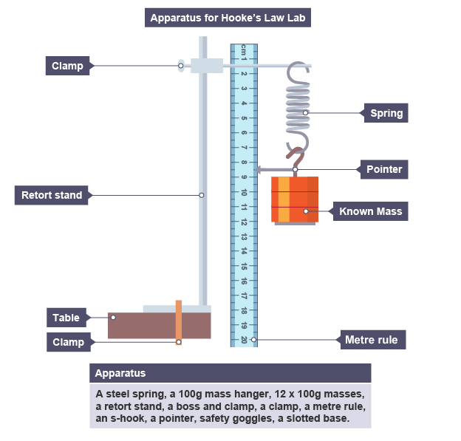 Method
- Set up apparatus as shown in the diagram.
- Attach the mass hanger s -hook and pointer to the lower end of the spring. The pointer should just touch the metre rule.
- Read the pointer value from the metre rule. Record this length in a suitable table. This is the initial length of the spring for zero mass. We can neglect the mass of the hanger.
- Add a 20 g slotted mass to the hanger. Record the mass in kg in the table.
- Read the new position of the pointer on metre rule. This is the stretched length of the spring. Record this length in the table.
- Calculate the stretching force = weight of masses: W = mg.
- Calculate: extension = stretched length – original length.
- Repeat the procedure by adding 20g masses Record the new stretched length by reading the position of the pointer on the metre rule. Subtract the original length from the new stretched length to calculate each extension.
Trial | masses (gm) | F=mass(kg)*g | ΔL=L-L˳
1
2
3
4
5

