Central nervous system (CNS) drugs
Agents that act on the brain and spinal cord—are used for medical and nonmedical purposes. Medical applications include relief of pain, suppression of seizures, production of anesthesia, and treatment of psychiatric disorders.

Several major differences exist between neurons in the ANS and those in the CNS:
- The circuitry of the CNS is much more complex than that of the ANS, and the number of synapses in the CNS is far greater.
- The CNS, unlike the peripheral ANS, contains powerful networks of inhibitory neurons that are constantly active in modulating the rate of neuronal transmission.
- CNS communicates through the use of multiple neurotransmitters, whereas the ANS uses only two primary neurotransmitters, acetylcholine and norepinephrine.

Most drugs that affect the central nervous system (CNS) act by:
- Drugs affecting the CNS may act pre-synaptically by influencing the production, storage, release, or termination of action of neurotransmitters.
- Other agents may activate or block postsynaptic receptors.

2 types of neurotransmitters:
Inhibitory neurotransmitters:
1-Glycine 2- Serotonine 3- Dopamine 4-GABA
Excitatory neurotransmitters:
1-Glutamate 2-Aspartate 3-Nitric oxide
Ach and Norepinephrine acting both excitatory and inhibitory.
General Mechanisms of the Drugs that acting on the CNS
Most drugs that affect the central nervous system (CNS) act by altering some step in the neurotransmission process. Drugs affecting the CNS may act presynaptically by influencing the production, storage, release, or termination of action of neurotransmitters. Other agents may activate or block postsynaptic receptors.
In the CNS, receptors at most synapses are coupled to ion channels. Binding of the neurotransmitter to the postsynaptic membrane receptors results in a rapid but transient opening of ion channels. Open channels allow specific ions inside and outside the cell membrane to flow down their concentration gradients. The resulting change in the ionic composition across the membrane of the neuron alters the postsynaptic potential, producing either depolarization (excitatory) or hyperpolarization (inhibitory) of the postsynaptic membrane, depending on the specific ions and the direction of their movement.

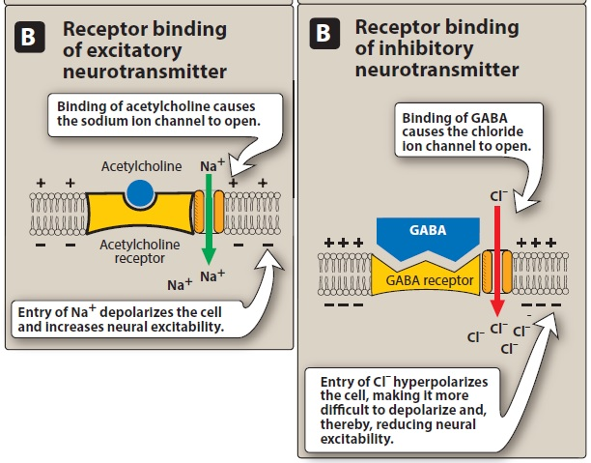
(Excitatory and inhibitory action)

Two types of CNS drugs:
1. CNS Depressant.
2. CNS Stimulants.

- CNS depressant
- Sedative-hypnotic drugs
The sedative-hypnotics are used primarily for two common disorders:
- Anxiety.
- Insomnia.
Sedative: Drugs that calm or quite the patient and reduce anxiety without induce normal sleep.
Hypnotics: Drugs that initiate and maintain the normal sleep without loss of consciousness.

Classification of sedative- hypnotic drugs:
- Benzodiazepines
- E.g.: Diazepam (Valium), Midazolam, Lorazepam.
- M.O.A:
A. The targets for benzodiazepine actions are the (GABAA) receptors (GABA is the major inhibitory neurotransmitter in the central nervous system (CNS).
B. triggers an opening of the central ion channel, allowing chloride through the pore).
C. The influx of chloride ions causes hyperpolarization of the neuron and inhibiting the formation of action potentials.
- Therapeutic actions of benzodiazepines
- Hypnotic (sleep inducing).
- Anxiolytic (anti-anxiety).
- Anticonvulsant.
- Amnestic (memory).
- Seizures (epilipticus).

- Barbiturates
- E.g.: classified into 3 types:
- Ultrashort-acting: (Methohexital).
- intermediate-acting (Secobarbital).
- Long-acting (Phenobarbital).
- M.O.A: The sedative–hypnotic action of the barbiturates is due to their interaction with GABA receptors. these drugs can
(1) enhance the inhibitory actions of GABA.
(2) directly mimic the actions of GABA.
- Therapeutic actions:
- Anesthesia.
- Anticonvulsant.
- Sedative/hypnotic

- Adverse effects:
- Respiratory depression.
- Hangover, dizzy, drowsiness, amnesia, disorientation.

ANALGESIC DRUGS
Analgesia: refers to absence of pain without the loss of consciousness.
Opioid: is any drug natural, semi synthetic or synthetic that has actions similar to those of morphine. Opioids are drugs of choice for moderate to severe pain that cannot be controlled with other classes of analgesics.

Opioid Analgesics: Powerful pain relievers. Originate from the opium poppy (plant). Opioid analgesics are the most effective analgesics and are used in the management of severe pain.
Opioid receptors: Three main classes of opioid receptors, designated as mu, kappa, and delta. From the pharmacologic perspective, mu receptors are the most important. This is because opioid analgesics act primarily through activation of mu receptors, although they also produce weak activation of kappa receptors

Can be classify by similarities in their chemical structure, by their mechanism of action, or by their efficacy into:
- Opioid Agonists with Moderate Efficacy (e.g. codeine, oxycodone)
- Opioid Agonists with High Efficacy (e.g. hydromorphone, meperidine, methadone, morphine (Kadian)
- Opioids with Mixed Agonist-Antagonist Effects (e.g. butorphanol, nalbuphine (Nubain), pentazocine)
- Other Analgesics (tramadol)
- Opioid Antagonists (naloxone (Narcan), naltrexone (ReVia).

- Mechanism of action: Stimulate opiate receptors in the brain. They relieve pain by mimicking the action of endogenous opioid peptides, primarily at mu receptors, or both mu and kappa receptors.

- Opioid antagonists may be used to reverse the symptoms of opioid toxicity or overdose, such as sedation and respiratory depression.

- Therapeutic actions of opioids: (morphine)
- Analgesia.
- Depression of cough reflex: Both morphine and codeine have antitussive properties.
- GI tract: Morphine relieves diarrhea by decreasing the motility and increasing the tone of the intestinal circular smooth muscle.
*** Non-Opioid Analgesics
The non-opioid analgesics include acetaminophen, NSAIDs, and a few centrally acting agents (tramadol).

*** Classification of Non-Opioid Analgesics:
- Acetaminophen (Tylenol).
- Selective COX-2 Inhibitors (celecoxib).
- Ibuprofen and Ibuprofen-Like: Non-Salicylates (diclofenac (Voltaren), ibuprofen (Advil, Motrin), ketoprofen, meloxicam (Mobicox), naproxen.
- Salicylates (Aspirin).

