Gastritis
The stomach J-shaped. It has two surfaces (the anterior and posterior), two curvatures (the greater and lesser), two orifices (the cardia and pylorus). It has fundus, body, antrum and pyloric.
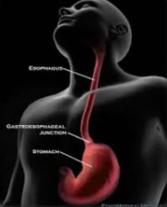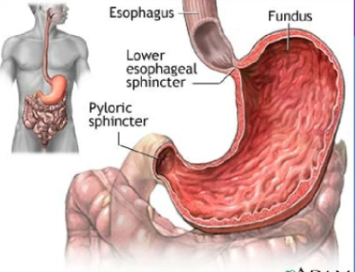
Gastritis: - is inflammation of the lining of the stomach. It may occur as a short time or may be long duration.
Signs and symptoms
- Nausea or vomiting
- Anorexia
- Abdominal pain
- Gastrointestinal blood loss
- Weight loss
- Dysphagia

Common causes
- infection with Helicobacter pylori
- use of non-steroidal anti-inflammatory drugs
- alcohol and smoking
- autoimmune problems
- radiation therapy
- Crohn's disease
Classification of gastritis
-Acute gastritis: - acute erosive gastritis typically involves discrete foci of surface necrosis due to damage to mucosal defenses, which increases the possibility of peptic ulcers forming.
-Chronic gastritis: - refers to a wide range of problems of the gastric tissues. Gastritis may also be caused reflux of duodenal contents into the stomach, Infection with H. pylori is strongly implicated in the etiology of chronic gastritis, Chronic hypochromic anemia. Immunological factors such as autoantibodies to gastric parietal cells in atrophic gastritis and autoantibodies against intrinsic factor.
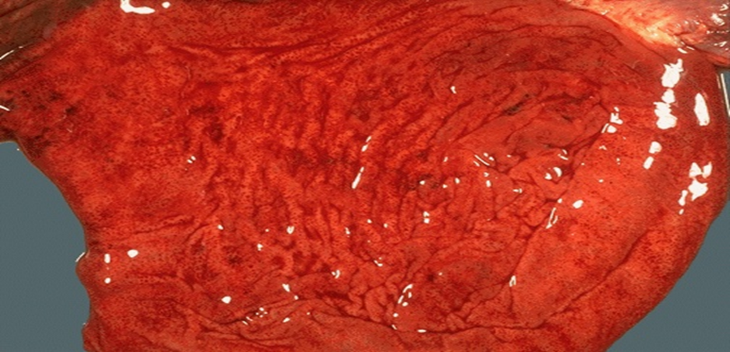
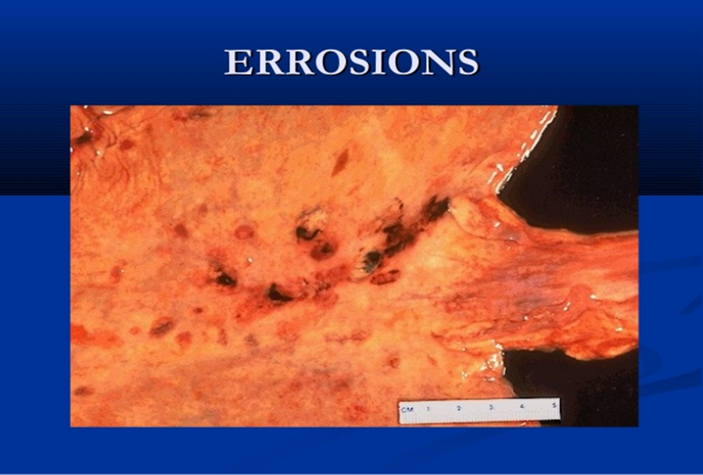

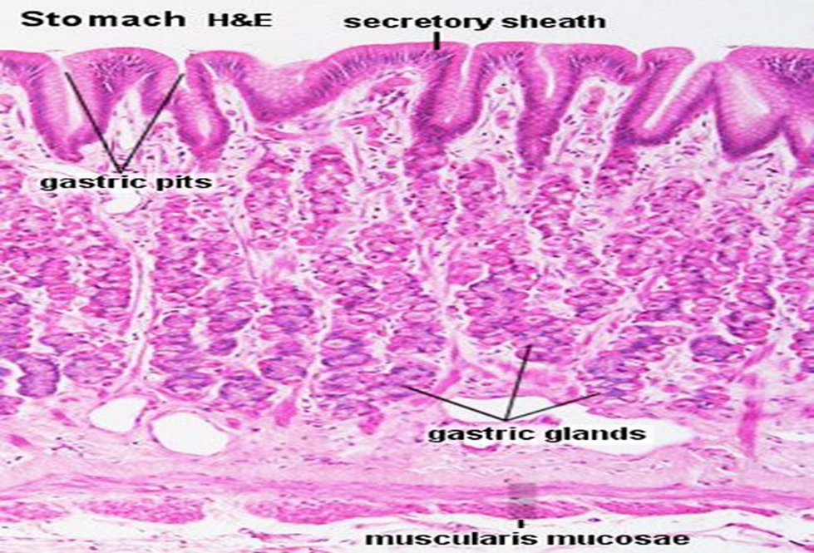
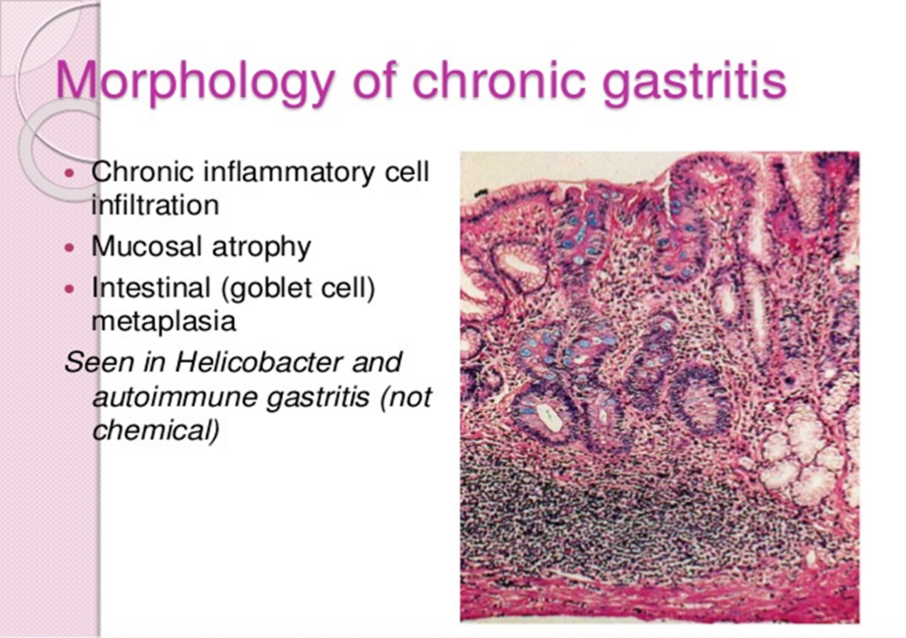

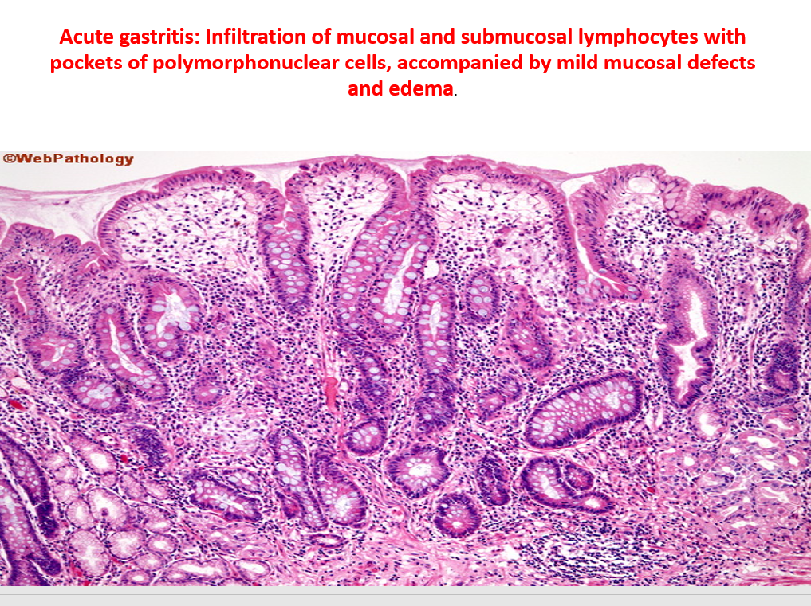
Peptic ulcers (stomach ulcer)
is a break in the inner lining of the stomach, the areas of degeneration and necrosis of gastrointestinal mucosa exposed to acid-peptic secretions. An ulcer in the stomach is called a gastric ulcer
