chemical reaction: a process in which one or more substances, the reactants, are converted to one or more different substances, the products. Substances are either chemical elements or compounds. A chemical reaction rearranges the constituent atoms of the reactants to create different substances as products.
We know that chemical reaction is occurs from:
1- Change in color
2- Production of light
3- Formation of a solid (such as a precipitate in solution, smoke in air, or a metal coating)
4- Formation of a gas (bubbles in solution or fumes in the gaseous state )
5- Absorption or release of heat (sometimes appearing as a flame)
Types of Chemical Reactions
A) Synthesis Reactions: Synthesis reactions are reactions that occur when two different atoms or molecules interact to form a different molecule or compound.
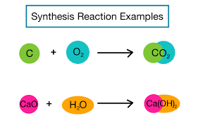
1- Most of the time needed.
2- energy is released
3- the reaction is exothermic. However, an endothermic outcome is also possible.
Impossible Synthesis Reactions:
1-Two metals cannot react to form a compound.
2-The noble gases He, Ne, and Ar never form compounds
B) Decomposition reaction is a reaction in which a compound breaks down into two or more simpler substances. The general form of a decomposition reaction is:
AB→A+B
2HgO(s) →2Hg(l) + O2(g)
In such reaction, the compounds decomposed into:
a-Its component elements
b-into simpler compounds
c- Into an element and simpler compound.
C) A Single Displacement Reaction: also known as a single-replacement reaction, is a type of chemical reaction where an element reacts with a compound. The element displaces one of the elements in the compound to react with the other.
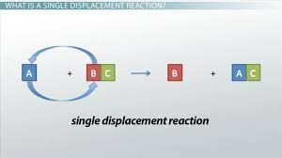
3AgNO₃ (aq) + Al(s) Al (NO₃)₃(aq) + 3Ag (s)
D) Double Displacement Reactions: is a reaction in which the positive and negative ions of two ionic compounds exchange places to form two new compounds. The general form of a double-replacement (also called double-displacement) reaction is:
AB + CD →AD + CB
2KI(aq) + Pb(NO3)2(aq) → 2KNO3(aq) + PbI2(s)

There are two types of double displacement reactions:
1-Precipitation reactions: a reaction will only occur if either compound AD or compound CB is not very soluble in water. If both AD and CB are soluble in water, then no reaction will occur.
2- Acid-base neutralization reactions: A neutralization reaction is a double - displacement reaction of an acid and a base.
E) Combustion Reactions: chemical reactions that are occur between substances such as hydrocarbons and oxygen gas and usually accompanied by the generation of heat and light in the form of flame.
C3H8 (g) + 5O2 (g) 3CO2 (g) + 4H2O (l)

