المحاضره السادسه/ ثاني أجهزه طبيه/ التشريح و الفسلجه / أ . د. خيري عبدالله العكيلي Lecture 6
الجهاز القلبي الوعائي Cardiovascular System
Heart : General characterizations :
1 – The heart is a complex organ that pumps blood through the body by blood vessels , blood reach to all organs except cartilage , eye lens , brain and skin (epidermis ) .
2 – Heart have four chambers( two atria and two ventricles ) , valves .
3 – It has own circulation system by coronary artery .
4 – It receives electric impulse that make it contract and relax , forming the cardiac cycle .
5 – Heart is enclosed in a sac called pericardium .
6 – Layers of heart wall ( Epicardium , myocardium , endocardium ) .

Movement of blood in the heart :

1 – The right atrium (RA) receive deoxygenated blood from the head , neck and other part of the body via superior and inferior vena cava .
2 – Blood pass from right atrium to the right ventricle via tricuspid valve .
3 – Right ventricle then pumps blood to the lungs through the pulmonary artery .
4 – The oxygenated blood is returned to the left atrium (LA) via the pulmonary veins .
5 – The blood pass from LA to the left ventricle (LV) through mitral valve ( bicuspid valve ) .
6 – Heart pumps blood from LV to the whole body through Aorta .

Cardiac Valves :
1 – Mitral valve ( bicuspid ) located between left atrium and left ventricle .
2 – Tricuspid valve located between right atrium and right ventricle .
3 – Pulmonary valve located between right ventricle and pulmonary artery .
4 - Aortic valve located between left ventricle and aorta .

Functions of heart valves :
1 - When the heart muscle contract and relax the valves are opened and shut letting blood flow pass .
2 – When the valves are shut prevent blood flow backwards .
Cardiac Muscle :
1 – Cardiac Muscle , involuntary muscle .
2 – Striated 3 - Cardiac muscle fibers are branched .
4 – Cardiac muscle cells have intercalated disc .

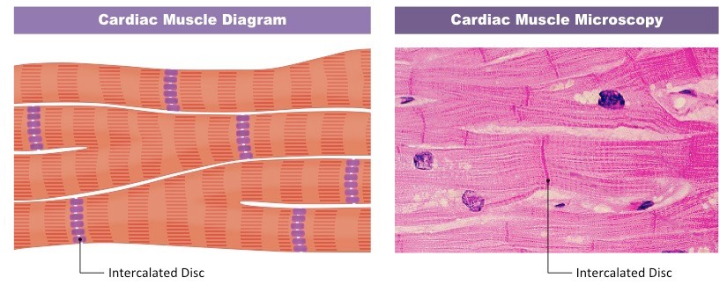

Conducting System and Heart Rhythm
Cardiac muscle involuntary muscle has ability to the contraction of the muscle cells .
1 – In the heart electrical changes needed to generate a cardiac impulse which starts with a specialized area of (Sinoatrial node SAN ) situated in the right atrium ) .
2 – SAN is a natural pacemakers , when working properly initiate impulses and stimulate cardiac contraction .
3 – The cardiac impulse passes from the SAN into atria which start to contract and transmitted to another specialized cells the atrioventricular node AVN .
4 – AVN is situated in the inter-atrial septum ( between RA and LA ) provided a pathway of conduction between atria and ventricles .
5 – The impulse then travels down into a large bundle of specialized tissue (bundle of His ) which conducts it down the ventricles .
6 – Bundle of His spilt into the right and left bundles in the interventricular septum .
7 - Purkinje fibers are a continuation to bundle of His , start before looping upwards and travelling in the lateral aspects of the RV and LV .

ECG (electrocardiogram ) : It is special technique used to know normal and abnormal heart rate ( rhythm or arrhythmias ) , using electrodes placed on the skin .
Tachycardia ; Fast heart beat Bradycardia : slow heart beat
Chest pain due to Angina pectoris
Atrial fibrillation .

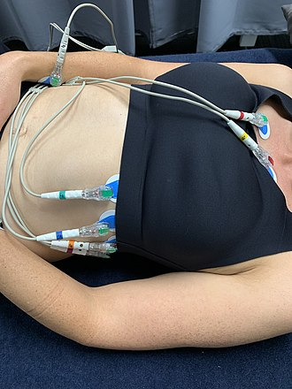
Electrodes of ECG technique to know heart rate ?
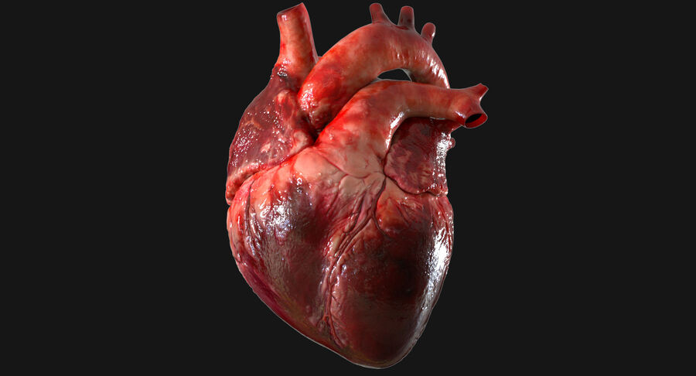
Heart of human / blood vessels left vena cava , middle aorta , right pulmonary artery .

Coronary thrombosis ( blood clot ) inside blood vessels .
Infarction of heart : Blood flow decreases or stop cause necrosis in heart muscle .
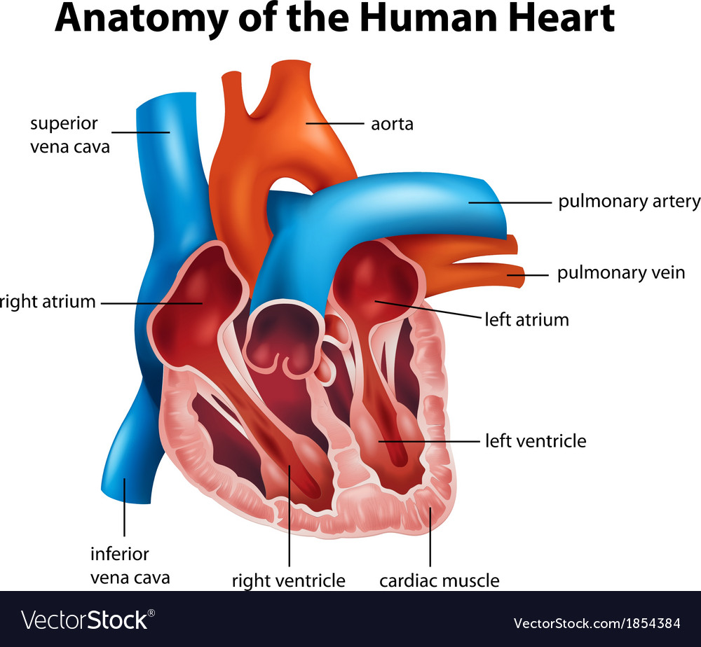Last picture : Conducting system / Electricity of heart 