AL-Mustaqbal University College
Radiology Techniques Department
First Class
computer applications
second lecture (computing Fundamentals/files& folders)
Lecturer: M.Sc. Ban kadhim

files and folders:
A file is an element that contains information such as text, images, or audio, such as a Word file or an Excel file, and it is part of a computer's software entity

- Each file has a nameEach file has a file name and a three-character extension in most files, for example
- DocWord files (version 2003) and docx files, Word files to later versions
- Eml Email file.

Folder:

It is a container that you can use to store hundreds of files inside
Other folders are stored within folders, and folders cannot be stored within a file

Create folder:
to create a new folder anywhere, do the following:
Open the location where you want to create the folder by double clicking with the left mouse button.
Right-click on any empty place in the place where we want to create the folder.
A menu appears, from which we choose New
A submenu appears from which we select Folder

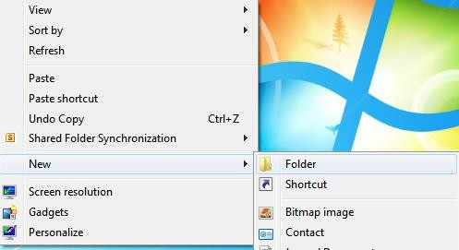

A new folder is created and has the default name Folder New and is waiting for you to change it if you want to
By typing the new name on the keyboard, then click the left mouse button once on any empty place
or click enter key
change folder name:
To change the name of a folder, right-click on the folder whose name you want to change. A list appears, from which we can choose
Rename The folder name will be shaded and then you can type the new name you want

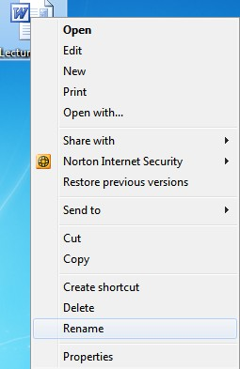

Create nested folders: You can create nested folders or what is called a tree
By following these steps:
-We create the main folder, which is called the root of the tree in one of the main storage places, such as:
Desktop, Document My or in one of the main storage areas within My Computer
-We open the window of the root folder (Root) that we created and create a new folder inside it
Follow the same steps to create a folder.
-We open the new folder and create another new folder inside it, following the same steps as creating a folder

Delete folders:
There are two types of deletion:
- Indefinite deletion: that is, it is transferred to the trash (meaning it command.
2. A confirmation message for deletion appears with two options: Yes: by clicking on it, it deletes the folder to the trash,
And the second option No: by clicking on it, the deletion process is undone
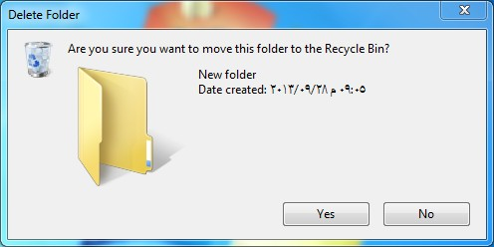

Permanent deletion: that is, it is not transferred to the trash (i.e., it is deleted from the calculator) and is done as follows:
1. Highlight the file or folder you want to delete by clicking the left mouse button once.
2. Using the keyboard, press the Delete + Shift keys. A confirmation message for deletion appears as
in infinite deletion

Recycle Bin:
- To deal with the Recycle Bin, you must follow the following steps:-
1. Open the Recycle Bin window (following one of the window opening methods).
2. It will show us all the files that were previously deleted

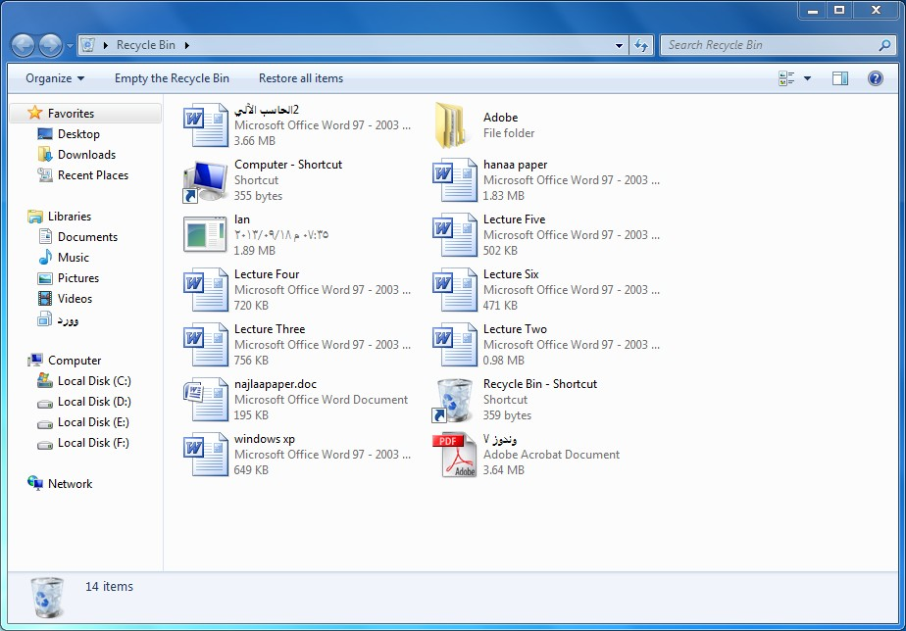

restore deleted files
To return the deleted file or folder to its previous location, do the following:
1. Select the desired file or folder.
2. We click with the right mouse button.
3. We choose Restore

Permanently delete deleted files
To delete a file or folder
Finally, from the calculator, we follow the following:-
1. Select the desired file or folder.
2. We right-click.
3. We choose Delet

To delete all files and folders in the Recycle Bin, choose Empty Recycle Bin
Bin Recycle (from the toolbar or from the "organize" menu)
Restore: means returning the file or folder to its original storage location.
Delete: permanently deleting the file or folder

Selecting Files & Folders

To select one file, folder or sub-folder:
In the Computer window, click the file, folder or sub-folder to select. The selected file will be highlighted.

To select several files, folders or sub-folders adjacent to each other:
- In the Computer window, click the first file, folder or sub-folder in the block.
- Press and hold the SHIFT key.
- Click on the last file, folder or sub-folder of the contiguous block to select.
- 4-Release the SHIFT key

The block of files, folders or sub-folders will be selected.

To select several files, folders or sub-folders that are non-adjacent to each other:
- In the Computer window, click the first file, folder or sub-folder to select.
- Press and hold the CTRL key.
- Click on the other files to select.
- Release the CTRL key.

Sorting Files

To view the details of files:
- In the Computer window, click the arrow next to the Change your view button. A pop-up menu will be displayed.
- Click Details.

Copying Files & Folders

To copy files, folders between folders and between drives:
- In the Computer window, select the file/s, folder/s or sub-folder/s to copy using one of the methods indicated in the previous section.
- Right-click the selected file/s, folder/s or sub-folder/s. A short-cut menu will be displayed.
- Click Copy.
- Right-click the folder or disk drive where you want to copy the file/s, folder/s or sub-folder/s. A short-cut menu will be displayed.
- Click Paste.

Note that:
- You can press the shortcut key combinations:
CTRL + C instead of step 3.
CTRL + V instead of step 5.

Moving Files & Folders

To move files, folders between folders and between drives:
- In the Computer window, select the file/s, folder/s or sub-folder/s to move.
- Right-click the selected file/s, folder/s or sub-folder/s. A short-cut menu will be displayed.
- Click Cut.
- Right-click the folder or disk drive where you want to move the file/s, folder/s or sub-folder/s. A short-cut menu will be displayed.
- Click Paste.

Note that:
- You can press the shortcut key combination: CTRL + X instead of step 3.

Deleting Files & Folders

Files, folders or sub-folders which you delete from the hard-disk are placed in the Recycle Bin or wastebasket. To delete files, folders or sub-folders:

- In the Computer window, highlight the file/s, folder/s or sub-folder/s to delete.
- Press Delete key. The Delete File dialog box is displayed prompting you to confirm if you wish to delete the selected file, folder or sub-folder.
Click Yes button. The Recycle Bin icon changes from empty to full

Restoring Deleted Files & Folders

Items in the Recycle Bin remain there until you decide to permanently delete them from your computer. These items still take up hard disk space and can be undeleted or restored back to their original location. When it fills up, MS Windows automatically cleans out enough space in the Recycle Bin to accommodate the most recently deleted files and folders.

To restore a file or folder:
- In the MS Windows desktop, double-click the Recycle Bin. The Recycle Bin window is displayed.
- Right-click the file or folder to restore. A shortcut menu will be displayed.
- Click Restore.

Compressing Files

File compression is the process of reducing the size of a data file to the smallest size possible. Compressed files take up less storage space and can be transferred to other computers more quickly than uncompressed files. You can work with compressed files and folders in the same way that you work with uncompressed files and folders. You can also combine several files into a single compressed folder. This makes it easier to share a group of files.

Typically compressed files are organised in a folder ending with the extension .ZIP (MS Windows) or .SIT, or .HQX (Macintosh). A folder containing compressed files is also known as an archive folder.

To compress files in a folder on a drive:
- Locate the file or folder that you want to compress.
- Right-click the file or folder. A short-cut menu will be displayed.
- Point to Send to.
- Click Compressed (zipped) folder. A new compressed folder is created in the same location.

To rename it, right-click the folder, click Rename, and then type the new name.

Extracting Compressed Files

To extract compressed files from a location on a drive:
- Locate the compressed folder that you want to extract files or folders from.
- Do one of the following:
To extract a single file or folder, double-click the compressed folder to open it. Then, drag the file or folder from the compressed folder to a new location.
To extract the entire contents of the compressed folder, right-click the folder, click Extract All, and then follow the instructions.

Thank you for listening

