AL-Mustaqbal University College
Radiology Techniques Department
First Class
computer applications
First lecture (computing Fundamentals)
Lecturer: M.Sc. Ban kadhim

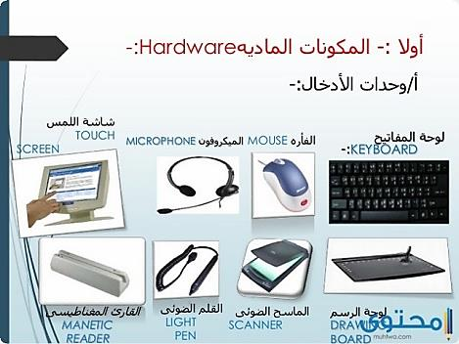

What are the components of a computer?
The computer is divided into two main parts, the software part and the physical part. The software part cannot be separated from the physical part of the computer. The software part needs electronic parts to function, and the physical part also needs an operating system or code in order to function and perform its functions and role in the processing or storage process
The software parts: are the parts that cannot be touched in the computer, and the software parts are the main part that determines the nature of the work and use of the computer, and the most famous operating systems are Microsoft Windows operating system, the Mac system, and the Linux system, and the software parts are divided into two parts

Operating system The operating system is defined as the main program responsible for running all other programs and applications on the computer, that is, it is responsible for running audio programs, editing text, the Internet, and other programs. The computer, meaning that the operating system is a graphical interface that acts as an intermediary between the user and the computer
Programs and applications or the so-called end-user programs, through which the user can conduct research, write documents, create charts, design, play various games, and many other tasks that the user may perform, and these programs are divided into two types depending on their purpose, Some are as simple as a calculator and some are as complex as a word processing program
Physical Parts The physical part of the computer is all the computer components that can be touched that perform a specific role and specific functions, and the physical parts of the computer consist of
Output units Among the most important output units that communicate with the computer are the following: Computer box: The computer case is one of the external parts of the computer (Computer Case), and it has other names such as the system unit, and the computer case has multiple functions, including: Containing and installing the internal computer parts inside the computer. Protect the internal parts of the computer from weather and liquids, while not being able to tamper with it. Keep the internal parts of the computer cool so that they do not overheat and malfunction. Reduce the noise of fans
Monitor: Monitor is classified as an output device. It is responsible for displaying information generated by a computer in the form of a video or image. The monitor is similar to television, but is distinguished from television by displaying information in high accuracy. Monitors are classified into three types: (CRT, LCD, OLED)
Printer: Printer is defined as a device for outputting information in the form of texts and graphics printed on paper, and printers differ from each other in several respects such as size, speed, sophistication, and cost. The Dot-Matrix printer is one of the most famous printers. It is characterized by its low cost, and the printers have other types, such as: the inkjet printer, and the laser printer
The input units of the most important input units that communicate with the computer are as follows: Keyboard: The keyboard is classified as input devices, and is used to enter text and numeric information into the computer. Using shortcuts on the keyboard
Mouse: It is a peripheral device used to send instructions from the user to the computer by moving the mouse pointer that deals with windows, files, and programs, and the mouse often contains two left and right buttons, and the mouse is used only in devices that contain the (GUI).
Scanner: (Scanner); It converts the information on paper into digital information by taking it as an image, where it is stored in the computer, and modified using specialized programs. The process of converting data using a scanner is also characterized by being less expensive, more quality and reliable in transferring images
Motherboard The motherboard is the main board in the computer, and it has other names such as: the system board, the main board, and its main function is to provide a connection between the central processing unit and random access memory, and between the rest of the other computer parts, and the motherboard has several types; Each type works with specific types of processors and memory modules
Central Processing Unit The Central Processing Unit is the brain of a computer, as it is the part responsible for interpreting and executing most of the commands issued by programs and devices connected to a computer. It is used in all modern electronic devices.
Power supply The power supply is also called the power supply unit (PSU), and the power supply has multiple functions, including the following: It provides power to the computer. It draws the right amount of electrical current and converts alternating current to direct current. Regulates voltage to eliminate surges from electrical systems. Power supplies are rated based on the number of watts they generate, the more power a computer has, the more watts it can deliver
Hard drives Hard drives are classified as the largest part of the internal parts of a computer, as they store data, such as: the operating system, most files, and some computers contain several letters for drives, such as: (C, D, E) The partitions that represent drives, usually the operating system on the primary hard drive
Random Access Memory Random access memory is defined as the temporary storage unit in a computer, where the information stored in it is lost as soon as the computer is closed, and this memory is installed on the motherboard, and one or more slices can be installed on the motherboard, There are two types of random access memory: dynamic random access memory (DRAM) and static random access memory (SRAM). It is common to use DRAM in personal computers; Because it is less expensive than SRAM, and the information on DRAM needs to be constantly updated while storing it
Optical disk drives (ODD; Optical Disc Drives) use laser radiation transmission technology, and this technology is used to read and write data from optical disks, where the ability to retrieve, modify and delete data, and examples of optical disks are the following: (CD, dvd, Blu-ray)

Computing Fundamentals:

Input | Processing | Output | Storage
You go to a grocery store and the store clerk scans an item’s barcode. | A computer processes the barcode.  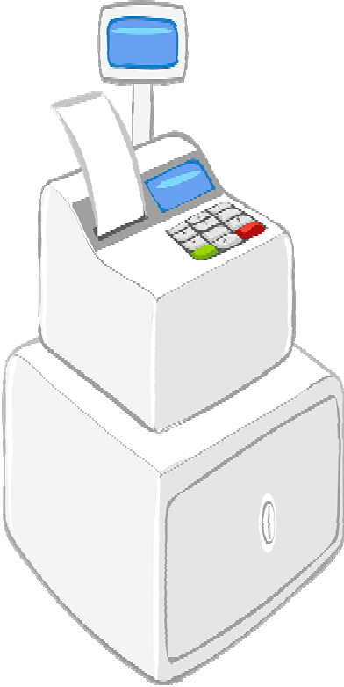 | The computer outputs the price and description of the item.  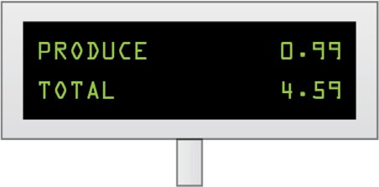 | Transaction information is stored on the computer for inventory purposes.  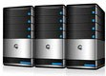

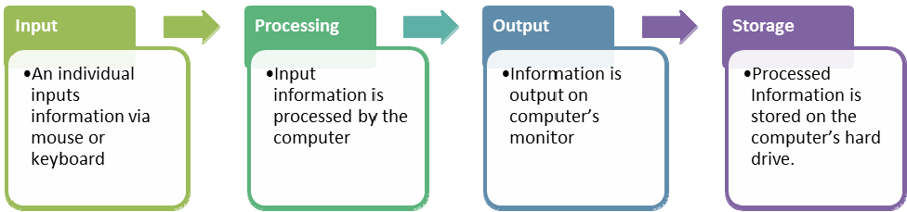

Types of Computers:

Example Image | Type of Computer | Purpose
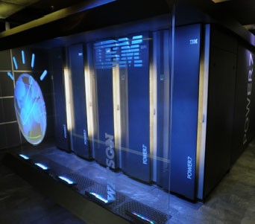 | Supercomputer | Supercomputers are high performing, extremely fast and often cost millions of dollars. They are often used more for calculations and problem solving.
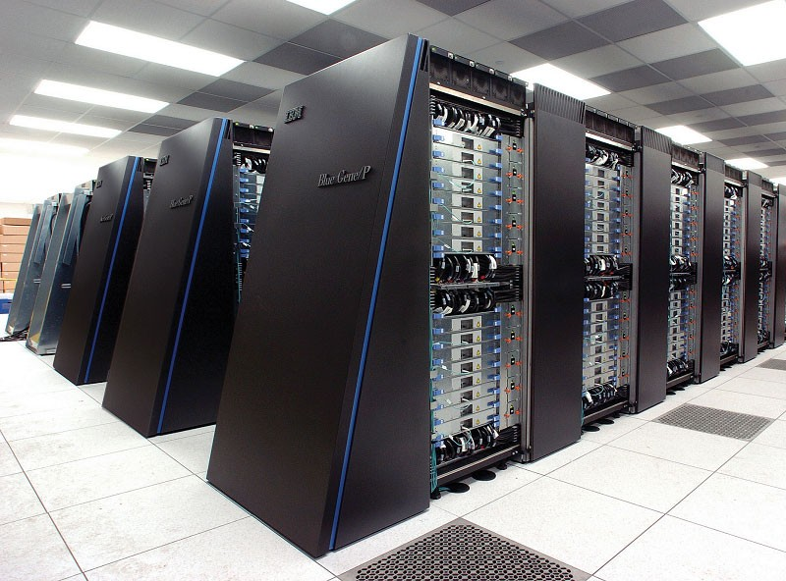 | Mainframe | Mainframe computers are like supercomputers in that they are high-performance very fast computers. They are often used for high volume and intense processing such as credit card transactions and scientific research. One of the biggest differences between a mainframe and a supercomputer is their hardware and the types of tasks they perform. Many mainframes cost hundreds of thousands of dollars.
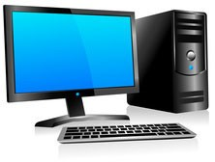 | Microcomputers | Personal computers (PC) are microcomputers, designed for personal and home use. Sometimes these computers are known as "desktop computers" but they can also be referred to as a server, microcomputer or laptop. Most of these computers use a keyboard, mouse, monitor and of course the system unit itself.

computer Systems:
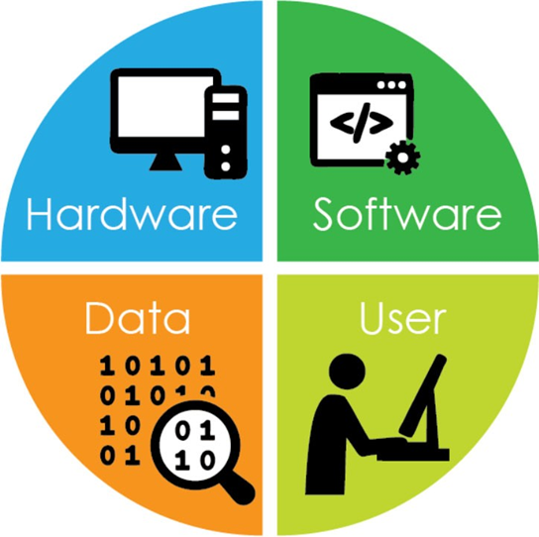

input devices and their functions
Example Image | Input Device | Purpose
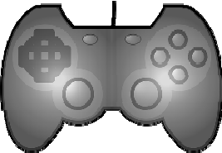 | Gamepad or game controller | Enables user to control movements on the screen when playing video games
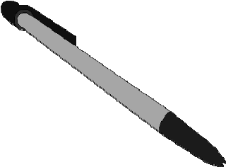 | Stylus | A digital pen that enables users to write directly on a touch screen
Example Image | Input Device | Purpose
 | Barcode reader | Enables user to scan and read information from printed barcodes
 | Fingerprint scanner | Enables user to verify a person's identity by copying, saving and matching digital images of a fingerprint  Used to prevent unauthorized access to a computer or device
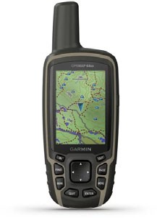 | GPS device | Determines the global position (that is, the location) of the device  Used to monitor location of device and/or its user

Output Devices:

Example Image | Output Device | Purpose
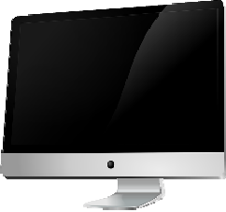 | Monitor | Displays the text or graphics processed by the computer
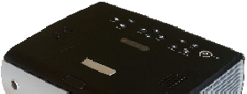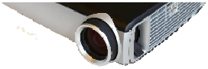 | Projector | Displays text or graphics processed by the computer by projecting content onto a large screen or wall
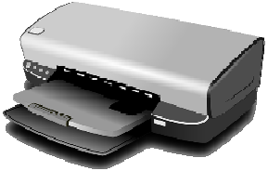 | Printer | Places digital content (such as text or images) on paper by printing it with ink, producing a "hard copy"
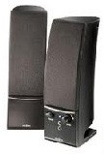 | Speakers | Plays audio files processed by a computer

