Lecture 1 Human biology

The word biology means, "the science of life", from the Greek bios, life, and logos, word or knowledge. Therefore, Biology is the science of Living Things. That is why Biology is sometimes known as Life Science.
One of the main ideas in biology is that living things depend on each other.
They are part of what is called the balance of nature.
All living things interact with other living things and with the world they live in. Without these relationships, nothing would survive.
Humans need plants and animals to supply us with food and raw materials, such as wood, oil, and cotton. Plants provide the oxygen in our air.

Characteristics of Living Things
Sometimes it is difficult to tell the difference between living and nonliving things. At times, nonliving things have one or more of the characteristics of life, but it is necessary to have all of the characteristics of life to be considered living.
Things that have all of the characteristics of life are known as organisms.

What are the characteristics of life?

One of the first things biologists look for when they are searching for characteristics of life is structure, or organization.
Whether an organism is made of a single cell or billions of cells, all of its parts work together in an orderly living system.
Another important characteristic of life is reproduction. Reproduction is the ability of an organism to make more of the same type of organism.
The new organisms that are made are called offspring. Although reproduction is not needed for the survival of an individual organism, it must occur for the continuation of the organism’s species.
A species consists of a group of organisms that can mate with each other and produce offspring that are able to reproduce. For example, there are many species of crocodiles including the American crocodile, the Australian freshwater crocodile, and the saltwater crocodile.
American crocodiles reproduce only American crocodiles. Without reproduction, the species would die out.
Another characteristic of life is that growth and development must take place. An organism begins life as a single cell. As time passes, it grows and develops. As growth and development take place, the organism takes on the characteristics of its species.
Growth results in the formation of new structures and an increase in the amount of living material.
Development refers to the changes that occur in each organism’s life.
One more characteristic of life is the ability to adjust to surroundings, or the environment.
Anything in the environment air, water, temperature, weather, other organisms that causes the organism to react is called a stimulus.
The organism’s reaction to the stimulus is called a response.
An organism also has the ability to control its internal environment in order to maintain conditions suitable for survival.
For example, an organism must make constant adjustments to maintain the right amount of water and minerals in its cells. This ability is called homeostasis.
How do organisms respond to change?
Organisms use energy to grow, develop, respond to stimuli, and maintain homeostasis. Energy is the ability to cause change., Organisms get their energy from food.
Any behavior, structure, or internal process that allows an organism to make changes in response to environmental factors and live long enough to reproduce is called an adaptation.
For example, the leaves of many desert plants have a thick, waxy coating. This is an adaptation that helps these plants conserve water. Having large eyes is an adaptation that lets owls see well at night. The gradual change in a species over time due to adaptations
is called evolution.

How is the environment organized?
The nonliving parts of the environment are called abiotic factors. Some examples are temperature, moisture, light, and soil. Ecology includes the study of abiotic factors because they are part of an organism’s life.
Living things also are affected by biotic factors. Biotic factors are all the living organisms in an environment. All organisms depend on others directly or indirectly for food, shelter, reproduction, or protection.

Levels of Organization

The levels are the organism, by itself, populations, communities, and ecosystems.

A population is a group of organisms that belongs to the same species. Population members breed with each other and live in the same area at the same time. 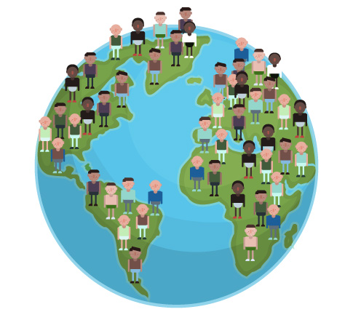

A biological community is made up of different populations in a certain area at a certain time. No species lives entirely alone. Every population shares its environment with other populations. This creates what is called a biological community.
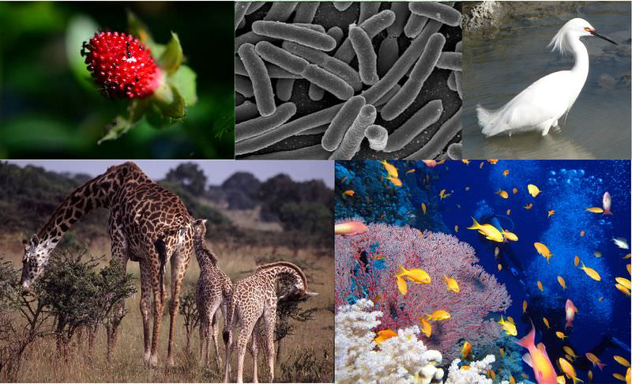
The relationships between different populations and their surroundings create an ecosystem. An ecosystem is made of all of the different populations in a biological community and the community’s abiotic factors. 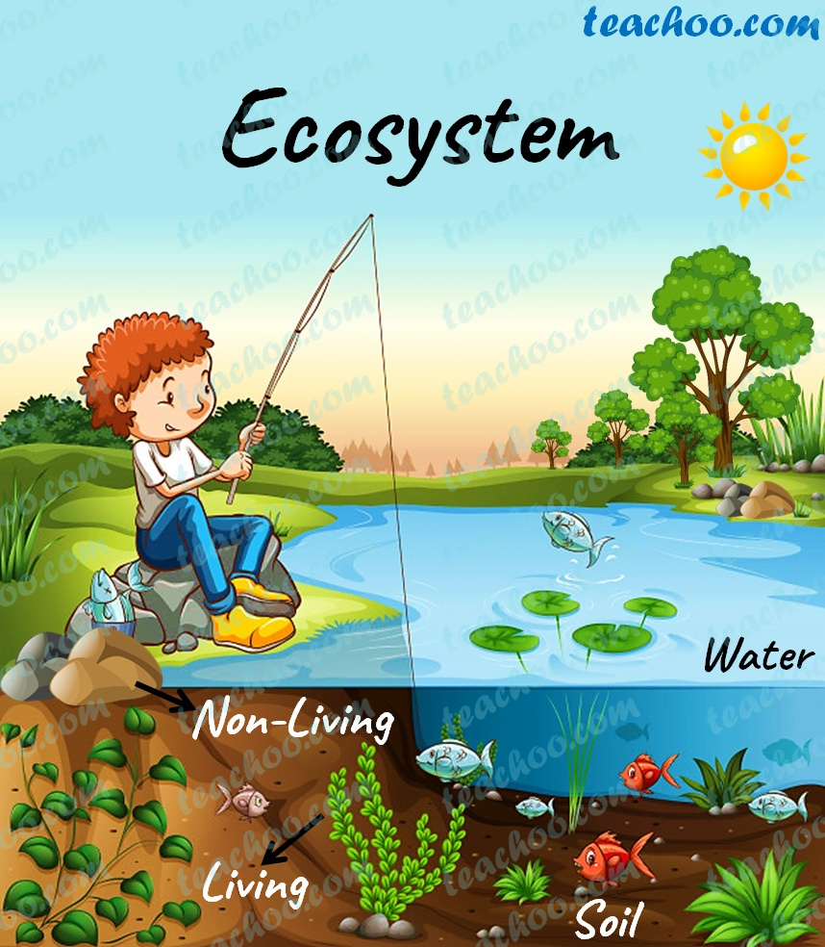

kinds of ecosystems

There are two major kinds of ecosystems terrestrial and aquatic.
Terrestrial ecosystems are those located on land. Examples include forests, fields, and a rotting log.
Aquatic ecosystems are found in both freshwater and salt water. Freshwater ecosystems include ponds, lakes, and streams. Oceans are a type of saltwater, or marine, ecosystem.

Organisms and Their Environment: -
Symbiosis
A relationship in which there is a close and permanent association between organisms of different species is called symbiosis, Symbiosis means living together. There are three major kinds of symbiosis, mutualism, commensalism and parasitism.

Mutualism is a relationship between two species that live together in which both species benefit. The relationship between ants and an acacia tree is a good example of mutualism. The ants protect the tree by attacking any animal that tries to feed on the tree. The tree provides nectar as a food for the ants. The tree also provides a home for the ants. In an experiment, ecologists removed the ants from some acacia trees. Results showed that the trees with ants grew faster and lived longer than the trees with no ants.

Commensalism is a relationship in which only one species benefit and the other species is not harmed or helped. For example, mosses sometimes grow on the branches of trees. This does not help or hurt the trees, but the mosses get a good habitat.

Parasitism is a relationship in which a member of one species benefit at the expense of another species. For instance, when a tick lives on a dog, it is good for the tick but bad for the dog.
The tick gets food and a home, but the dog could get sick. The tick is a parasite. A parasite is the organism that benefits from the relationship. The dog is a host. The host is the organism that is harmed by the relationship.
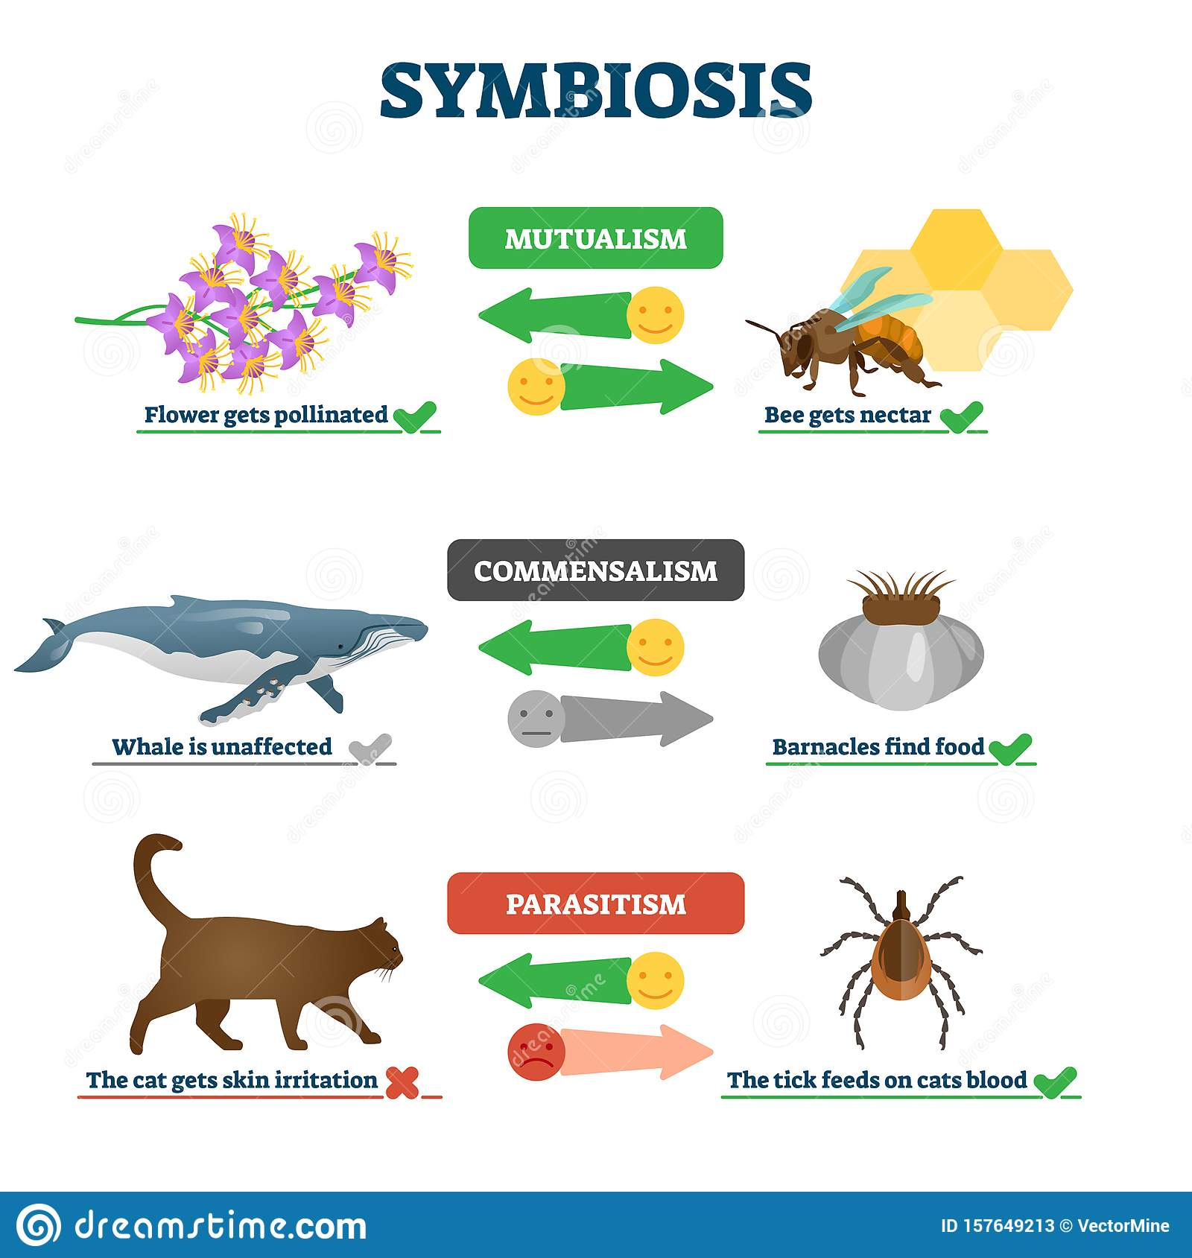
How Organisms Obtain Energy
One of the most important things about a species is how the species gets its energy.
The ultimate source of energy for all life is the sun, Plants use the sun’s energy to make food. This process is called photosynthesis This makes plants autotrophs.

Autotrophs or producers, are organisms that use light energy or energy stored in chemical compounds to make energy-rich compounds.
Grass, trees, and other plants are the most familiar autotrophs, but someone celled organisms, such as green algae, also make their own food.
Some organisms cannot make their own food. They must eat other organisms to get their food and energy. These organisms are called consumers, or heterotrophs Some heterotrophs, such as rabbits, feed only on autotrophs.
Other heterotrophs, such as lions, feed only on other heterotrophs. Still other heterotrophs, such as bears and humans, feed on both autotrophs and heterotrophs.

There are other organisms called decomposers. They break down the complex compounds of dead and decaying plants and animals. They change these compounds into simpler forms that they can use for fuel. Some protozoans, many bacteria and most fungi are decomposers.

Flow of Matter and Energy in Ecosystems

When you eat food, such as an apple, you consume matter. Matter, in the form of carbon, nitrogen, and other elements, flows through the levels of an ecosystem from producers to consumers. Scientists call this flow of matter cycling.
The apple is more than matter, though. It also contains some energy from sunlight.
This energy was trapped in the apple as a result of photosynthesis. As you cycle the matter in the apple by eating it, some trapped energy is transferred from one level of the ecosystem to the next.
At each level, a certain amount of energy is also transferred to the environment as heat.





