Lecture 2 cell structure and function
Eukaryotic cells
Eukaryotic cells have a nucleus, a large structure that controls the workings of the cell because it contains the genes.

Outer Boundaries of Animal and Plant Cells
All cells, including plant and animal cells, are surrounded by a plasma membrane, a phospholipid bilayer in which protein molecules are embedded.
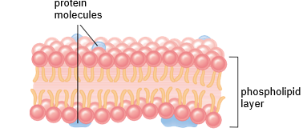
The plasma membrane is a living boundary that separates the contents of the cell from the surrounding environment.
Inside the cell, the nucleus is surrounded by the cytoplasm, a semifluid medium that contains organelles. The plasma membrane regulates the entrance and exit of molecules into and out of the cytoplasm.
Plant cells (but not animal cells) have a permeable but protective cell wall in addition to a plasma membrane. Many plant cells have both a primary and secondary cell wall. A main constituent of a primary cell wall is cellulose molecules. Cellulose molecules form fibrils that lie at right angles to one another for added strength. A cell wall sometimes forms inside the primary cell wall. Secondary cell walls contain lignin, a substance that makes them even stronger than primary cell walls.
organelles of Animal and plant cells
The nucleus
The nucleus, which has a diameter of about 5 mm, is a prominent structure in the eukaryotic cell. The nucleus is of primary importance because it stores genetic information that determines the characteristics of the body’s cells and their metabolic functioning.
Every cell contains a complex copy of genetic information, but each cell type has certain genes, or segments of DNA, turned on, and others turned off. Activated DNA, with RNA acting as an intermediary, specifies the sequence of amino acids during protein synthesis. The proteins of a cell determine its structure and the functions it can perform.
In the nucleus Chromatin looks grainy, but actually it is a threadlike material that undergoes coiling into rodlike structures called chromosomes, just before the cell divides. Chemical analysis shows that chromatin, and therefore chromosomes, contains DNA and much protein, and some RNA. Chromatin is immersed in a semifluid medium called the nucleoplasm,
a difference in pH between the nucleoplasm and cytoplasm.
when you look at an electron micrograph of a nucleus, you will see one or more regions that look darker than the rest of the chromatin.
These are nucleoli (sing., nucleolus) where another type of RNA, called ribosomal RNA (rRNA), is produced and where rRNA joins with proteins to form the subunits of ribosomes. (Ribosomes are small bodies in the cytoplasm that contain rRNA and proteins.).
The nucleus is separated from the cytoplasm by a double membrane known as the nuclear envelope which is continues with the endoplasmic reticulum discussed on the next page. The nuclear envelope has nuclear pores of sufficient size (100 nm) to permit the passage of proteins into the nucleus and ribosomal subunits out of the nucleus.

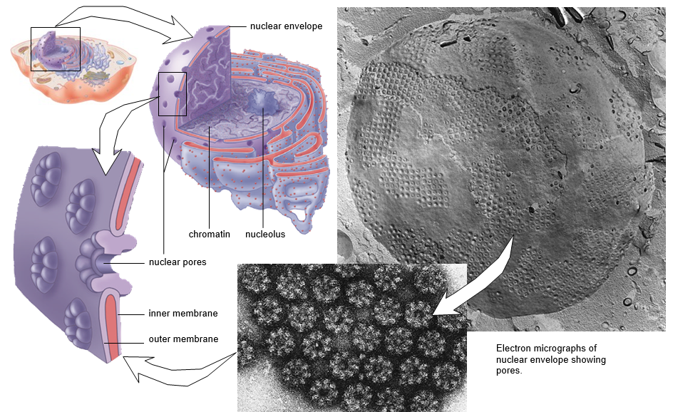
Ribosomes
Ribosomes are composed of two subunits, one large and one small. Each subunit has its own mix of proteins and rRNA. Protein synthesis occurs on the ribosomes. Ribosomes occur free within the cytoplasm either singly or in groups called polyribosomes.
Ribosomes are often attached to the endoplasmic reticulum, a membranous system of saccules and channels. Proteins synthesized by cytoplasmic ribosomes are used in the cell, such as in the mitochondria and chloroplasts. Those produced by ribosomes attached to endoplasmic reticulum may eventually be secreted from the cell.
**Ribosomes are small organelles where protein synthesis occurs. Ribosomes occur in the cytoplasm, both singly and in groups (polyribosomes).
Numerous ribosomes are attached to the endoplasmic reticulum.
The endomembrane system
The endomembrane system consists of the nuclear envelope, the endoplasmic reticulum, the Golgi apparatus, and several vesicles (tiny membranous sacs).
The endoplasmic reticulum (ER), a complicated system of membranous channels and saccules (flattened vesicles), is physically continuous with the outer membrane of the nuclear envelope.
Rough ER is studded with ribosomes on the side of the membrane that faces the cytoplasm. Here proteins are synthesized and enter the ER interior where processing and modification begin.
Smooth ER, which is continuous with rough ER, does not have attached ribosomes. Smooth ER synthesizes the phospholipids that occur in membranes and has various other functions depending on the particular cell. In the testes, it produces testosterone, and in the liver, it helps detoxify drugs. Regard- less of any specialized function, smooth ER also forms vesicles in which large molecules are transported to other parts of the cell. Often these vesicles are on their way to the plasma membrane or the Golgi apparatus.
**ER is involved in protein synthesis (rough ER) and various other processes such as lipid synthesis (smooth ER). Molecules that are produced or modified in the ER are eventually enclosed in vesicles that often transport them to the Golgi apparatus.

The endoplasmic reticulum (ER).
- Rough ER has attached ribosomes but smooth ER does not.
- Rough ER appears to be flattened saccules, while smooth ER is a network of interconnected tubules.
- A protein made on a ribosome moves into the lumen of the system and eventually is packaged in a transport vesicle for distribution inside the cell.

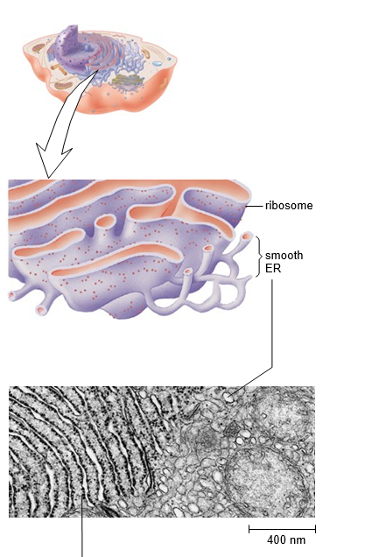

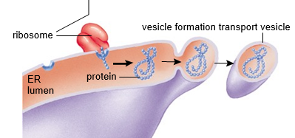
The Golgi apparatus
The Golgi apparatus consists of a stack of three to twenty slightly curved saccules whose appearance can be compared to a stack of pancakes.
**The Golgi apparatus contains enzymes that modify proteins and lipids. For example, it can add a chain of sugars to proteins, thereby making them glycoproteins and glycolipids, which are molecules found in the plasma membrane.
**The vesicles that leave the Golgi apparatus move to different locations in the cell. Some vesicles proceed to the plasma membrane, where they discharge their contents. Because this is secretion, it is often said that the Golgi apparatus is involved in processing, packaging, and secretion. Other vesicles that leave the Golgi apparatus are lysosomes.

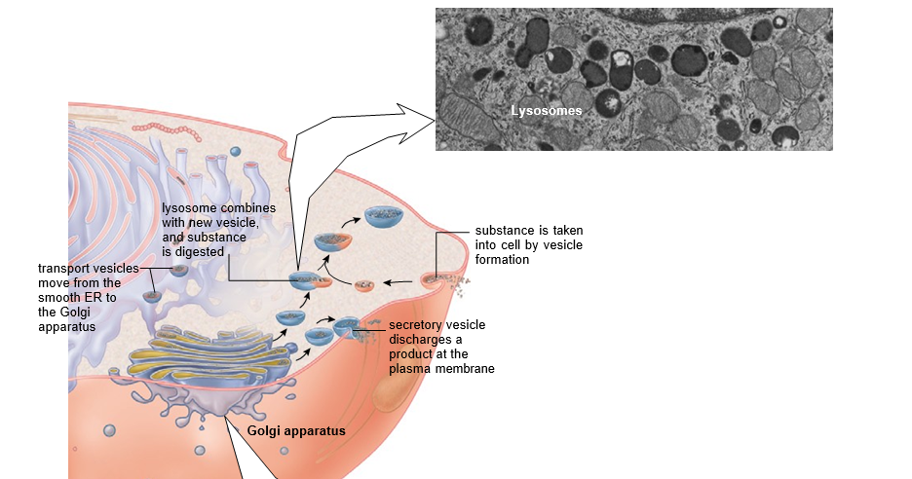

Lysosomes
Lysosomes are membrane-bounded vesicles produced by the Golgi apparatus in animal cells and plant cells. Lysosomes contain hydrolytic digestive enzymes.
Sometimes macromolecules are brought into a cell by vesicle formation at the plasma membrane. When a lysosome fuses with such a vesicle, its contents are digest- ed by lysosomal enzymes into simpler subunits that then enter the cytoplasm.
Some white blood cells defend the body by engulfing bacteria that are then enclosed within vesicles. When lysosomes fuse with these vesicles, the bacteria are digested.
Vacuoles

A vacuole is a large membranous sac. A vesicle is smaller than a vacuole. Animal cells have vacuoles, but they are much more prominent in plant cells. Typically, plant cells have a large central vacuole so filled with a watery fluid that it gives added support to the cell.
Vacuoles store substances. Plant vacuoles contain not only water, sugars, and salts but also pigments and toxic molecules.
The pigments are responsible for many of the red, blue, or purple colors of flowers and some leaves. The toxic substances help protect a plant from herbivorous animals.
The vacuoles present in unicellular protozoans are quite specialized, and they include contractile vacuoles for ridding the cell of excess water and digestive vacuoles for breaking down nutrients.
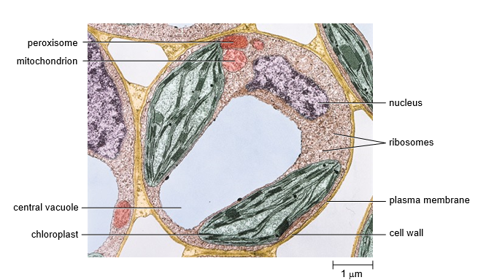

Peroxisomes
Peroxisomes, similar to lysosomes, are membrane-bounded vesicles that enclose enzymes. These enzymes were synthesized by free ribosomes and imported directly into a peroxisome. Peroxisomes contain enzymes for oxidizing certain organic substances with the formation of hydrogen peroxide (H₂O₂).
Hydrogen peroxide, a toxic molecule, is immediately broken down to water and oxygen by another peroxisomal enzyme called catalase. Peroxisomes are abundant in cells that metabolize lipids and in liver cells that metabolize alcohol. They help detoxify alcohol.

Energy-Related Organelles
(mitochondria)
All eukaryotic cells, including plant cells, contain mitochondria. This means that plant cells contain both chloroplasts and mitochondria. Most mitochondria are usually 0.5–1.0 m in diameter and 2–5 mm in length.
Mitochondria, like chloroplasts, are bounded by a double membrane.
In mitochondria the inner fluid- filled space is called the matrix. The matrix contains DNA, ribosomes, and enzymes which break down carbohydrate products, releasing energy that is used for ATP production.
The inner membrane of a mitochondrion invaginates to form cristae. Cristae provide a much greater surface area to accommodate the protein complexes and other participants that produce ATP.
Mitochondria and chloroplasts are able to make some proteins, but others are imported from the cytoplasm.
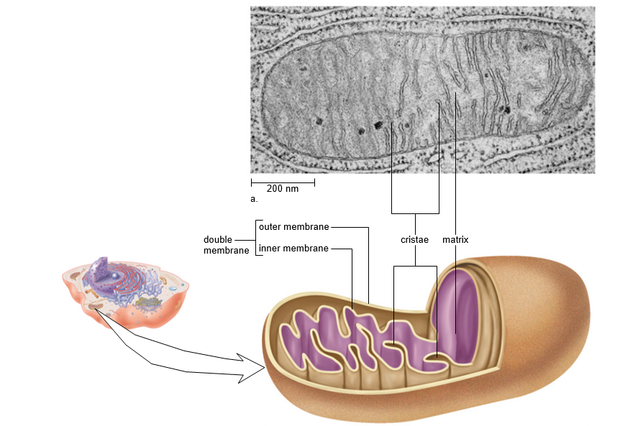
Prokaryotic cells
Bacteria are prokaryotic cells in the kingdom Monera. Most bacteria are 1–10 mm in size; therefore, they are just visible with the light microscope.
The cell wall contains peptidoglycan, a complex molecule with chains of a unique amino disaccharide joined by peptide chains.
In some bacteria, the cell wall is further surrounded by a capsule and/or gelatinous sheath called a slime layer.
Motile bacteria usually have long, very thin appendages called flagella (sing., flagellum) that are composed of subunits of the protein called flagellin. The flagella, which rotate like propellers, rapidly move the bacterium in a fluid medium. Some bacteria also have fimbriae, which are short appendages that help them attach to an appropriate surface.
A membrane called the plasma membrane regulates the movement of molecules into and out of the cytoplasm, the interior of the cell.
Cytoplasm in a prokaryotic cell consists of a semifluid medium, and thousands of granular inclusions called ribosomes that coordinate the synthesis of proteins.
In prokaryotes, most genes are found within a single chromosome (loop of DNA, or deoxyribonucleic acid) located within the nucleoid, but they may also have small accessory rings of DNA called plasmids.
In addition, the photosynthetic cyanobacteria have light-sensitive pigments, usually within the membranes of flattened disks called thylakoids.
