Lecture 3 Membrane Structure and Function

Plasma Membrane Structure and Function
The plasma membrane separates the internal environment of the cell from the external environment.
It regulates the entrance and exit of molecules into and out of the cell in this way, it helps the cell and the organism maintain a steady internal environment.
What’s the plasma membrane structure?
The plasma membrane is a phospholipid bilayer in which protein molecules are either partially or wholly embedded.
The phospholipid bilayer has a fluid consistency, comparable to that of light oil.
The proteins are scattered either just outside or within the membrane; therefore, they form a mosaic pattern. This description of the plasma membrane is called the fluid mosaic model of membrane structure.
The proteins in a membrane may be peripheral proteins or integral proteins. The peripheral proteins on the inside surface of the membrane, Integral proteins are embedded in the membrane, but they can move laterally back and forth
The hydrophilic (water-loving) polar heads of the phospholipid molecules face the outside and inside of the cell where water is found, and the hydrophobic (water-fearing) nonpolar tails face each other.

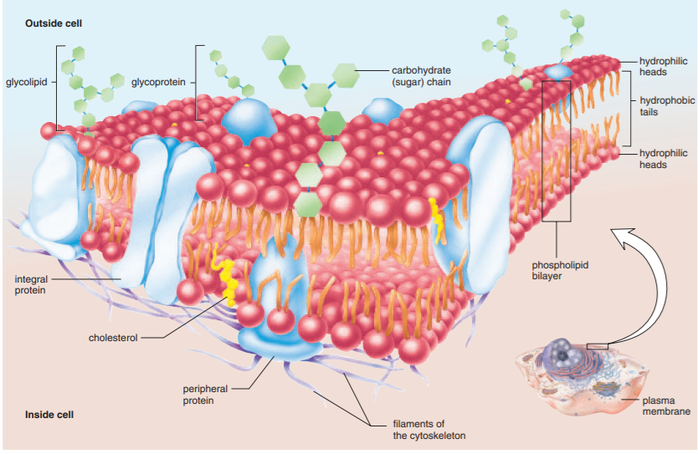

Both phospholipids and proteins can have attached carbohydrate (sugar) chains. If so, these molecules are called glycolipids and glycoproteins respectively.
Cholesterol is another lipid found in animal plasma membranes; related steroids are found in the plasma membranes of plants.
The Carbohydrate Chains
The carbohydrate chains of cell recognition proteins give the cell a “sugar coat,” more properly called the glycocalyx. The glycocalyx protects the cell and has various other functions. For example, it facilitates adhesion between cells, reception of signal molecules, and cell-to-cell recognition.
What’s the function of lipid in plasma membrane?
Cholesterol stiffens and strengthens the membrane, thereby helping to regulate its fluidity.

What’s the function of proteins in plasma membrane?
*Channel proteins through which a substance can simply move across the membrane.
* Carrier proteins that combine with a substance and help it move across the membrane.
* Receptor protein has a shape that allows a specific molecule to bind to it. The binding of a molecule, such as a hormone (or other signal molecule), can cause the protein to change its shape and bring about a cellular response.
* Enzymatic proteins that carry out metabolic reactions directly.
*The peripheral proteins associated with the membrane often have a structural role in that they help stabilize and shape the plasma membrane.

The Permeability of the Plasma Membrane
The plasma membrane is differentially (selectively) permeable. This means that some substances can move across the membrane, and some cannot.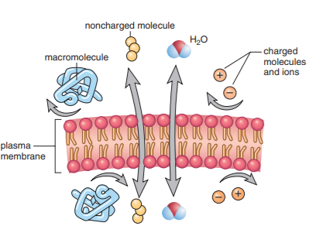

The ways of crossing a plasma membrane are classified as passive or active.
Passive transport, which does not use chemical energy, involves diffusion or facilitate transport.
Active transport not only requires a carrier protein, it also requires chemical energy, i.e., ATP.
*These molecules are said to follow their concentration gradient as they move from an area where their concentration is high to an area where their concentration is low.

Passage of Molecules into and out of Cells

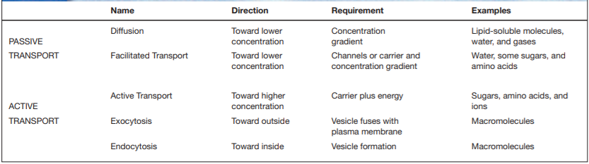

Diffusion and Osmosis
Diffusion is the movement of molecules from a higher to a lower concentration that is, down their concentration gradient until equilibrium is achieved and they are distributed equally.
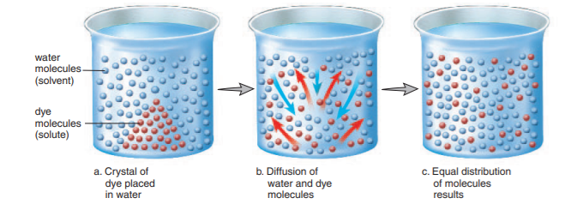
Osmosis
The diffusion of water across a selectively permeable membrane due to concentration differences is called osmosis.
Osmosis in Cells
Isotonic Solution: that is, the solute concentration and the water concentration both inside and outside the cell are equal.
Hypotonic Solution: Solutions that cause cells to swell, or even to burst, due to an intake of water.
Hypertonic Solution: Solutions that cause cells to shrink or shrivel due to loss of water.
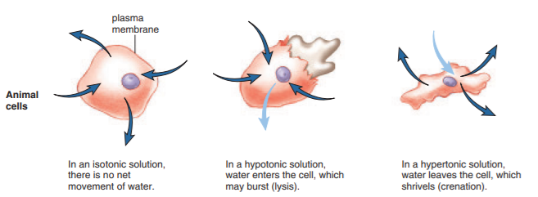

Exocytosis and Endocytosis
Exocytosis, vesicles fuse with the plasma membrane as secretion occurs. during exocytosis, the membrane of the vesicle becomes a part of the plasma membrane, which is thereby enlarged. For this reason, exocytosis occurs automatically during cell growth.
In humans, molecules transported out of the cell by exocytosis include digestive enzymes, such as those produced by the pancreatic cells, and hormones, such as growth hormone produced by anterior pituitary cells.
A rise in blood sugar, for example, signals pancreatic cells to release the hormone insulin.
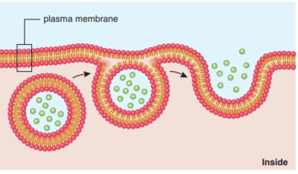

Endocytosis
During endocytosis, cells take in substances by vesicle formation. A portion of the plasma membrane invaginates to envelop the substance, and then the membrane pinches off to form an intracellular vesicle.
There are three kinds of endocytosis:
1- Phagocytosis: When the material taken in by endocytosis is large, such as a food particle or another cell.
occurs in humans. Certain types of human white blood cells are amoeboid they are mobile like an amoeba, and are able to engulf debris such as worn-out red blood cells or bacteria.
2- Pinocytosis:
occurs when vesicles form around a liquid or around very small particles. Blood cells, cells that line the kidney tubules or the intestinal wall.
pinocytosis involves a significant amount of the plasma membrane because it occurs continuously. The loss of plasma membrane due to pinocytosis is balanced by the occurrence of exocytosis.
3- Receptor-mediated endocytosis:
Receptor-mediated endocytosis is a form of pinocytosis that is quite specific because it uses a receptor protein.
The receptors for these substances are found at one location in the plasma membrane. This location is called a coated pit because there is a layer of protein on the cytoplasmic side of the pit. Once formed, the vesicle is uncoated and may fuse with a lysosome. If a vesicle fuses with the plasma membrane, the receptors return to their former location.
Receptor-mediated endocytosis is selective and much more efficient than ordinary pinocytosis. It is involved in uptake and also in the transfer and exchange of substances between cells. Such exchanges take place when substances move from maternal blood into fetal blood at the placenta.

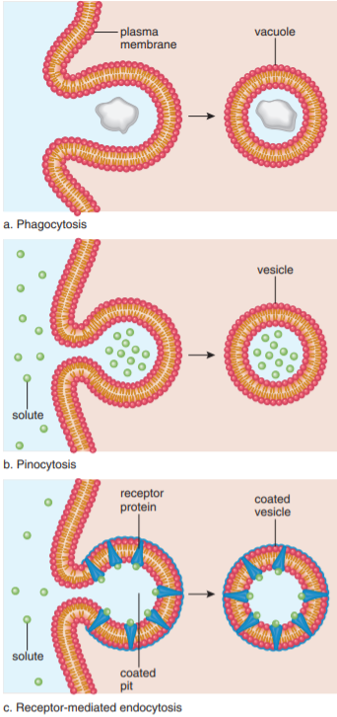

a. Phagocytosis occurs when the substance to be transported into the cell is large; amoebas ingest by phagocytosis. Digestion occurs when the resulting vacuole fuses with a lysosome. b. Pinocytosis occurs when a macromolecule such as a polypeptide is to be transported into the cell. The result is a vesicle (small vacuole). c. Receptor-mediated endocytosis is a form of pinocytosis. Molecules of substance to be taken in first bind to specific receptor proteins, which migrate to or are already in a coated pit. The vesicle that forms contains the molecules and their receptors.

