Stress and Strain/Part 2
Example
A Steel rod (E=200 GPa) has a circular cross section and is 10m long. Determine the minimum diameter if the rod must hold a 30 kN tensile force without deforming more than 5mm. Assume the steel stays in the elastic region. Note, 1 GPa = 10⁹ Pa.
Solution:
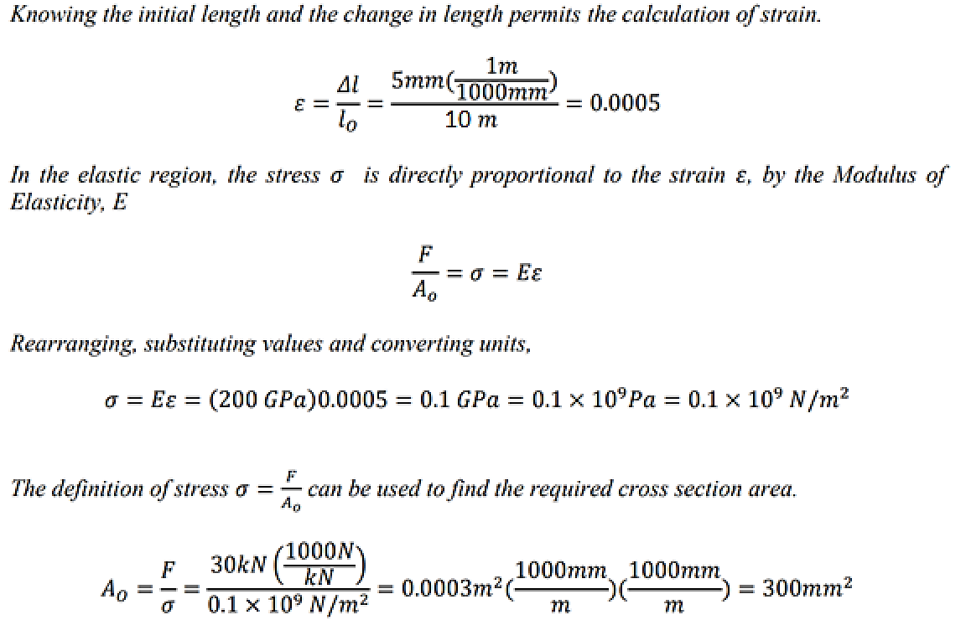
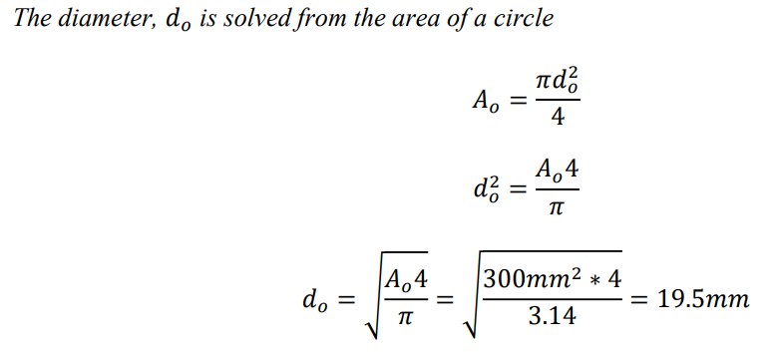
Poisson Ratio
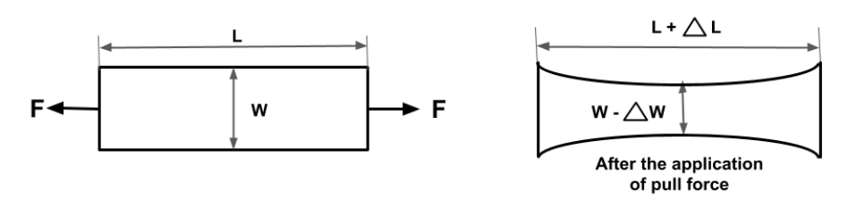
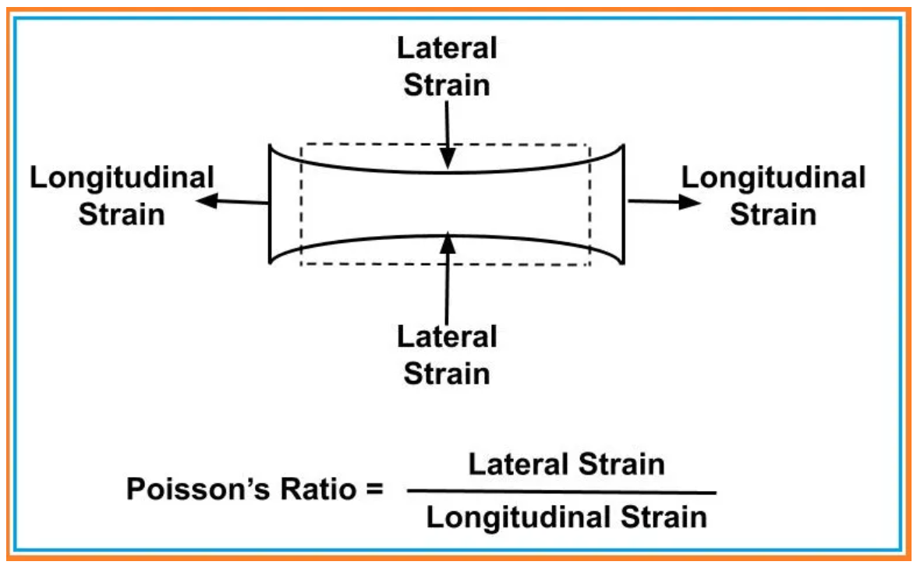

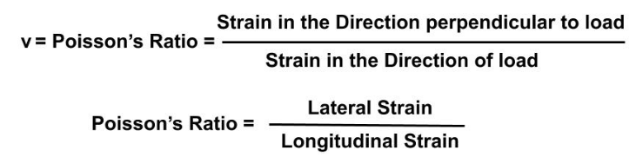

*lateral strain, also known as transverse strain, is defined as the ratio of the change in diameter of a circular bar of a material to its diameter due to deformation in the longitudinal direction. It occurs when under the action of a longitudinal stress, a body will extend in the direction of the stress and contract in the transverse or lateral direction (in the case of tensile stress). When put under compression, the body will contract in the direction of the stress and extend in the transverse or lateral direction. It is a dimensionless quantity, as it is a ratio between two quantities of the same dimension.

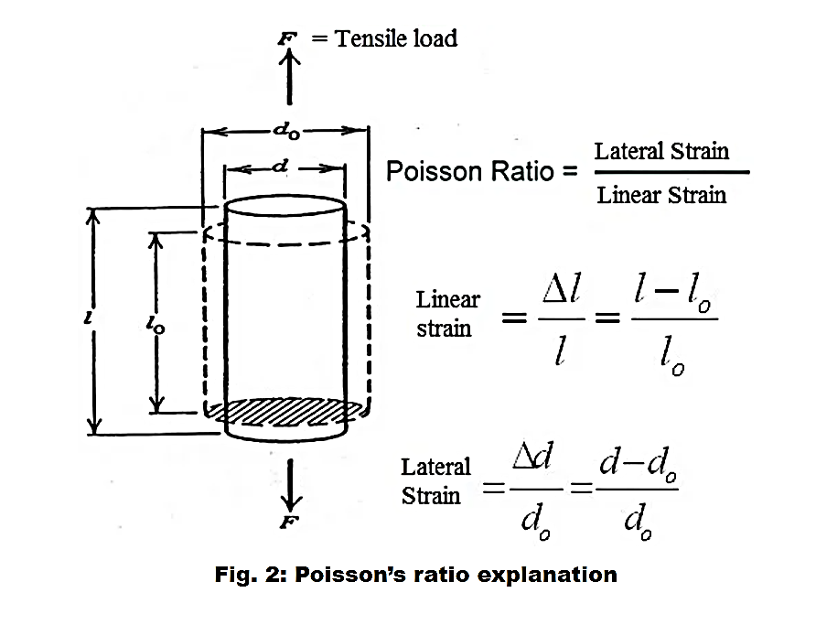
º

Poisson’s Ratio=Transverse (Lateral) Strain/Axial (Longitudinal) Strain
Let’s understand this philosophy using the example in Fig. 2. In this image, A tensile force (F) is applied in a bar of diameter do and length lo. With the action of this force F, the bar elongates and final length in l. Also, the diameter reduces and the final diameter is d.
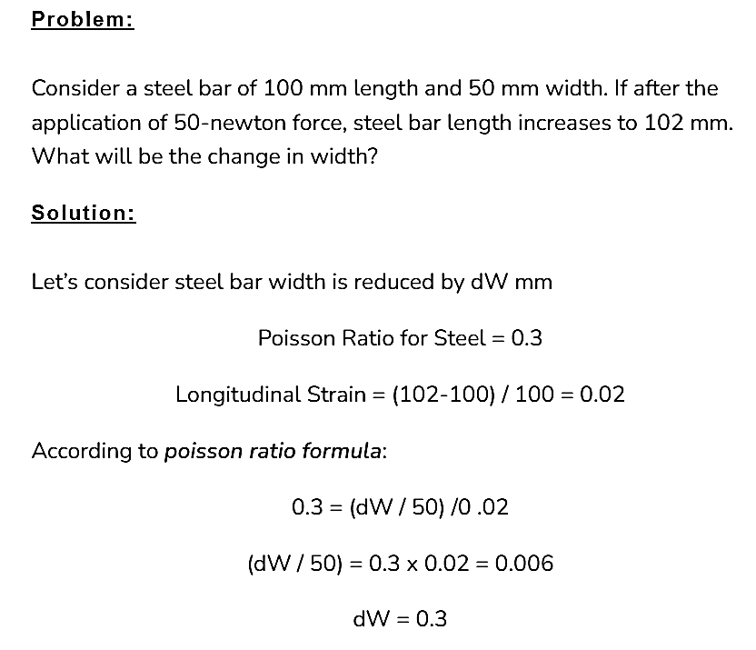

Examples
