Toughness and Resilience
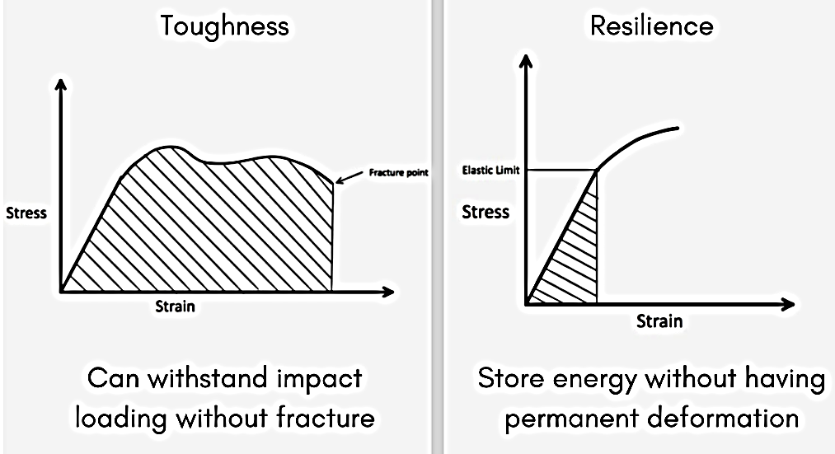

Toughness and Resilience are both properties of materials. Material can withstand impact loading without fracture because of toughness and can store energy without having permanent deformation because of resilience
What is toughness?
Toughness is the property due to which the material can withstand impact loading without fracture (At fracture, it breaks!). If the material can take more strain without undergoing fracture then it will be the tougher material.
What is resilience?
Resilience is the property due to which a material can store energy without having permanent deformation;The energy is released as soon as the load is removed due to which there is no permanent deformation in the body.This property is desired in a material for spring action.
Modulus of Resilience
​Modulus of toughness quantifies this toughness. It is the area under the stress-strain curve upto fracture point. It can also be defined as the strain energy stored per unit volume of the material upto fracture.
- Ductile material can take more strain upto the fracture point than the brittle material
- Mild steel is tougher than Cast iron because of this reason

Modulus of Resilience quantifies this resilience. It is defined as the area under the stress-strain curve upto elastic limit. In other words it is the strain energy per unit volume for a material upto its elastic limit. (We are interested only till elastic limit because that is the energy which can be recovered)
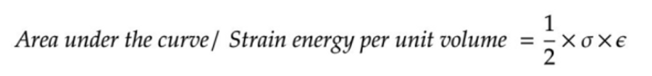

Bonding in Materials Engineering materials
Bonding in Materials Engineering materials possess interatomic attraction which leads to atomic bonding. If there were no such attraction each atom would behave independently, and the material would have no resistance to external forces.
Bonds can be classified two groups:
• Primary bonds: These are metallic, ionic and covalent bonds and all are relatively strong bonds.
• Secondary bonds: These are van der waals and hydrogen bonds. Both are relatively weak.
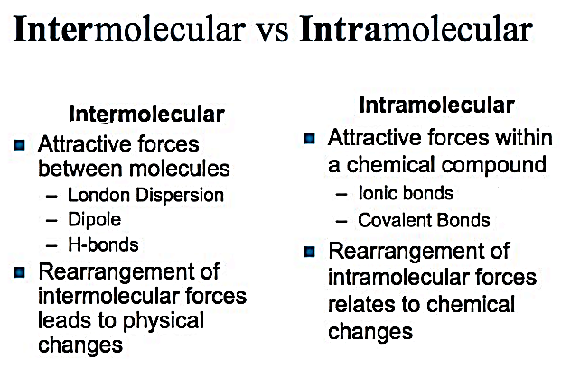
1-An ionic bond
is a chemical bond wherein there is a transfer of an electron from one atom to another. For an ionic bonding to occur there must be an electron donor (often a metal) and an electron acceptor (often a nonmetal). The transfer of electrons is referred to as electrovalence. The atom that loses one or more electrons will turn into a positive ion and will be called a cation. The other atom that gains one or more electron will become a negative ion and will be referred to as an anion
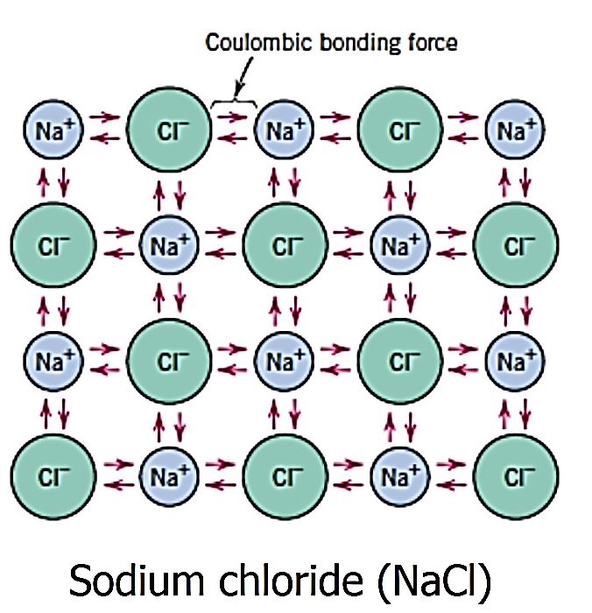

2- Covalent bond
A covalent bond is a chemical bond that involves the sharing of electrons to form electron pairs between atoms. These electron pairs are known as shared pairs or bonding pairs. The stable balance of attractive and repulsive forces between atoms, when they share electrons, is known as covalent bonding.
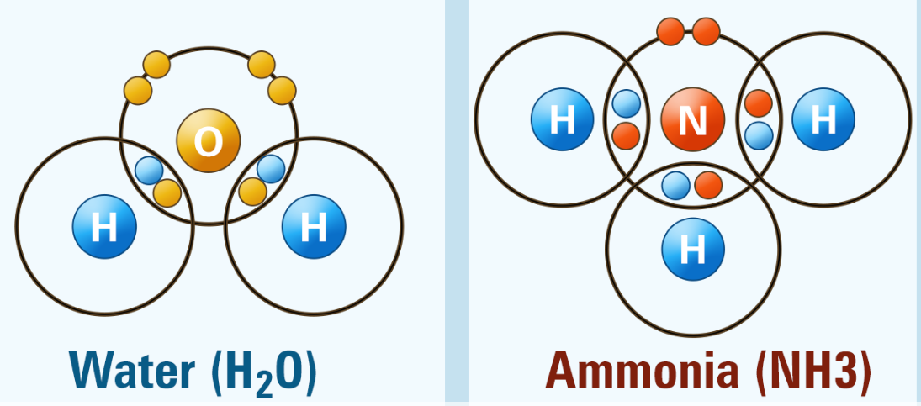
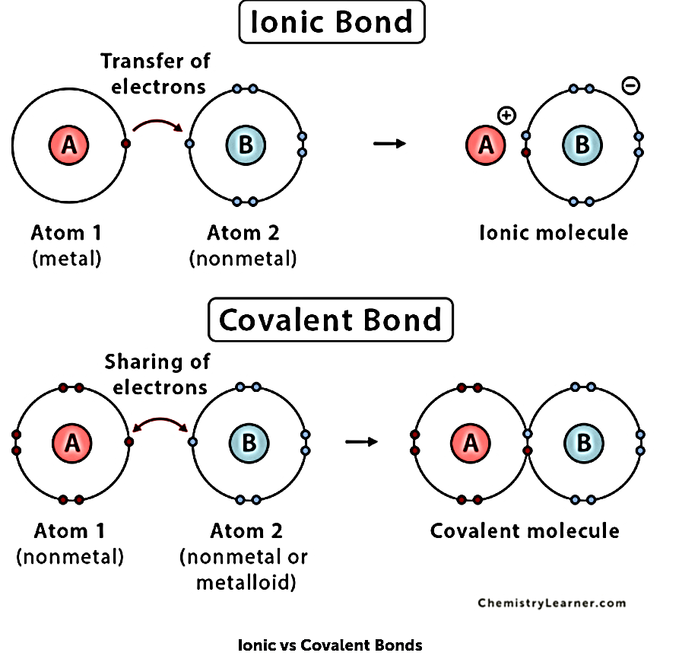

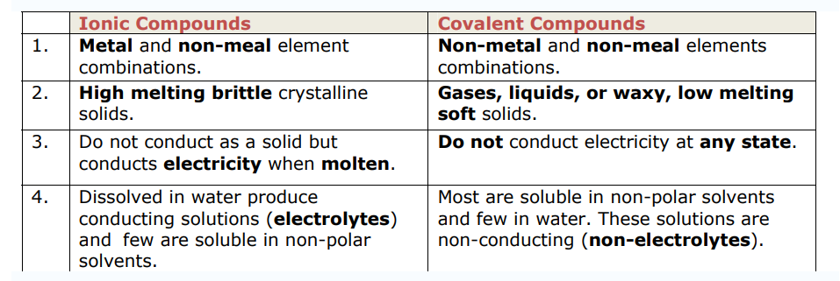
3- Metallic Bond
‘Metallic bond’ is a term used to describe the collective sharing of a sea of valence electrons between several positively charged metal ions.
The factors that affect the strength of a metallic bond include:
1-Total number of delocalized electrons.
2-Magnitude of positive charge held by the metal cation.
3-Ionic radius of the cation
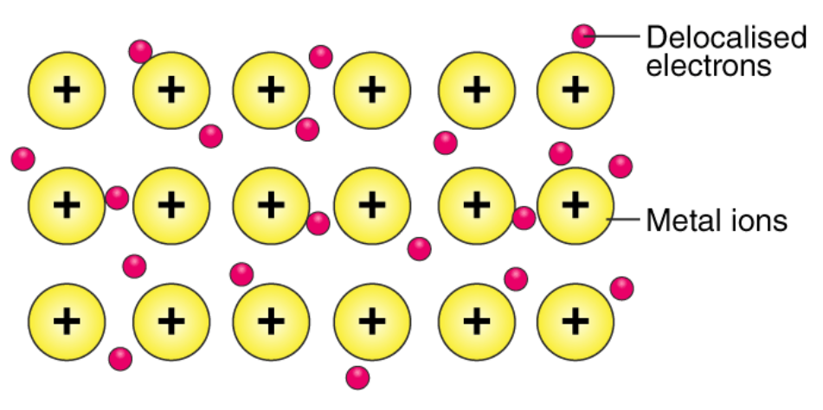

Metallic bonds are not broken when the metal is heated into the melt state. Instead, these bonds are weakened, causing the ordered array of metal ions to lose their definite, rigid structure and become liquid. However, these bonds are completely broken when the metal is heated to its boiling point.

4- Van der Waals forces
Van der Waals forces, also known as van der Waals bonds or van der Waals interaction, are weak intermolecular interactions observed in condensed phases like solid and liquid. They are responsible for the bulk properties of substances, like the boiling and melting points. Van der Waals bonds are secondary bonds in molecules where ionic and covalent bonds form the primary bonds.
Induced electrical interactions between two or more atoms or molecules that are very near to each other produce Van der Waals forces. The Van der Waals interaction is the weakest of all the intermolecular forces that hold molecules together.Van der Waals forces are weak intermolecular forces that are dependent on the distance between atoms or molecules. These forces arise from the interactions between uncharged atoms/molecules.
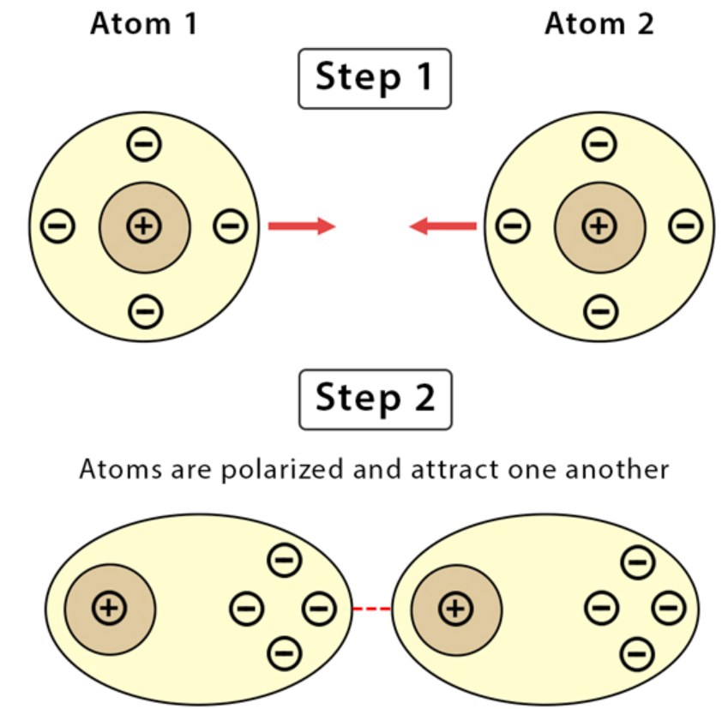

When the electron density around the nucleus of an atom undergoes a transient shift, it is common for Van der Waals forces arising. For example, when the electron density increases in one side of the nucleus, the resulting transient charge may attract or repel a neighbouring atom. The nature of these forces is dependent on the distance between the atoms:
- When the distance between the atoms is greater than 0.6 nanometres, the forces are extremely weak and cannot be observed.
- When the distance between the atoms ranges from 0.6 to 0.4 nanometres, the forces are attractive.
- If the interatomic distance is smaller than 0.4 nanometres, the forces are repulsive in nature.
