Heat capacity is a material’s ability to absorb heat from the external surroundings; it represents the amount of energy needed to increase the temperature of a substance 1 degree, so the units are J / oC. In mathematical terms, the heat capacity C is expressed as follows:
C = ΔQ/ΔT = dQ/dT [J/deg]
Where dQ is the energy required to produce a dT temperature change. Ordinarily, heat capacity is specified per mole of material (e.g., J/mol-K, or cal/mol-K).

Specific heat: A more useful procedure is to compare heat capacities for one gram of material. This is called the pecific heat capacity or simply specific heat. Specific heat is the quantity of heat required to raise the temperature of one gram of material one degree Celsius (or one kelvin). We get the specific heat when we divide the heat capacity of a material by its mass.
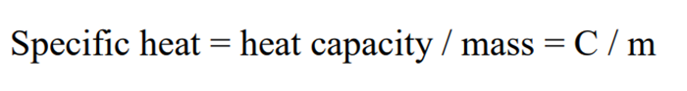

• Specific heat is heat capacity per unit mass. It has units as J/kg-K or Cal/kg-K. With increase of heat energy, dimensional changes may occur. Hence, two heat capacities are usually defined, Cp and Cv
• Heat is absorbed through different mechanisms: lattice vibrations and electronic contribution (in that electrons absorb energy by increasing their kinetic energy).

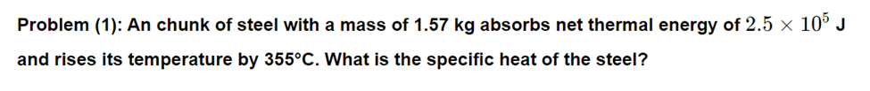
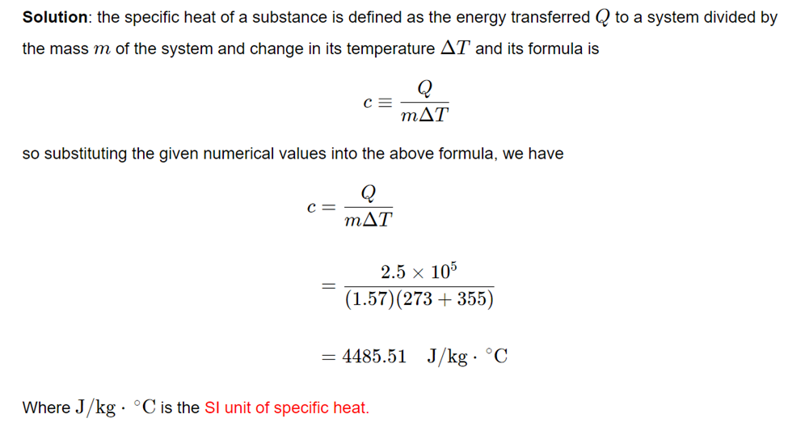

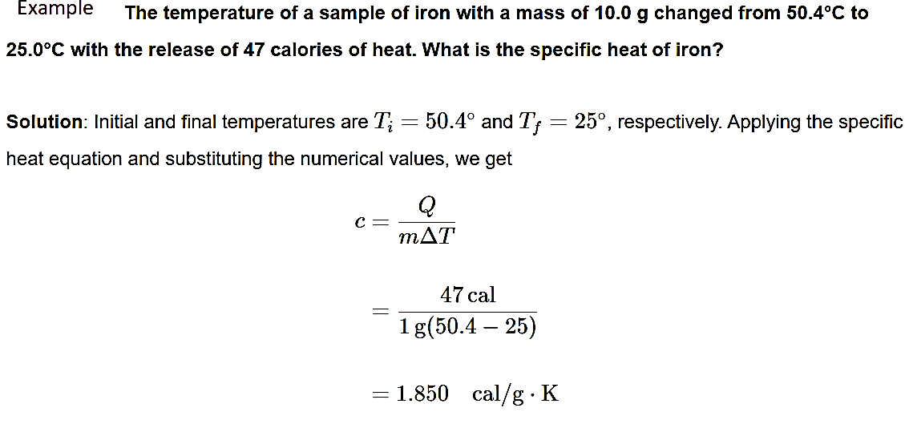

Thermal expansion:- Most solid materials expand upon heating and contract when cooled. The change in length with temperature for a solid material may be expressed as follows:
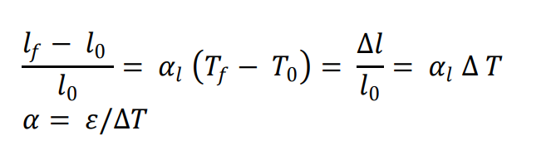
α values:
• for metals 5-25x10 ⁻⁶
• for ceramics 0.5-15x10 ⁻⁶
• for polymers 50-400x10 ⁻⁶
The highest values are found in linear and branched polymers because the secondary intermolecular bonds are weak, and there is a minimum of crosslinking. With increased crosslinking, the magnitude of the expansion coefficient diminishes; the lowest coefficients are found in the thermosetting network polymers such as phenol-formaldehyde, in which the bonding is almost entirely covalent.
Where
𝑙_{𝑓} and𝑙₀ represent, respectively, final and initial lengths with the temperature change from T₀ to T_{f} .
The parameter 𝛼_{𝑙} is called the linear coefficient of thermal expansion; it is a material property that is indicative of the extent to which a material expands upon heating, and has units of reciprocal emperature [(⁰C)⁻¹ or (⁰ F)⁻¹ ]
A volume coefficient of thermal expansion, 𝛼_{𝑣} = 3𝛼_{𝑙} is used to describe the volume change with temperature.
