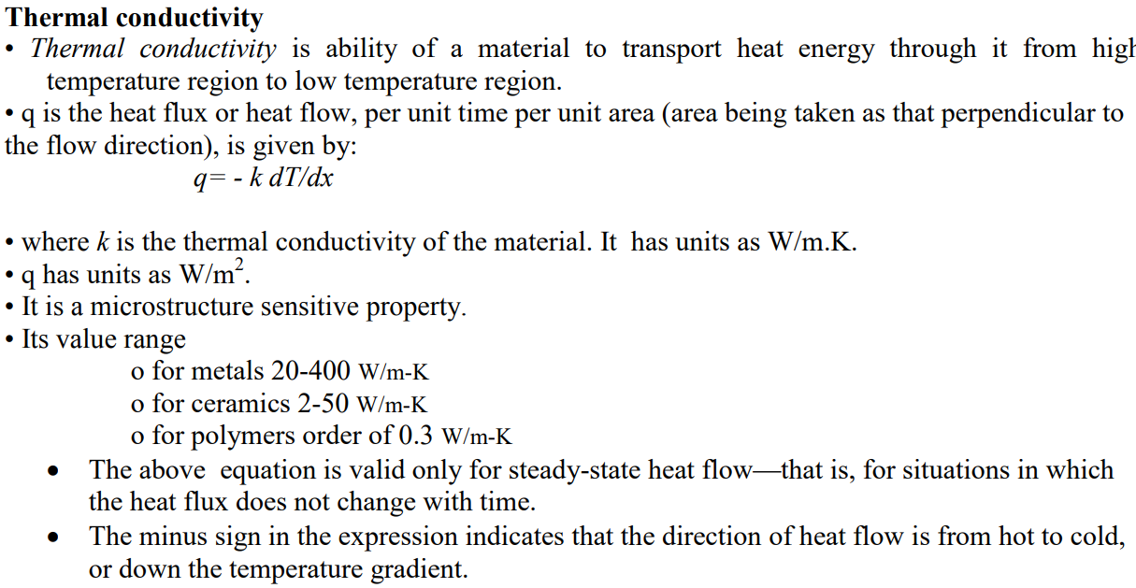

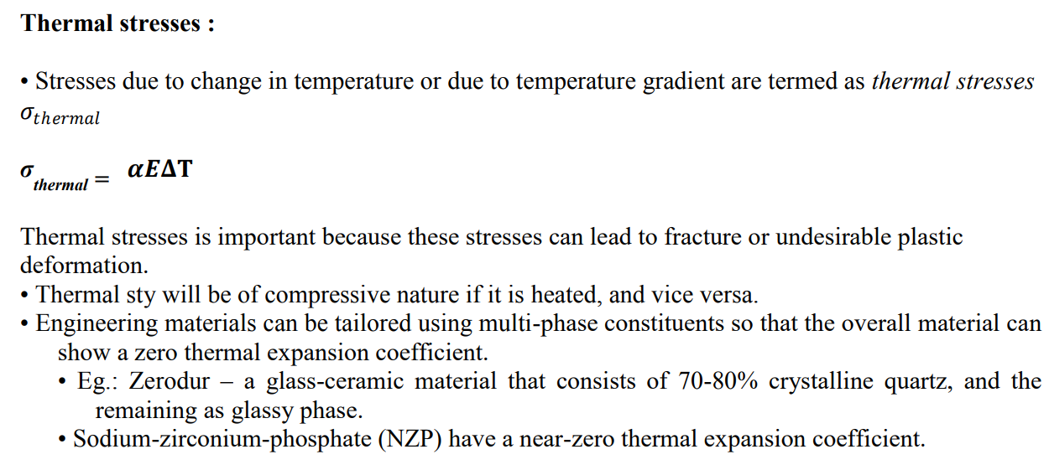
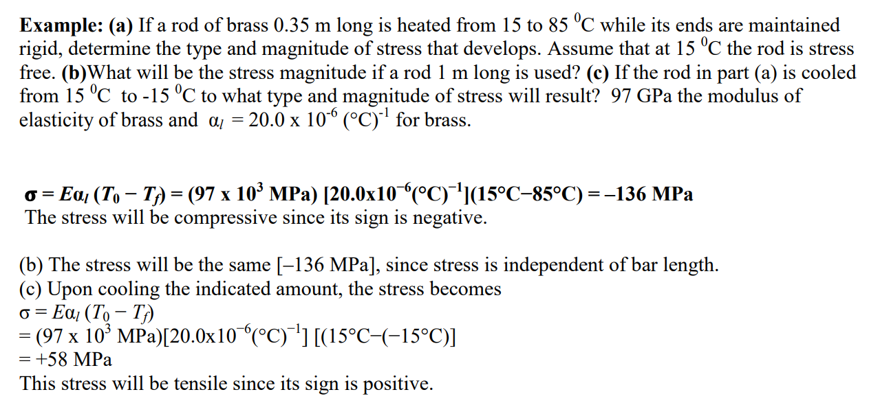

Glass Transition Temperature
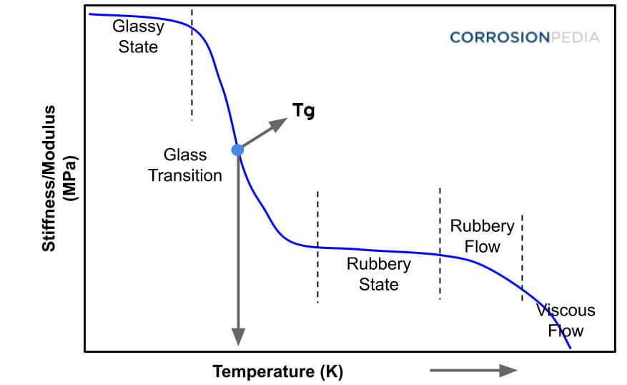
Figure 1. Graph of glass transition temperature plotting the temperature and stiffness of

When an amorphous polymer is heated, the temperature at which the polymer structure turns “viscous liquid or rubbery" is called the Glass Transition Temperature, Tg. It is also defined as a temperature at which amorphous polymer takes on characteristic glassy-state properties like brittleness, stiffness and rigidity (upon cooling).
This temperature (measured in °C or °F) depends on the chemical structure of the polymer and can therefore be used to identify polymers.
- Amorphous polymers only exhibit a Tg.
- Crystalline polymers exhibit a Tm (melt temperature) and typically a Tg since there is usually an amorphous portion as well (“semi”-crystalline).
The value of Tg depends on the mobility of the polymer chain, and for most synthetic polymers lies between 170 K to 500 K.
The transition from the glass to the rubber-like state is an important feature of polymer behavior, marking a region of dramatic changes in the physical properties, such as hardness and elasticity.
At Tg, changes in hardness, volume, percent elongation to break and Young’s modulus of solids are mainly seen.
Some polymers are used below their Tg (in glassy state) like polystyrene, poly(methyl methacrylate) etc., which are hard and brittle. Their Tgs are higher than room temperature.
Some polymers are used above their Tg (in rubbery state), for example, rubber elastomers like polyisoprene, polyisobutylene. They are soft and flexible in nature; their Tgs are less than room temperature

