Types of Engineering Materials

1-Metals and Alloys:-
An alloy is a metal that contains additions of one or more metals or non-metals. In general, metals have good electrical and thermal conductivity. Metals and alloys have relatively high strength, high stiffness, ductility or formability, and shock resistance. They are particularly useful for structural or load-bearing applications. Although pure metals are occasionally used, alloys provide improvement in a particular desirable property or permit better combinations of properties.
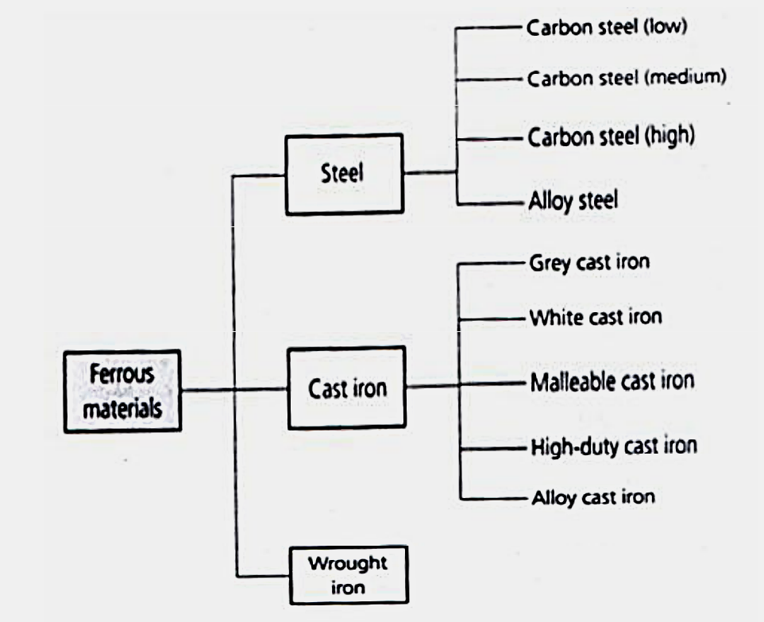
2-Ceramics:-
Ceramics can be defined as inorganic crystalline materials. Beach sand and rocks are examples of naturally occurring ceramics. Ceramics are strong and hard, but also very brittle.
used as barrier coatings to protect metallic substrates in turbine engines , consumer products as paints, and tires, and for industrial applications such as the tiles for the space shuttle, tableware, toilets, bathroom sinks, refractories (heat-resistant material), and abrasives. In general,
Due to the presence of porosity (small holes), ceramics do not conduct heat well; they must be heated to very high temperatures before melting.
Glasses and Glass-Ceramics:-
Glass is an amorphous material, often, but not always, derived from a molten liquid. used in houses, cars, computer and television screens, and hundreds of other applications.
Glasses can be thermally treated (tempered) to make them stronger. Forming glasses and nucleating (forming) small crystals within them by a special thermal process creates materials that are known as glass-ceramics which is used to make the mirror substrates for large telescopes .
3-Polymers:-
Polymers are typically organic materials. Polymers typically are good electrical and thermal insulators although there are exceptions such as the semiconducting polymers. Although they have lower strength, polymers have a very good strength-to-weight ratio. They are typically not suitable for use at high temperatures. Many polymers have very good resistance to corrosive chemicals.
Usually polymers are classified into three categories
-Thermoplastics: usually soft and easy to be recycled.
- Thermosetting plastics: usually stiff and not easy to be recycled.
-Elastomers: flexible (rubbers).
4-Composite Materials:-
These are formed from two or more materials, producing properties not found in any single material. Concrete, plywood, and fiberglass are examples of composite materials.
Fiberglass is made by dispersing glass fibers in a polymer matrix. The glass fibers make the polymer stiffer, without significantly increasing its density. With composites, we can produce lightweight, strong, ductile, temperature-resistant materials or we can produce hard, yet shockresistant, cutting tools that would otherwise shatter. Advanced aircraft and aerospace vehicles rely heavily on composites such as carbon fiber-reinforced polymers. Sports equipment such as bicycles, golf clubs, tennis rackets, and the like also make use of different kinds of composite materials that are light and stiff.

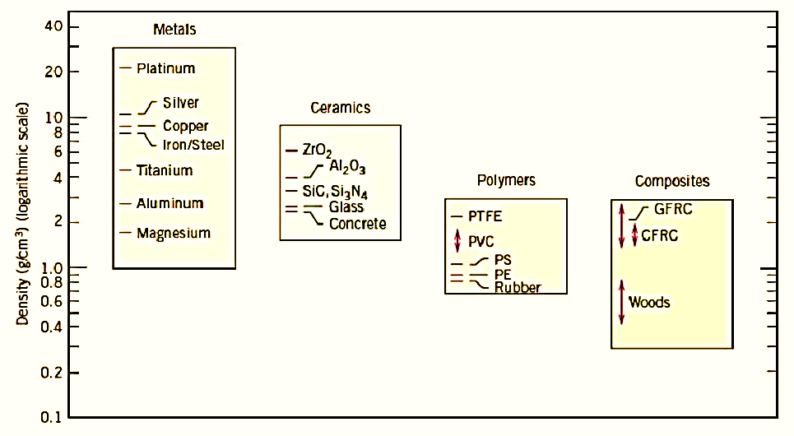
Advanced Materials
Materials that are utilized in high-technology (or high-tech) applications are sometimes termed advanced materials. By high technology we mean a device or product that operates or functions using relatively intricate and sophisticated principles; examples include electronic equipment (camcorders, CD/DVD players, etc.), computers, fiber-optic systems, spacecraft, aircraft, and military rocketry. These advanced materials are typically traditional materials whose properties have been enhanced, and, also newly developed, high-performance materials.

