**Stress and Strain**

**Stress (σ(**

When a material is subjected to an external force, a resisting force is set up within the component. The internal resistance force per unit area acting on a material or intensity of the forces distributed over a given section is called the stress at a point

• It uses original cross section area of the specimen and also known as engineering stress or conventional stress.



• P is expressed in Newton (N) and A, original area, in square meters (m2), the stress σ will be expresses in N/ m2. This unit is called Pascal (Pa).

• As Pascal is a small quantity, in practice, multiples of this unit is used.

1 kPa = 103 Pa = 103 N/ m2 (kPa = Kilo Pascal)

1 MPa = 106 Pa = 106 N/ m2 = 1 N/mm2 (MPa = Mega Pascal)

1 GPa = 109 Pa = 109 N/ m2 (GPa = Giga Pascal)

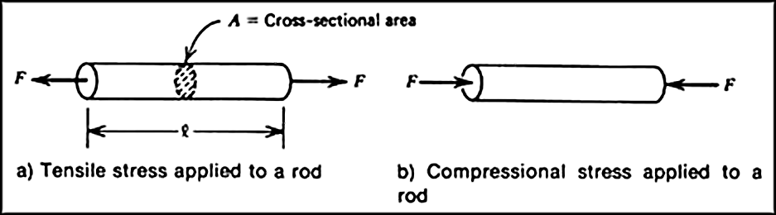

**Types of Stress**

**1-Tensile stress (σt)**

If σ > 0 the stress is tensile. i.e. The fibres of the component tend to elongate due to the external force. A member subjected to an external force tensile P and tensile stress distribution due to the force is shown in the given figure.

**2- Compressive stress (σc)**

If σ < 0 the stress is compressive. i.e. The fibres of the component tend to shorten due to the external force. A member subjected to an external compressive force P and compressive stress distribution due to the force is shown in the given figure.

**3-Shear stress (σ s )**

When forces are transmitted from one part of a body to other, the stresses developed in a plane parallel to the applied force are the shear stress. **Shear stress acts parallel to plane of interest.** Forces P is applied transversely to the member AB as shown. The corresponding internal forces act in the plane of section C and are called shearing

**Strain**

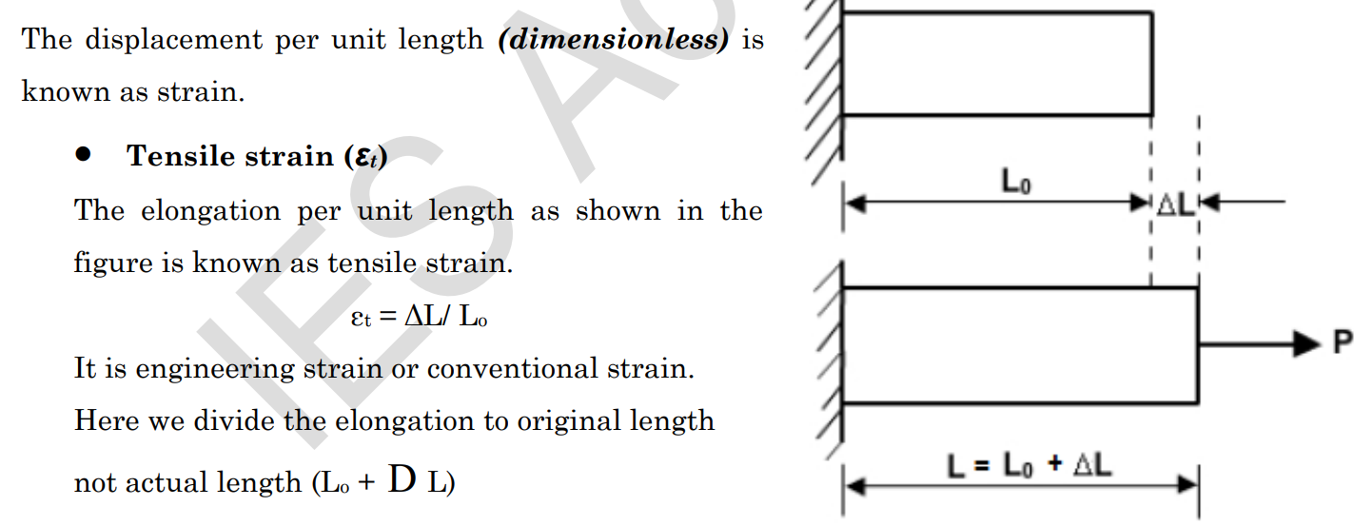

* **Compressive strain (εc)**

If the applied force is compressive then the reduction of length per unit length is known as compressive strain. It is negative. Then εc = (–ΔL)/ Lo

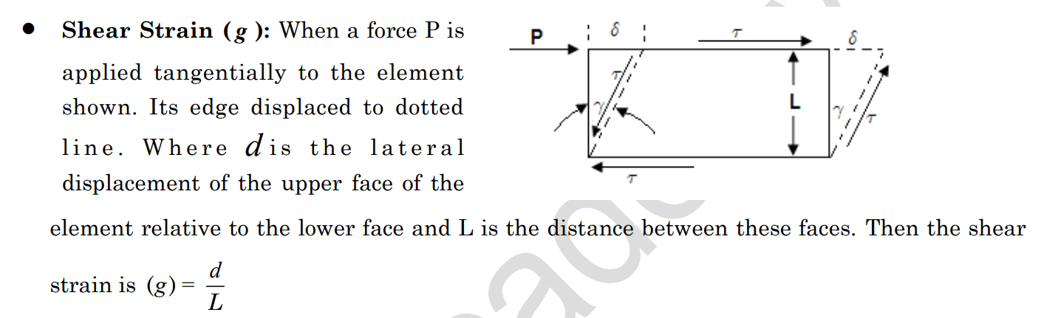

**Young’s modulus (E)**

is the modulus of elasticity under tension or compression. In other words, it describes how stiff a material is or how readily it bends or stretches. Young’s modulus relates stress (force per unit area) to strain (proportional deformation) along an axis or line.

The basic principle is that a material undergoes elastic deformation when it is compressed or extended, returning to its original shape when the load is removed. More deformation occurs in a flexible material compared to that of a stiff material.

-A low Young’s modulus value means a solid is elastic.

-A high Young’s modulus value means a solid is inelastic or stiff.

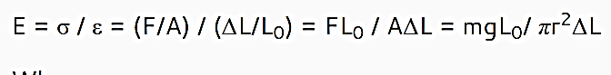

* E is Young’s modulus
* σ is the uniaxial stress (tensile or compressive).
* ε is the strain, which is the change in length per original length
* F is the force of compression or extension
* A is the cross-sectional surface area.

**Shear Modulus**

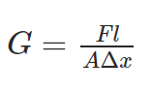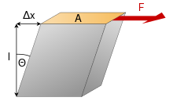

**Passion ratio**

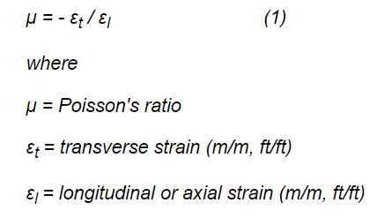

**Examples**

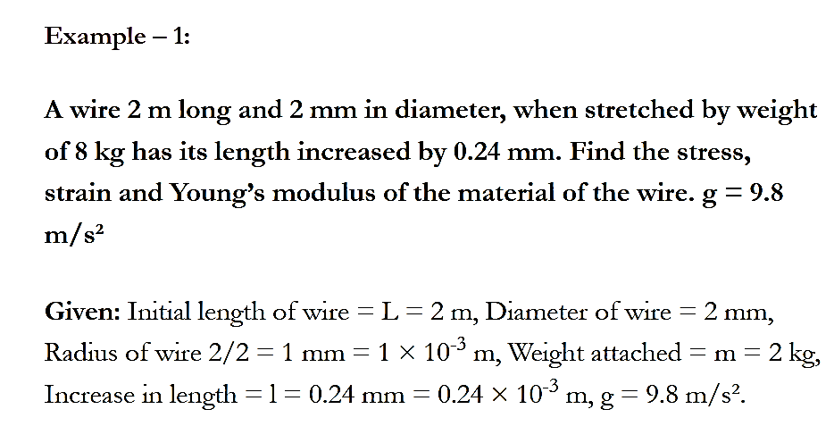

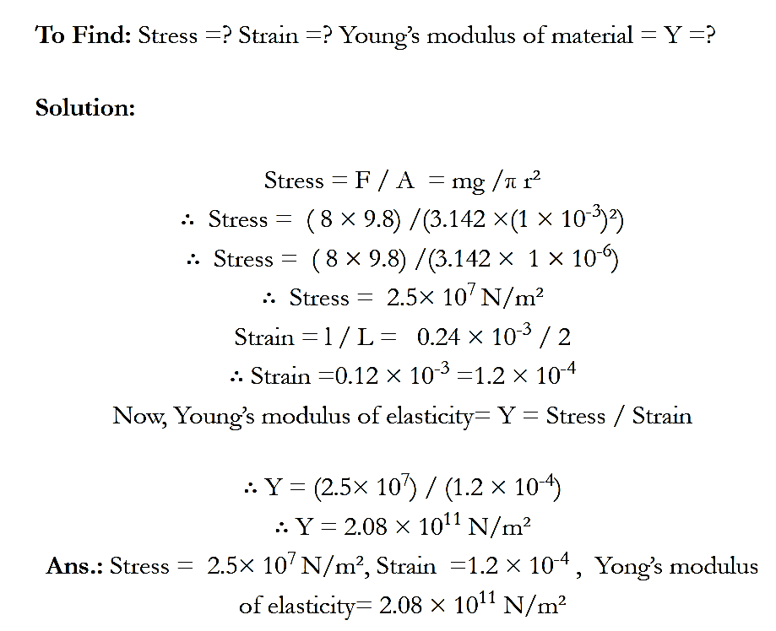

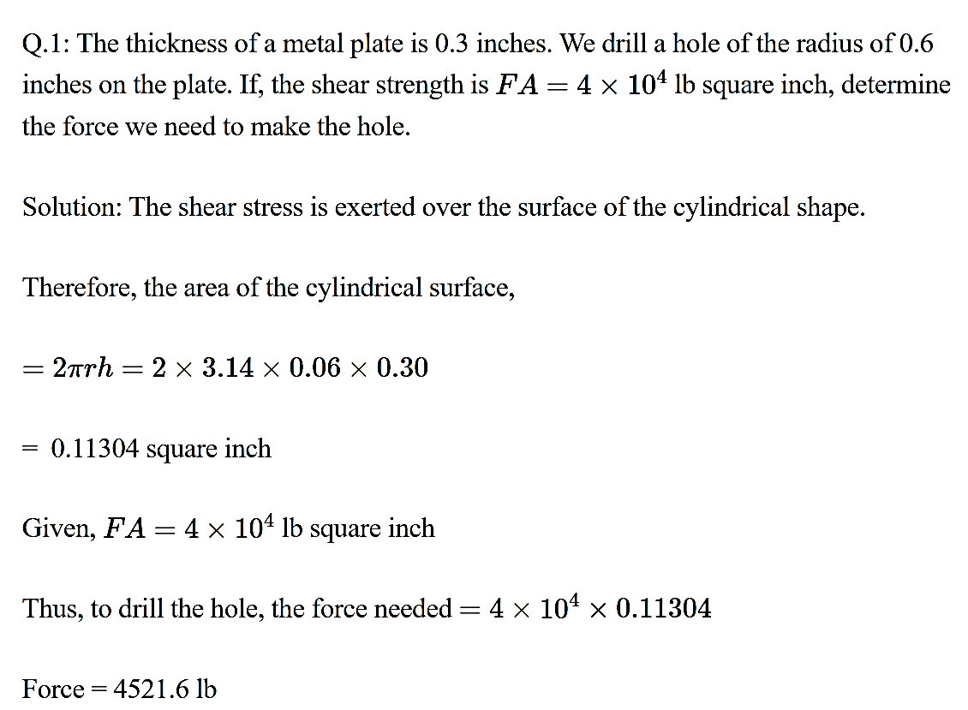

Example:-

