Mechanical Properties of Materials
The mechanical properties of materials define the behavior of materials under the action of external forces called loads.
There are a measure of strength and lasting characteristics of the material in service and are of good importance in the design of tools, machines, and structures.

List of Mechanical Properties of Materials
1.Ductility
2.Hardness
3.Toughness
4.Brittleness
5.Elasticity
Ductility :-
- The ductility is a property of a material which enables it to be drawn out into a thin wire.
- Mild steel, copper, aluminium are the good examples of a ductile material
-Brittleness :-
Brittleness is the property of a metal which allows little bending or deformation without shattering. A brittle metal is apt to break or crack without change of shape. Because structural metals are often subjected to shock loads, brittleness is not a very desirable property. Cast iron, cast aluminum, and very hard steel are examples of brittle metals.
-Toughness :-
A material which possesses toughness will withstand tearing or shearing and may be stretched or otherwise deformed without breaking. Toughness is a desirable property in aircraft metals.
-Hardness :-
Hardness refers to the ability of a material to resist abrasion, penetration, cutting action, or permanent distortion. Hardness may be increased by cold .

-Elasticity:-
Elasticity is the ability of a deformable body (e.g., steel, aluminum, rubber, wood, crystals, etc.) to resist a distorting effect and to return to its original size and shape when that influence or force is removed.

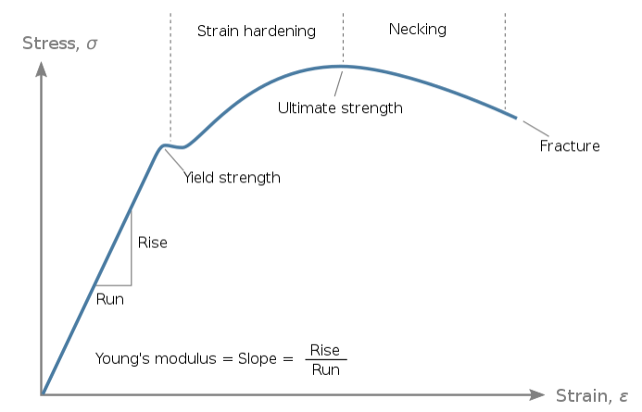
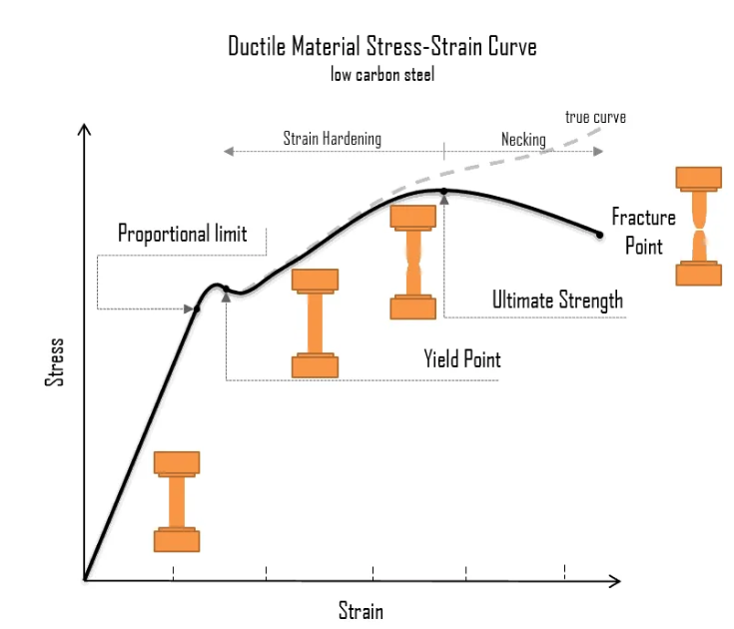

1-Yield Strength
yield point is the point on a stress-strain curve that indicates the limit of elastic behavior and the beginning plastic behavior.
2- yield stress is the material property defined as the stress at which a material begins to deform plastically. In contrast, the yield point is where nonlinear (elastic + plastic) deformation begins. Before the yield point, the material will deform elastically and return to its original shape when the applied stress is removed. Once the yield point is passed, some fraction of the deformation will be permanent and non-reversible. Some steels and other materials exhibit a behavior termed a yield point phenomenon.
3-Ultimate Tensile Strength
The maximum ordinate in the stress-strain diagram is the ultimate strength or tensile strength. The maximum stress that a material can withstand while being stretched or pulled before breaking.
4- Fracture
At this stage, the material fails permanently, meaning it is broken.

