Lecture Two
16/10/2022
Crystal Structure of Material
- Solid materials may be classified according to the regularity with which atoms or ions are arranged with respect to one another.
- A crystalline material is one in which the atoms are situated in a repeating or periodic array over large atomic distances—that is, the atoms will position themselves in a repetitive three-dimensional pattern, in which each atom is bonded to its nearest-neighbor atoms.
- lattice means a three-dimensional array of points set of mathematical points coinciding with atom positions.
- small groups of atoms form a repetitive pattern. called unit cells.
- Unit cells for most crystal structures are parallelepipeds or prisms.
- Amorphous materials are those that have no detectable crystal structure. Amorphous film materials can be formed by: • Deposition of a natural “glassy” material such as a glass composition.
Three relatively simple crystal structures are found for most of the common metals: -
1-Face centered cubic. (F.C.C.)
2- Body- centered cubic . (B.C.C.)
3- Hexagonal close-packed. (H.C.P.)

1-Face centered cubic. (F.C.C.)
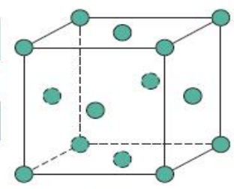
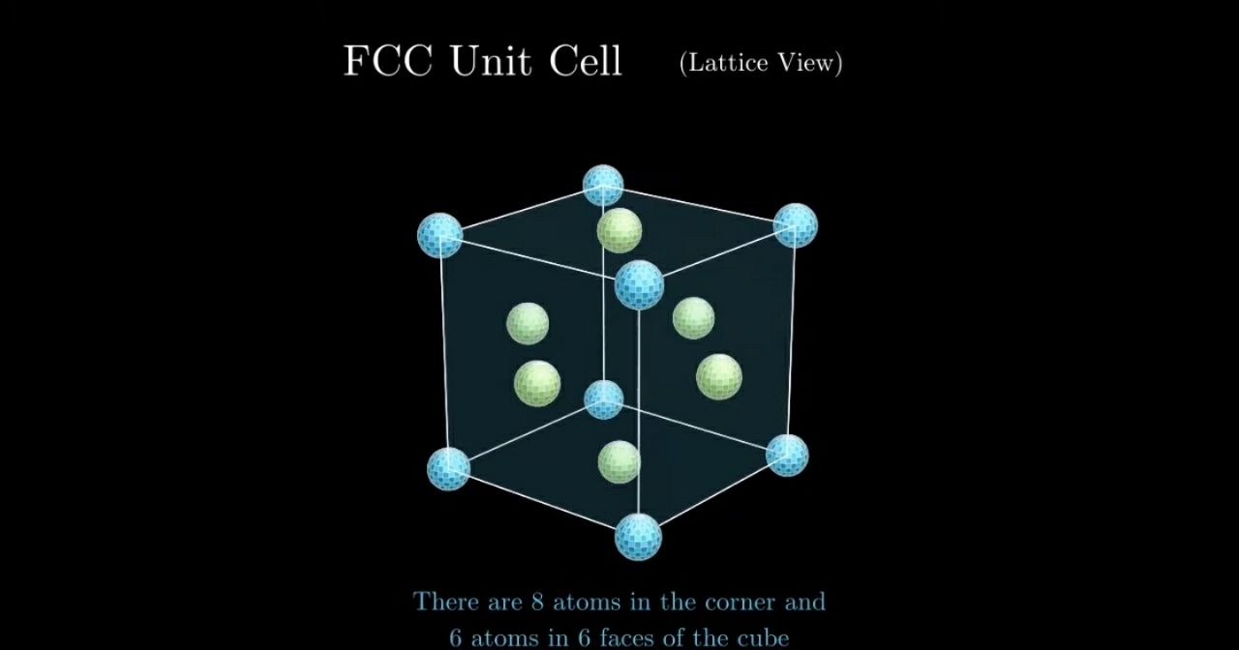

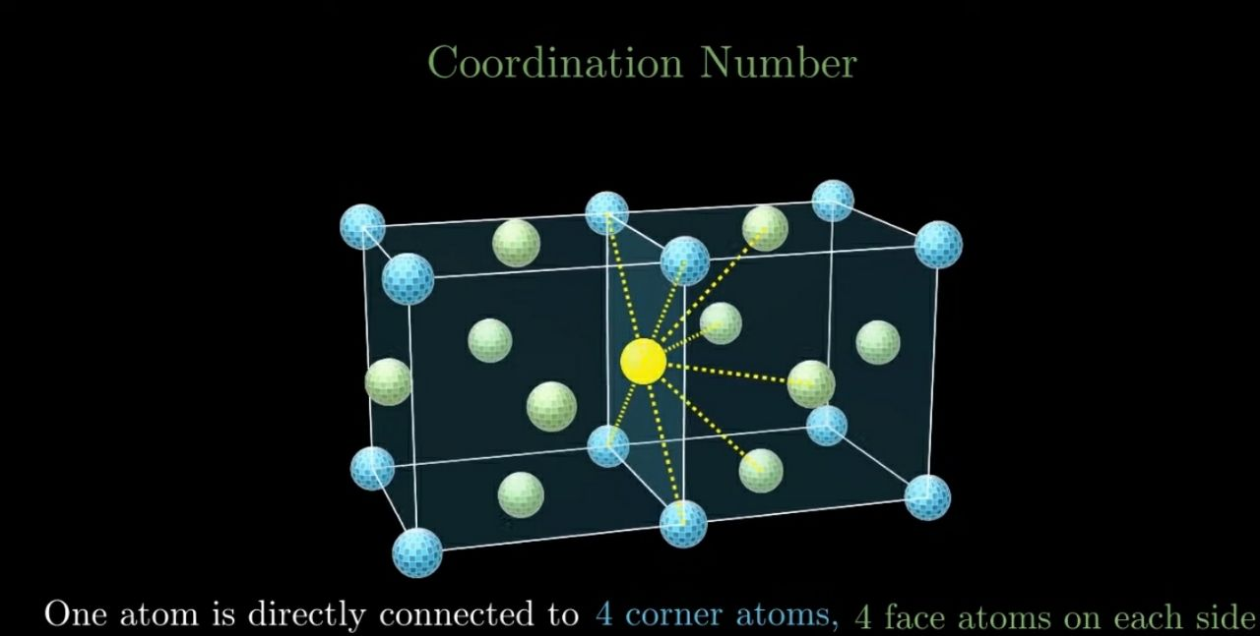

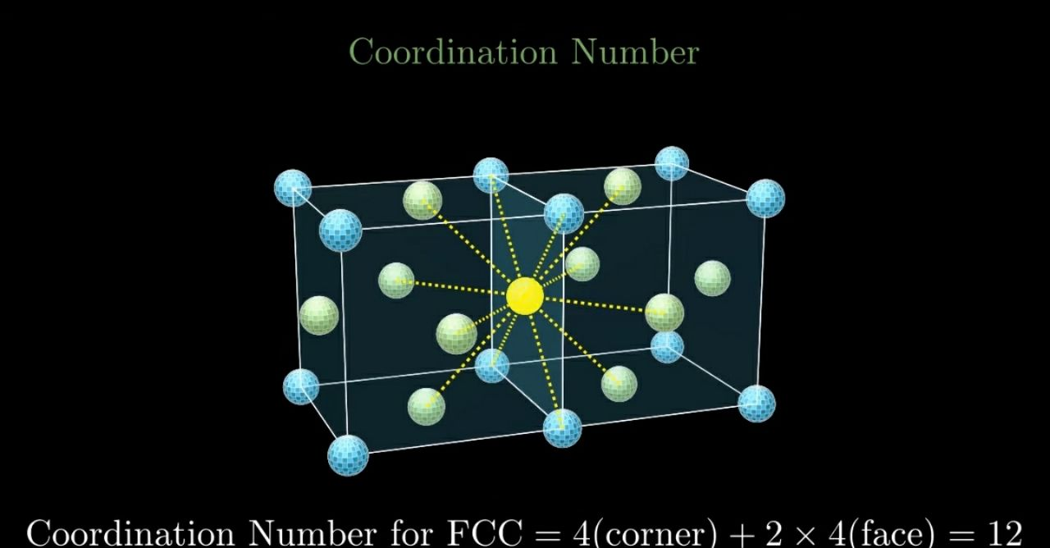

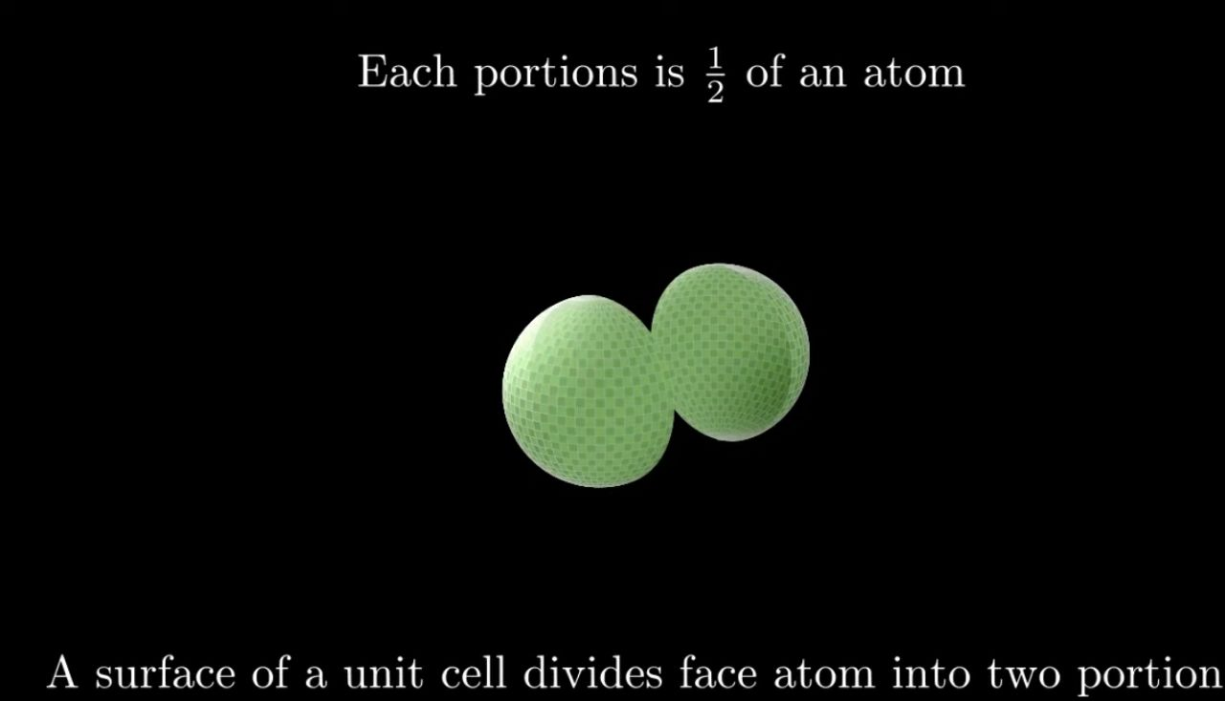

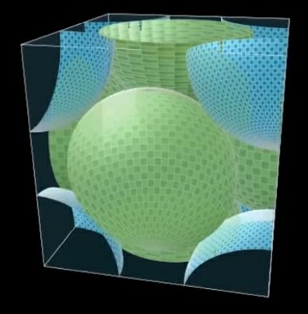
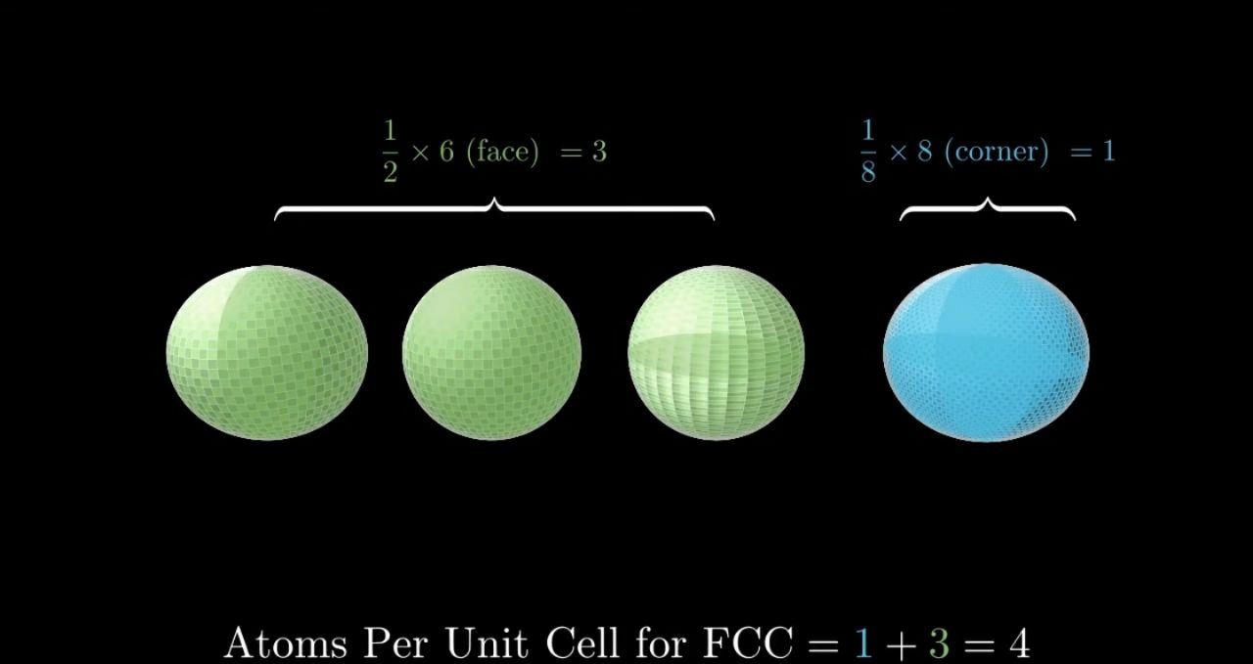
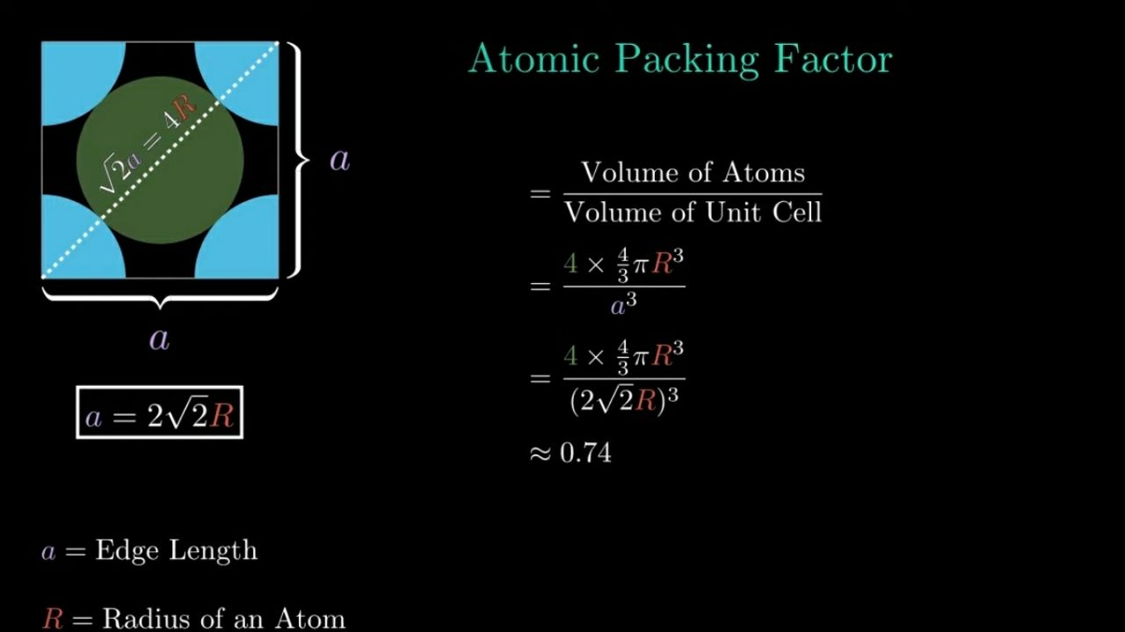

2- Body Center Cubic (B.C.C)
