Ministry of Higher Education and Scientific Research
Al-Mustaqbal University College
Radiology Technique Department

Subject: Theoretical Physiology
Class: 1st

Lecture Number: 1
Lecture Title: Blood Physiology I

Prepared By
M.Sc. Doua’a S.Altaie

(Blood physiology)Or “Haematology “
*******************************
The blood:-

-Blood is specialized connective tissue consisting of cellular elements suspended in plasma.
-The cells make up approximately 45% of the total blood volume.
-The blood is one of the largest organs of the body, which a volume of about 5 liters & a weight of 5.5 kg an average 70 kg man.
-Normal peripheral blood is composed of three types of cell, red blood cells, white blood cells & platelets, suspended in a pale yellow fluid called plasma.

(1) The cellular elements:-
A- Red blood cells (erythrocytes)
B- White blood cells (leucocytes)
C- Platelets.
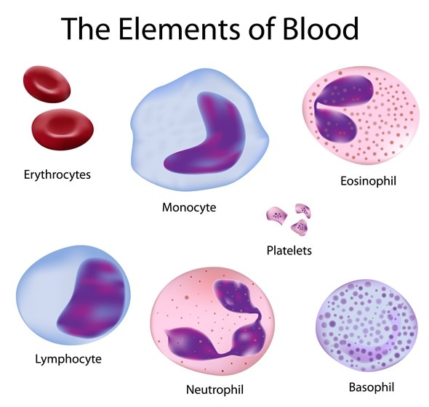

(A) Red blood cells (RBCs ) :-

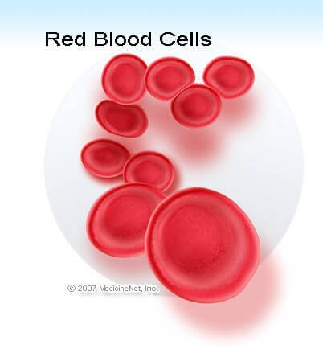
-Mature RBCs, or erythrocytes, are the most numerous of the blood cells: about 5x10¹² normally are present in each liter of blood.
-RBCs are biconcave discs approximately 7.5 micron in diameter and 2 micron thick, but their extreme pliability allow them to squeeze through capillaries less than 5-micron diameter.
-Red blood cells survive in the circulation for about 120 days before being sequestered in the spleen & consumed by the phagocytic cells of the reticuloendothelial system..
-The red cell membrane is freely permeable to water & anions (chloride & bicarbonate) transverse the membrane in less than second, & is relatively impermeable to cations (+ charge) .
-The major function of red cells is to transport hemoglobin, which in turn carries oxygen from the lungs to the tissues & transport CO₂ from tissues back to the lungs.
-The percentage of the total blood volume comprised of red blood cells is called the hematocrit, & this is normally about 40% in women & about 45% in men.

(B):-White blood cells ( leucocytes ) :-

-The leucocytes are the mobile units of the body’s protective system.
-They are formed partially in the bone marrow (the granulocytes & monocytes, & a few lymphocytes) & partially in the lymph tissue (lymphocytes & plasma cells), but after formation they are transported in the blood to the different parts of the body where they are to be used.
-The number of white blood cells in the blood is normally only 1/600 the number of red blood cells.

-Leucocytes are of two main types :-

(1) Granular leucocytes.
(2) A granular leucocytes.

(1):- Granular leucocytes :-
-Are the most numerous. Always contain specific granules, & they are characterized by the presence of many lobed nucleus for this reasons they are referred to as Polymorphonuclear leucocytes.

There are three types of granular leucocytes :-
(a):-Neutrophils (b):-Eosinophils (c):-Basophils.

(a):-Neutrophils :-
-They are the most numerous of the leukocytes in human blood, which constitute 50-70% of the total white blood cells.
-The neutrophil nucleus is highly polymorphous Which usually consist of from 3 to 5 irregular ovoid lobes connected by a thin chromatin strand.
-Neutrophil cytoplasm contains numerous fine neutrophil granules, which are special types of lysosomes that contains principally hydrolytic enzymes.
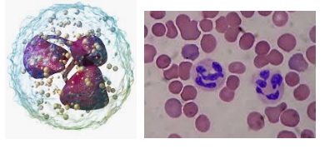
-Neutrophils constitute the first line of defense against invading organism so the main function of neutrophils is bacterial killing by phagocytosis.
-Neutrophils are highly mobile, highly phagocytic, & are attracted out of the blood into tissue areas where tissue destruction is occurring by a process called chemotaxis, which means attraction by the destruction products from the damaged tissues.

(b):-Eosinophil :-
-They normally constitute about 1 to 4 percent of the total white blood cells.
-The nucleus is usually bilobed.
-This name is derived from the staining Characteristic of the large cytoplasmic granules of uniform sized which stain strongly with the acidic dye eosin.
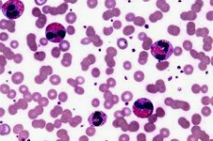
-Eosinophils are produced in large numbers in persons with parasitic infections.
-The parasites are usually too large to be phagocytized, but the eosinophils attach themselves to the surface & release lethal substances that can kill many of the parasites.
-Large numbers of eosinophils also appear in the blood in allergic conditions & may help detoxify toxins that are released by allergic reactions.

(c) Basophils :-
-These cells are difficult to find in human blood, since they constitute only about 0.5 to 1 percent of the total number of leucocytes.
-The nucleus often is irregular in outline & partially constricted into two lobes (S shape like).
-The cytoplasmic granules are round & variable in size, which stain with basic dyes.
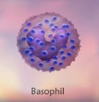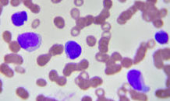
-The basophils are very similar to mast cells located immediately outside many of the capillaries in the body.
-Basophils & mast cells are important for allergic reaction.
-Also, basophils & mast cells liberate heparin into the blood, a substance that can prevent blood coagulation. As well as histamine.
-Basophils differ from neutrophils in that they are no phagocytic.

