Ministry of Higher Education and Scientific Research
Al-Mustaqbal University College
Radiology Technique Department
2022-2023

Subject: Physiology
Class: 1st

Lecture Number: 2
Lecture Title: Blood Physiology II
Prepared By
Assist Lecturer. Doa'a Adil AL-Musawi
Assist. Lecturer . Douaa S. Altaee

(2) – A granular leucocytes :-
- This cells have cytoplasm that appears homogenous & nuclei that are spherical to reniform in shape.

There are two types of a granular leucocytes :-
(a):- Lymphocytes:-
-Lymphocytes are the second most common white cell in the peripheral blood, with arrange of 20 to 40 percent of circulating white blood cells.
-Typically, lymphocytes are much smaller than monocytes (10-12 micron in diameter).
-The majority of the lymphocytes are small in size, spherical cells, with small amount of cytoplasm surrounding dense, round nucleus.
-Most of lymphocytes are formed in lymph nodes, thymus & spleen.
-Lymphocytes are divided into two major populations , which play distinct roles in specific immunity .
-One of the population is responsible for forming the activated lymphocytes that provide cell - mediated immunity, which called T lymphocyte.
-The other population is for forming the antibodies that provide humoral immunity, which is called B-lymphocytes.
-In the blood 70 – 80% of small lymphocytes are T cells & 15 – 20% are B cells.

(b):-Monocytes:-
-Monocytes are phagocytic leucocytes that play a major role in defense against pathogenic organism & foreign cells.
-The monocytes is larger than neutrophils, & have abundant cytoplasm in relation to the nucleus.
-The nuclei of monocytes frequently are kidney shaped.
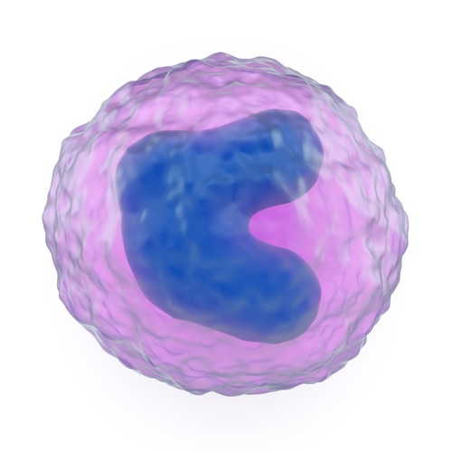
-Monocytes enter the circulation from the bone marrow but after about 24 hours, they enter the tissues to become tissue macrophage.
-The tissue macrophage system has generally been called the reticuloendothelial system.
-The macrophages migrate in response to chemotaxis stimuli & engulf & kill bacteria by phagocytosis.

(3) – Platelets:-
-Blood platelets are small protoplasmic disks, which are non-nucleated, granulated bodies, constitute about 300,000m³ of circulating blood.
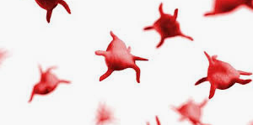
-The primary role of the blood platelet is in the arrest of blood loss. Adequate number of Functionally normal platelets are essential for
optimal hemostasis.

Blood functions
(1):-Transport of nutrients from digestive tract to tissues.
(2):-Transport of metabolites ( eg . lactic acid from muscle to liver ) .
(3):-Transport of excretory products from tissues to excretory organs (urea in liver to kidney).
(4):-Transport of gases (O₂&CO₂) between respiratory organs & tissues.
(5):-Transport of hormones & vitamins.
(6):-Transport of heat from deeper organs to surface.
(7):-Coagulation, serves to protect against blood loss.
(8):-Forms antibodies which helps to resisting the various specific infections.

