Digital Signal Processing (DSP)
Exp.1 continuous time signal v.s. discrete time signal

(1)Continuous time signal

t= 0:0.2:10
f=2
a=1
y=a*cos(f*t)
subplot(2,1,1)
plot(t,y,'r','LineWidth',2);
xlabel('time')
ylabel('amplitude ')
title ('continuous time signal ');

%$$$$$$$$$$$$$$$$$$$$$$$$$$$$$$$$$$$$$$$$$

(2)Discrete time signal %%%%%

t= 0:0.2:10
f=2
a=1
y=a*cos(f*t)
subplot(2,1,2)
stem(t,y,'b','LineWidth',2);
xlabel('time')
ylabel('amplitude ')
title ('discrete time signal ');

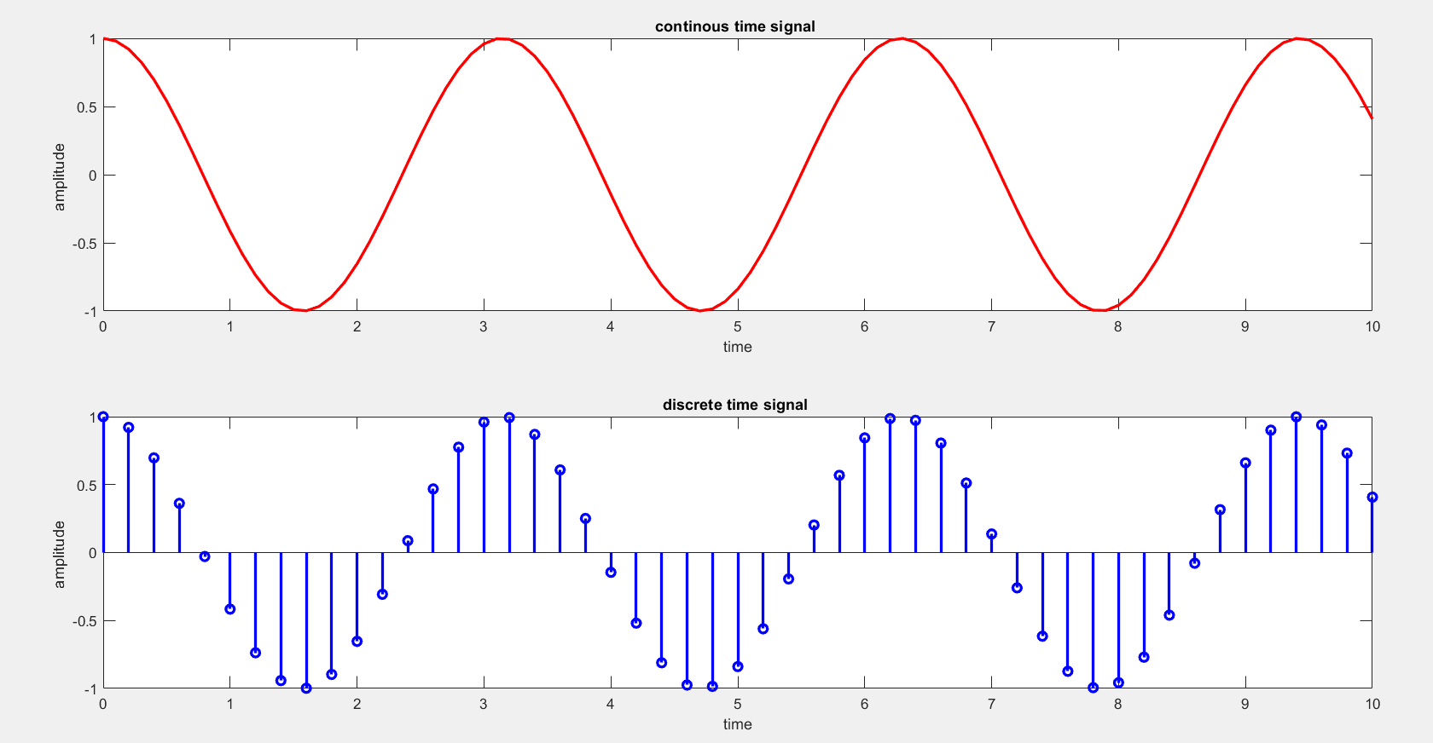

Discussion:
Q1/ Generate cosine signal with the following parameters:
t = 0:0.2:12
a = 5
f = 4Hz
The figure must be having name, axes titles, and grid.

