What is a Microprocessor?
In simple words, The microprocessor is useful in very intensive processes. It only contains a CPU (central processing unit) but there are many other parts needed to work with the CPU to complete a process. These all other parts are connected externally.
Microprocessors are not made for a specific task as well as they are useful where tasks are complex and tricky like the development of software, games, and other applications that require high memory and where input and output are not defined.
Do you understand? I think a bit, but it's ok, let’s understand by some daily life examples
A) Household devices: Complex home security, Home computers, Video game systems and many more.
B) Transportation and Industrial Devices: Automobiles, trains, planes, Computer servers, high tech medical devices, etc.
Did you notice! All the above applications are complex and they need to process all complicated data.
Let’s know about microcontroll

What is Microcontroller?
The microcontroller is designed for a specific task or to perform the assigned task repeatedly. Once the program is embedded on a microcontroller chip, it can’t be altered easily and you may need some special tools to reburn it. As per application, the process is fixed in microcontroller. Hence, the output depends on the input given by the user or sensors or predefined inputs.
The applications easily connect with concepts, so let's find out day to day life examples
e.g. Calculator, Washing Machine, ATM machine, Robotic Arm, Camera, Microwave oven, Oscilloscope, Digital multimeter, ECG Machine, Printer so on and so forth.
I think this is enough for introduction. The real story about microprocessor and microcontroller difference is here!!!

Difference between microprocessor and microcontroller:
Let’s try to understand by this diagram,
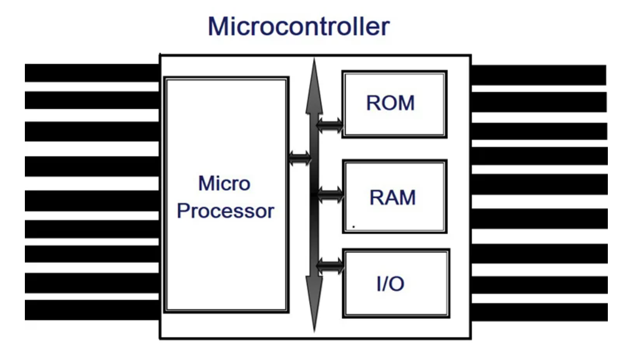
fig.1 Block diagram of microcontroller
We can see microprocessor is part of a microcontroller with extra memory, I/O ports, and peripherals such as timer and counters.
This gives a major clarity between both, but let's dig deep some technical differences.

Microcontroller Microprocessor:
We need to connect peripherals externally. So it makes circuit bulky. | The presence of peripherals such as RAM, ROM, Input-output, and Timers are In-built. So It is available on a single chip.
It increases the overall cost of the system high. | The overall cost of the system is less.
We can connect external memory in ranges of Mbytes and even Gbytes. But speed is less. | The inbuilt finite memory helps to improve the speed of operations.
You can't use it in a compact system. | You can use it in compact systems.
Due to external components, the total power consumption is high. Therefore, it is not ideal for the devices running on stored power like batteries. | As external components are low, total power consumption is less. So it can be used with devices running on stored power like batteries.
Most of the microprocessors do not have power-saving features. | Most of the microcontrollers offer power-saving mode.
The microprocessor has a smaller number of registers, so more operations are memory-based. | The microcontroller has more register. Hence the programs are easier to write.
These are based on the von Neumann model where program and data are stored in the same memory module. | These are based on Harvard architecture where program memory and data memory are separate.
It is a central processing unit on a single silicon-based integrated chip. | It is a byproduct of the development of microprocessors with a CPU along with other peripherals.
It uses an external bus to interface to RAM, ROM, and other peripherals. | It uses an internal controlling bus.
Microprocessor-based systems can run at a very high speed because of the technology involved. | Microcontroller based systems run up to 200MHz or more depending on the architecture.
It's useful for general purpose applications that allow you to handle loads of data. | It's useful for application-specific systems.
It's complex and expensive, with a large number of instructions to process. | It's simple and inexpensive with less number of instructions to process.

Brief overview:
- Microprocessor consists of only a Central Processing Unit, whereas Micro Controller contains a CPU, Memory, I/O all integrated into one chip.
- The microprocessor is useful in Personal Computers whereas Micro Controller is useful in an embedded system.
- The microprocessor uses an external bus to interface to RAM, ROM, and other peripherals, on the other hand, Microcontroller uses an internal controlling bus.
- Microprocessors are based on Von Neumann model Microcontrollers are based on Harvard architecture
- The microprocessor is complicated and expensive, with a large number of instructions to process but Microcontroller is inexpensive and straightforward with fewer instructions to process.
Register :
Registers are the smallest data holding elements that are built into the processor itself. These are the memory locations that are directly accessible by the processor. It may hold an instruction, a storage address or any kind of data such as a bit sequence or individual characters. For example, an instruction may specify that the contents of two defined registers be multiplied together and then placed in a specific register.
- Example: Accumulator register, Program counter, Instruction register, Address register, etc.
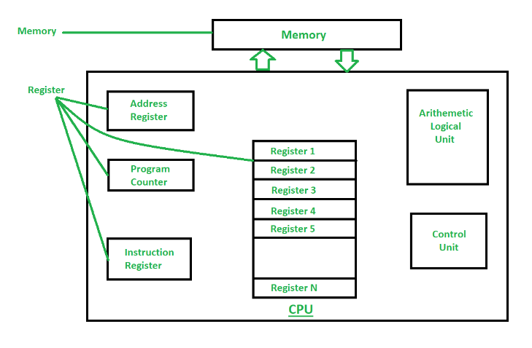
Memory :
Memory is a hardware device used to store computer programs, instructions and data. The memory that is internal to the processor is a primary memory (RAM), and the memory that is external to the processor is a secondary memory (Hard Drive). Memory can also be categorized on the basis of volatile and non-volatile memory. Volatile memory is memory that loses its contents when the computer or hardware device loses power. RAM (Random Access Memory) is an example of volatile memory. Non-volatile memory is the memory that keeps its contents even if power gets lost. EPROM is an example of non-volatile memory.
Example : RAM, EPROM etc.
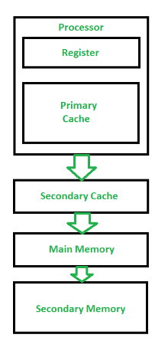

Difference between Register and Memory :
