Image Distortion
Objective

Learning how can image distortion affect the finished radiographic image
Apparatus
- ray machine, x-ray cassette, x-ray film, processing device, object with thickness and shapes
Theory
Distortion results from the radiographic misrepresentation of either the size (magnification) or the shape of the anatomic part. When an image is distorted, spatial resolution is also reduced.
- The SID and OID play important roles in minimizing the amount of size distortion or magnification created
Distortion can interfere with diagnosis. Distortion depends on
  - Object thickness 2. Object position 3. Object shape
Object Thickness With a thick object, the object-to-image receptor distance (OID) changes measurably across the object. Consider two rectangular structures of different thicknesses (Figure1). Because of the change in OID across the thicker structure, the image of that structure is more distorted than the image of the thinner structure.
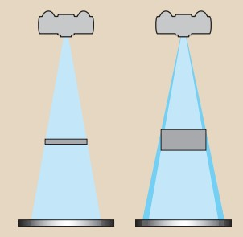
Figure (1): Thick objects result in unequal magnification and thus greater distortion compared with thin objects.

  - Thick objects are more distorted than thin objects.
The image of the sphere appears less distinct because of its varying thickness, but it does appear circular (see Figure2).
  - When these objects are positioned laterally to the central ray.
The sphere appears not only less distinct but elliptical because of its thickness (see Figure2)
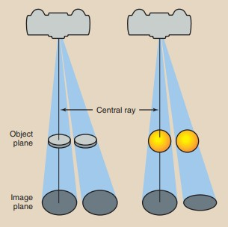

Figure 2
This distortion resulting from object thickness is shown more dramatically in (see Figure 3) in the image of an irregular object.
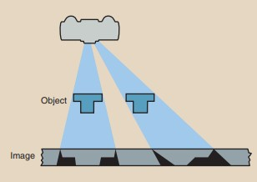

Figure 3
  - Irregular anatomy or objects such as these can cause considerable distortion when radiographed off the central ray (figure 3).

Object Position, distortion is possible in every radiographic examination if the patient is not properly positioned.
  - If the object plane and the image plane are not parallel, distortion occurs.
Shape distortion can radiographically appear in two different ways:

elongation or foreshortening.
  - Elongation refers to images of objects that appear longer than the true objects.
  - Foreshortening refers to images that appear shorter than the true objects.
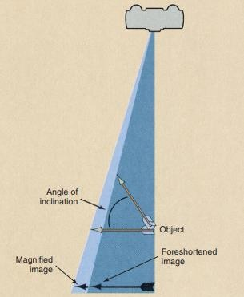Figure 4, shows the image of an inclined object can be smaller than the object itself. In such a condition, the image is said to be foreshortened. The amount of foreshortening, that is, the extent of reduction in image size, increases as the angle of inclination increases.

Figure (4): Inclination of an object results in a foreshortened image.
Figure 5 illustrates this situation and shows that the image of an inclined object can be severely foreshortened, or elongated.

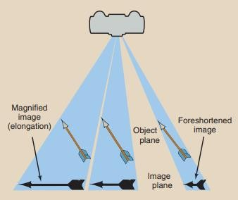

Figure 5: An inclined object that is positioned lateral to the central ray may be distorted severely by elongation or foreshortening.
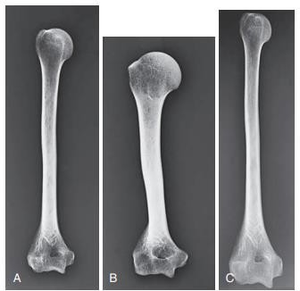
Figure 4: A, No distortion. B, Foreshortened. C, Elongated.

Central Ray Alignment
Shape distortion of the anatomic area of interest can occur from inaccurate central ray (CR) alignment of the tube, the part being radiographed, or the IR.
In addition to creating shape distortion, CR angulation and misalignment of the tube, part, and IR could affect the exposure to the IR. For example, when the CR is angled, the distance between the source of the radiation and the IR is increased.
- Generally, when the CR is angled, the SID is accordingly decreased to maintain exposure to the IR.

Image B has a distorted shape due to misalignment of the part and image receptor.
Note the improper alignment of the radial head with the capitulum in the image.

C, Improper alignment among the x-ray tube, part, and image receptor. Image C has shape distortion due to the central ray not being perpendicular to the part. Note the elongation of the olecranon process.

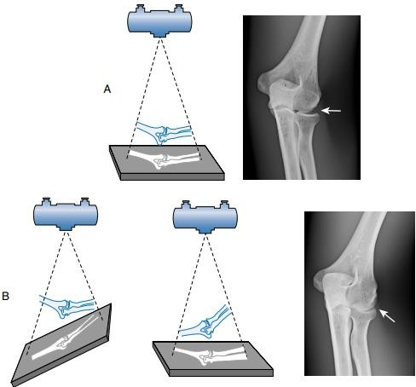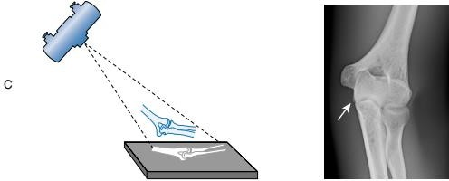

Figure 6
If misalignment occurs among the tube, part, or IR, the distance between the source of radiation and the IR or the part and the IR could be increased or decreased.
  - Sometimes, shape distortion is advantageous in particular projections or positions. For example, CR angulation is sometimes required to elongate a part so that a particular anatomic structure can be visualized better. Also, rotating the part (and therefore creating shape distortion) is sometimes required to eliminate superimposition of objects that normally obstruct visualization of the area of interest.

Procedures
- Make a radiographic image of a thick object and a thin object at the central ray and at the same plane with image receptor
- Make another radiographic image of disk and sphere of the same diameter laterally to the central ray and at the same plane with image receptor
- Make another radiographic image of an object laterally to the central ray and not at the same plane with image receptor
- Compare between these differ

