Magnification
All images on the radiograph are larger than the objects they represent, a condition called magnification. For most medical images, the smallest magnification possible should be maintained.

Source-to-Image-Receptor Distance
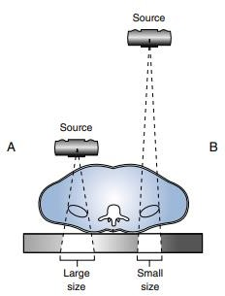
The distance between the radiation source and the IR, known as source- to-image-receptor distance (SID), affects the amount of radiation reaching the patient. Because of the divergence of the x-ray beam
This relationship between distance and x-ray beam intensity is best described by the inverse square law. This law states that the intensity of an x-ray beam is inversely proportional to the square of the distance from the source
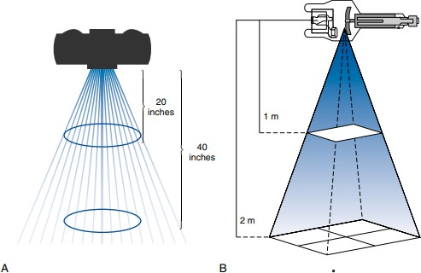

𝐼1

𝐼2
𝐷 2
=
2
𝐷2
1

(H.W) If the intensity of radiation at an SID of 40 in is equal to 400 mR, what is the intensity of radiation when the distance is increased to 72 in?

SID and mAs
Because increasing the SID decreases x-ray beam intensity, the mAs must be accordingly increased to maintain proper exposure to the IR

𝑚𝐴𝑠1

𝑚𝐴𝑠2
𝑆𝐼𝐷²
= 𝑆𝐼𝐷²
1
2

(H.W) Optimal exposure to the IR is achieved at an SID of 40 in using 25 mAs. The SID must be increased to 72 in. What adjustment of mAs is needed to maintain exposure to the IR?

Standard of the SID
Standard distances for SID are used in radiography to accommodate equipment limitations .
- Except for chest and cervical spine radiography, a 40 in (100 cm) or 48 in (120 cm) SID is standard .
- A larger 72 in (180 cm) SID, such as that used for chest imaging, decreases the magnification of the heart and records its size more accurately.
- Certain circumstances, such as trauma or mobile radiography, do not permit the use of standard distances.
- In these circumstances, the radiographer must determine the change needed in the mAs to obtain a quality radiograph. When a 72 in (180 cm) SID cannot be used, adjusting the SID to 56 in (140 cm) requires half the mAs.

Object-to-Image-Receptor Distance
When distance is created between the object being radiographed and the IR, known as object to-image-receptor distance (OID), a decrease in beam intensity may result.

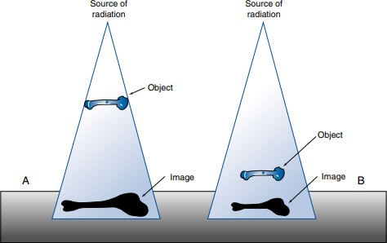
When sufficient distance between the object and IR exists, an air gap is created, also preventing the scatter radiation from striking the IR
- Reducing the scattered radiation reaching the IR by increasing the OID
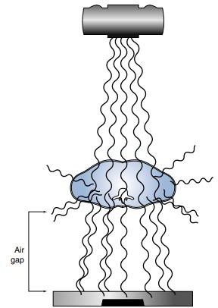
The radiographer must position the area of interest as close to the IR as possible
In certain situations, it is difficult to minimize OID because of factors or conditions beyond the radiographer’s control. In these situations, size distortion can still be reduced by increasing the SID.

Calculating Magnification
To observe the effect of distance (SID and OID) on size distortion, it is necessary to consider the magnification factor (MF). This factor indicates how much size distortion or magnification is demonstrated on a radiograph

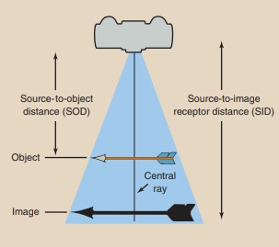
- Quantitatively, magnification is expressed by the magnification factor (MF), which is defined as follows
MF=Image size
Object size
Question: If a heart measures 12.5 cm at its maximum width and its image on a chest radiograph measures 14.7 cm, what is the MF?
MF = ^{14.7} = 1.176
12.5
MF = source−to−image receptor distance SID source−to−object distance SOD

MF=Image size = 𝑆𝐼𝐷
Object size SOD
Object size = Image size (^{𝑆𝑂𝐷})
SID
Source-to-object distance (SOD) refers to the distance from the x-ray source (focal spot) to the object being radiographed
(H.W) A renal calculus measures 1.2 cm on the radiograph. The SID is 100 cm, and the SOD is estimated at 92 cm. What is the size of the calculus?
- the percentage of magnification of the object can be calculated by the following formula:
Object % of Magnification = ^{Image} ^{size−} ^{Object} ^{size} × 100
Object size

Magnification radiography is a technique that is used principally by interventional radiologists and frequently in mammography.
Conventional radiography strives to minimize the OID. Magnification radiography deliberately increases the OID.

